Climate Lab
Videos

Video #0: How to Solve the Climate Problem [#0]

Introduction
Hi, my name is Glenn Weinreb, and I am the director of the AspenCore Climate Solutions Research Center.
AspenCore is the largest publishing company in the electronics industry,
and I've published possibly more than anyone else on {SLOW} climate solutions.
I'm often asked,
{Pic 4x ideas} What are the big ideas for solving the entire climate problem?
This might seem like a simple question, but answering clearly, in several minutes, is not easy to do.
Again, {SLOW} we're looking at how to solve,
{SLOW} the entire climate problem, {SLOW} at the lowest cost, to society.
I usually focus on {SLOW} four big ideas.

Big Idea #1: Decarbonization will not fix this.
Idea number 1 is, {PAUSE} Decarbonization {SLOW} will not fix this.
{Pic conference table} Thirty years ago, scientists stated we could solve the climate problem by
{Pic carbon fuel} replacing coal, oil and natural gas {Pic wind mill} with green energy.
However, it seems like we've moved beyond the point, where decarbonization alone, will fix this.
But where's the evidence this is the case?
The best source, is probably the {Pic 6x En-roads} MIT climate solutions simulator.
We can use this tool, to see what would happen, {*}
{SLOW} if a global tax, {SLOW} caused the price of fossil fuel, {SLOW} to increase 4-fold.
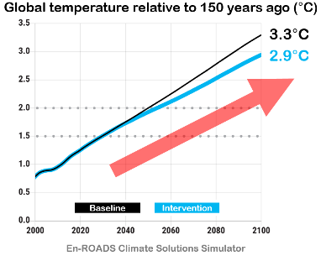
According to the software, {*} this would {SLOW} lower the projected end-of-century temperature,
{*} from 3.3 degrees Celsius, {*} to 2.5.
And, we would still get, {*} {PAUSE} runaway climate change.
{*} These temperatures values,
are relative to, {PAUSE} where we were, {PAUSE} 150 years ago.
Okay, so what does this tell us?
In a nutshell, it means
{Pic Earth} mother-nature is {SLOW} larger
{Pic Gov't} {SLOW} than typical government policy.
{Pic v1 v2} For details on what to do about this,
see Climate Videos 1 and 2.

Big Idea #2: Emit air pollution higher.
Idea number 2 is to {SLOW} emit air pollution higher.
{Pic AI spray plane} In theory, airplanes could spray, sulfur-based gases, into the upper atmosphere,
{Pic 1% Reflect} to reflect about 1%, of sunlight, back into outer space,
to prevent {SLOW} runaway climate change.
{Video: fossil fuel / sulfur / S} Sulfur is already {Pic coal} present in coal and oil,
and is therefore {Video: smoke / smoking-chimneys-in-a-large} released upon combustion.
And, sunlight {Pic reflect} reflects off atmosphere, laden with sulfur.
In theory, we could
{Pic Refinery} harvest sulfur, from fuel, before combustion,
{Pic Truck} transfer it to an airplane,
{Pic Airplane} and emit it, at a high altitude,
{Pic Bus} instead of, at ground level.
High-altitude sulfur, stays aloft for one to two years,
{Video: Smoke Stack / smoking-factory-chimneys} while ground-level sulfur, typically stays aloft for hours to days.
Therefore, changing the emission site reduces the planet's temperature,
{SLOW} without increasing total sulfur emissions.
This is important, since sulfur is {Pic man coughing} harmful to people, plants and oceans.
In other words, we don't want to increase total sulfur emissions.
However, {Video: reflect sunlight / passenger-jet-flying-by-at-cruising}, {SLOW} moving it higher should be okay.
According to one study, this {Pic $18B} would cost about 18 billion dollars, per year.
{Pic v7…v10} For details, see Climate Videos 7, through 10.

Big Idea #3: Observe basic principles of economics.
Idea number 3 is to observe basic principles of economics.
Let's begin, by looking at, decarbonization incentive, or lack thereof.
No one benefits from {Video: House / BBQ / 603914_Cooking_Skewers} {SLOW} reducing their own carbon dioxide emissions.
They are {VERY SLOW} too small to matter.
{Video: Smoke Stack / 568237_Chimney_Smoke} Instead, harm comes from the {SLOW} collective emissions
{Video: city / pedestrians / 98801_pedestrians_and_traffic} of our planet's {SLOW} eight billion people.
{Video: activism / successful-business-man-with-megaphone}
For this reason, {SLOW} each person, wants {SLOW} everyone else, to reduce.
Put differently, it is in everyone's best {SLOW} financial interests,
{Video: signs / money / money-makes-the-world-go-round} to minimize their own expenses,
{Video: activism / Moscow-Russia-August} while putting on a show of concern,
{Video: activism / businessmen-talking-into-a-megaphones} and encouraging others, to act.
This may sound negative, but it’s just basic economics.
It follows that, if you accept these economic realities, there's only one solution:
{Pic create slides} And that is to do R&D, to the extent required, to:
{*} Drive down the cost of 24/7 green energy, to below that of fossil fuel, and
{*} Determine how to reflect sunlight, at reasonable cost, and without harm.
In short, we need a surge of R&D, in key areas, with known technologies,
and favorable cost models.
But what can we develop, that is not already being worked on?
We examine this in Climate videos 11, through 16.

Big Idea #4: An engineered approach to climate
And lastly, idea number 4, is to consider an engineered approach, to climate.
Our society's current approach is not working.
Therefore, an alternate approach, should be, considered.
For example, one that calculates the lowest cost way to solve the entire problem,
and creates an implementation plan.
One might refer to {Pic engineer…} this as “an engineered approach, to climate.”
In theory, {SLOW} a website could create {SLOW} climate plans,
based on {SLOW} website user requirements.
For example, someone might want to prevent the first climate tipping point, from activating,
and also decarbonize, a specific nation, over a set number of years,
all at the lowest possible cost.
A website that creates climate plans does not exist; however, it could be developed.
{Pic v4…v5} For details, see Climate Videos #4 and #5.
{PAUSE} {PAUSE} Okay, that's it.
That's the several minute summary, of how to save the planet, from climate change.
For a complete list of climate solution videos, visit a plan to save the planet dot org.
Thanks for watching, and I’ll talk to you all real soon.

Video #1: Introducing The Climate Lab

Introduction
Hi, my name is Glenn Weinreb, and today we're announcing a new YouTube channel called “The Climate Lab” {Logo}

We’re a group of alumni from MIT who are interested in setting up a laboratory
that prevents runaway climate change.
More specifically, this lab would conduct R&D,
to the extent required,
to prevent the activation, of climate tipping points.
{Video: Ocean sea ice / Greenland / 6050710_Greenland_Iceberg} These are critical thresholds in Earth’s systems that,
{Video: Earth / glacier / 6233499_Perito_Moreno_Glacier} once crossed, trigger abrupt changes.
{Video: Ocean sea ice / Aerial-view-of-ice-floes} The first to go would probably be North Pole sea ice.
It is roughly 2 meters thick, and once it melts,
{Pic Absorb} sunlight would be absorbed by water,
{Pic Reflect} instead of being reflected by sea ice.
{Video: scientists / FRAME zoom-out-view}
And, according to scientists, this would increase the average global temperature by 0.6 degrees Celsius.
And that's just the beginning.
{Video: ocean / sea rise / ocean-waves} Over the next 100 years, we can expect to see several meters of sea level rise.

Runaway Climate Change
After the first tipping point activates,
{Video: signs / dominos-effect-3d} others are likely to follow, like a chain of falling dominoes.
This is sometimes {Video: global warming / city / 496570_Berlin (graph)}
referred to as runaway climate change, and yes, it could be bad.
Think: {Pic food} less food production,
{Video: city / pedestrians / silhouettes-of-a-crowd} mass migration, and
{Pic can't sleep} widespread disruption.
{Video: scientists / growth-of-startup} We believe, a surge of R&D, in key areas,
{Pic domino push} can help prevent this, and in our videos, we’ll explain how.
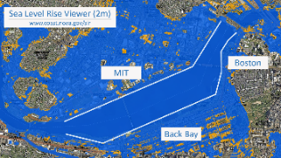
For us, this hits close to {Video: city / mit campus / mit-and-Boston-wide} home. Much of the MIT campus is built on landfill, which means it would be the first to go.
{Pic pre NOAA} This shows what {Pic post NOAA} 2 meters of additional water would do. {Pic guy chair} Obviously, this would be bad.

Is Decarbonization Helpful?
{Pic conference table} Thirty years ago, scientists suggested we can solve the climate problem by
{Pic replace} replacing coal, oil and natural gas with {slowly} green energy.
However, it seems like {Video: Earth / Tipping Points / 612648_Ball_Rolling}
we have progressed, beyond the point, where this will solve the problem.
{Pic 6x En-roads} To get a better sense of this, we can use the MIT climate solutions simulator,
to see what would happen, if a global tax caused, the cost of fossil fuel, to double.
According to the software, this would reduce the average global temperature anomaly,
at the end of this century, from 3.3 degrees Celsius, to 2.9.
And, we would still get, runaway climate change.
These temperatures refer to the increase,
from pre-industrial times, 150 years ago.
Okay, what about adding a worldwide, 200-dollar-per-ton,
tax on carbon dioxide, to roughly quadruple the cost of fossil fuel.
Would that help?
Nope. We still get runaway climate change.
Okay, so what does this mean?
{Video: earth from space / animation-on-the-subject (Earth)} In a nutshell, this means fixing climate, is more complicated,
{Video: smoke stack / 536923_Chimney_Pollution} than reducing carbon dioxide.
Furthermore, typical energy policies promoted by Conservatives,
and typical energy policies promoted by Liberals,
are both {slow} too small,
to influence tipping points,
in either direction.
{Pic Capital Building} In other words, Liberals are not helping, and Conservatives are not hurting.
All of this is another way of saying
{Video: earth from space / 695534_Space_Planet_Earth} mother-nature is larger
{Video: gov't / 6156789_City_Cityscape_Golden} than your typical government policy.

The Journalism Problem
Part of the problem is {Video: news / medium-shot} journalists report on existing climate initiatives,
{Video: Earth / from space / motion-graph-orange} without quantifying their impact on the planet.
For example, {Video: power / solar / aerial-view-of-solar-farm-in-English}
a news story might cover a new solar farm and suggest it will help
{Pic 4x jammed up} bears, penguins, rice farmers, and people late for work.
But leave out the fact that even {Video: power / solar / portrait-of-maintenance-engineer}
if the world built these up to the level where they supply all electricity when sunny,
{Video: earth / primal / primal-earth-images-rangipo} it would have little impact on tipping points.
There are several techniques for quantifying the impact of so-called climate remedies,
one of which is to use a climate simulator.
However, few journalists are familiar with these techniques,
and this has led to a distorted view of the problem, and the solution.

Actively Cooling the Planet
To prevent runaway climate change, we probably need to
{Pic reflect arrow 1%} reflect approximately 1% of sunlight back into outer space,
to cool the planet, and offset global warming.
In theory, this could be done with
{Video: reflect sunlight / passenger-jet-flying} airplanes that spray reflective gasses, into the upper atmosphere.
{Pic 4x white bars} To get a sense of what 1% looks like, we placed a white bar in this image, and then made it 10% transparent, followed by 1%. As one can see, 1% is barely visible to the naked eye.
It would cost little money to conduct reflectivity experiments and look for harm.
{Pic spray plane} For example, an experimental spray plane could inject material into the upper atmosphere,
{Pic monitor plane} and a monitor plane could visit the site once a day, for several weeks.
{Gsw waves hands up/down/thru} Multiple parameters could be measured by flying above the material,
below the material, and through the material.
{KC-135, https://chatgpt.com/c/689ce952-bd24-8320-82b9-7f50aca794d9}
{Search "ATom: In-Situ Measurements of Airflow and Aerosols from Multiple Airborne Campaigns"}
{Search "The NASA Atmospheric Tomography (ATom) Mission"}
{https://espo.nasa.gov/atom}
{Video: Activism / Tired-mature-businessman (rub eyes)} Reflecting sunlight is not popular;
{Video: Earth / storms / 6317090_Clouds_Storm} however, as the climate crisis worsens,
{Pic Contingency Plan} our society will be pushed in this direction —
{Video: smoke stack / heat-electro power-station} in addition to, reducing carbon dioxide.
This raises important questions. {Tick 3 fingers}
Can we reflect sunlight without causing harm?
How much would this cost?
Can we run small-scale tests, in a limited part of the sky, to measure side effects?
We'll explore these questions, as we
{Video: signs / the-concept-of-fair-scale} compare reflecting sunlight,
{Video: earth / drought / clear-skyline (bridge in China, low water level in river)} with not reflecting sunlight.
{Video: signs / clocks-spiral-tunnel} Unfortunately, we may also have a timing problem
—by the time we act, it could be too late.
We'll talk about that too.

Energy Economics
Currently, the world spends
{Video: fossil fuel / gas / aerial-view-of-an-oil-and-gas-drilling} approximately 4 trillion dollars, on fossil fuel, each year.
{Pic 4x fuel} This includes 2.5 trillion for oil, 1 trillion for coal, and a half trillion for natural gas.
{Video: power / wind / 204551_Wind_farm_Environment} If we switched over,
this money instead would be used to produce green energy.
Or, more precisely,
{Video: economics / man-hands} it would pay down the mortgage on
{Video: power / dam / 204881_Dam_Hydroelectric_Power} facilities that produce green energy.
{Video: signs / money / cartoon-fantasy-100-dollars} These are big numbers.
{Video: signs / money / digital-animation-of-finance}
And we'll look at the economic forces that would be needed to push this forward.
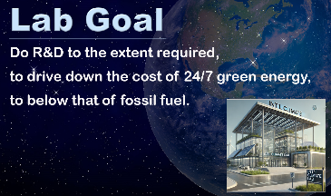
{Video: scientists / mid-adult-professor} According to basic principles of economics,
there's only one way to decarbonize worldwide,
within a reasonable amount of time.

Lab Goal - Statement
{We use the word "goal" yet don't push too much that it is our goal}
{Pic 4x Lab Goal - Statement} And that is to do R&D, to the extent required, to drive down the cost of 24/7 green energy, to below that of fossil fuel.

Lab Goal - SLIDE
Do R&D to the extent required, to drive down the cost of 24/7 green energy, to below that of fossil fuel.
This is not being done; however, it could be done.
And this would cost little, relative to costs typically associated with climate.

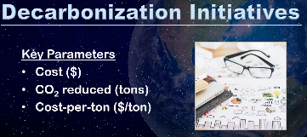
An Engineered Approach to Climate
{Pic, 4 slides} Each decarbonization initiative can be summarized with three key parameters:
the cost to society,
the amount of carbon dioxide reduced in units of tons,
and the cost per ton.
In theory,
{Video: gov't / washington-dc-july-21-2023 (DOE)} economists can estimate these for each decarbonization initiative,
{Video stock Pic woman at calculator} and identify the lowest-cost approach.
But in practice, this is rarely done. Yet why not? Why is our society inept at tackling climate?
{Video: activism / 6294387_Crowd_Megaphones} Is it possible, our fundamental approach, to this problem, is flawed?
And if so, {Video: signs / the-face-of-the-thinking-person} what might be a better approach? If we instead
{Video: scientists / an-array-of-bitcoin-infographics} pursued an engineered approach,
{Video: stock signs / money / close-up-hands (calculator)} where the lowest cost solution is favored,
{Video: gov't / pensive-senior-businessman} what might that look like?
In later videos, we'll do a deep dive, on what it means to tackle climate, at lowest-cost.

Climate Plan
A plan that decarbonizes over several decades would involve both speed and scale.
It would not look {video: power / nuclear / factory-nuclear} at building one nuclear fission reactor,
and instead would support building thousands.
Also, it would not look at building {video: power / fusion / artist-recreation-fusion-reactor-SBV-306249629}
one experimental fusion reactor 10 years from now,
and instead would support achieving economic fusion within several years,
given a very large R&D budget.
{Video: scientists / successful-business-team (Man at Dryboard)}
No one has ever presented a plan that solves the entire climate problem, let alone at the lowest cost.
{Video: scientists / company employee}
But in theory, a website could generate a plan, based on criteria specified by the website user.
{Video: scientists / silhouette-of-a-web} This website does not exist; however, it could be built.

A Surge of R&D in Key Areas
{Video: gov't / washington-dc-circa-2017-aerial-view-of-white-house} President Biden issued
{Video: signs / money / 94402_Machine_printing} 93 billion dollars in climate-related,
loan guarantees, during the last few months, of his presidency.
This level of funding is probably needed to solve the entire climate problem
{Video stock Pic AI R&D} with additional R&D.
However, it would need to be {Pic target} focused on the right areas, and managed responsibly.
We’ll look at how this might be done.

Politics is not the Problem
Let's take a break from climate, {Video: gov't / washington-dc-circa-2017-aerial-view-of-capitol} and look at politics.
{Video: stock gov't / flags-of-the-nations} Nations are dominated politically {Video: stock} by large industries
that employ millions of people.
Examples are, {Pic 4x} the fossil fuel industry, labor unions, auto makers, and factories.
{Video: activism / 479180_Girl_Holding_Sign_Forest} Climate, in comparison, employs
{Video: signs / glowing-figure-with-info} few people, and is therefore politically weak.
In a sense, {Pic gorilla} large industries are political gorillas,
while {Pic monkey} climate is the small monkey.
But surprisingly, this is not a problem.
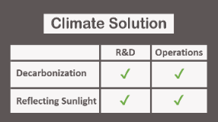
{Video: activism / annoyed-Asian (later, eyes roll)} That might sound strange,
but it can be explained.
Preventing runaway climate change, for real,
primarily involves two activities {2 fingers} at large scales.
{Pic 2x2 table} One is Decarbonization, and the other is Reflecting Sunlight.
For each activity, there are two phases, R&D and Operations.
Political opponents cannot block R&D,
since it can be funded by a handful of environment-friendly governments, and foundations.
Also, political opponents cannot block Decarbonization Operations,
if the green option, costs less than, the carbon option.
And, political opponents are not likely to block Reflecting Sunlight,
since runaway climate change, would be bad for business.
{Video: scientists / two-young-scientists (2 people at blackboard)} Also, for very little money, researchers
{Video: signs / scientists / digital-seamless-math (blackboard)} can calculate {very slow} how to avoid tipping points,
{Video: signs / money / frustrated-business (coin, calculator}} at the lowest cost to society.
{Pic Wake Smith} Wake Smith's excellent paper, is an example of this.
All of this suggests,
{Video: activism / happy-children-holding-hands} a path forward exists, {very slow} and it is not blocked by politics.
Also, if we get the
{Video: scientists / FRAME global-warming} right assignments to scientists and engineers,
{Pic relax 2 chairs beach} practically everyone else can relax,
{Video: gov't / 166307_People_Business (LATER)} while a relatively small group of people, handle this.

Do We Need a New Laboratory?
{Video: scientists / 122404_man_looking_downwards} Unfortunately, our society does not have a plan to solve the climate problem.
{Video: signs / money / footage-of-young} It does not evaluate the cost and impact of decarbonization initiatives.
{Video: signs / money / frustrated-businessman-making} It does not have a mechanism that favors the lowest-cost approach.
{Video: scientists / scientist-pondering} And no one feels responsible for solving the entire problem.

Perhaps the last point is the most relevant.
Can we make someone — or some organization — responsible for fixing this? And if so, what might that look like?
{Pic BP} We've developed a business plan for an organization that could do this. This plan is open-source, which means it can be shared, edited, and used freely. To see it, click on the link, in the description below {BP}.

The Petraeus Method
Retired General David Petraeus is considered to be one of the most effective military thinkers of our time.
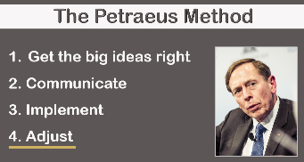
He has held top positions within the U.S. military,
in addition to leading the Central Intelligence Agency.
{Pic 5x Pet} He advocates a four-step process,
when solving complex problems.
Step #1 is to figure out the big ideas, and get them right.
Step #2 is to communicate those ideas.
Step #3 is to implement.
And Step #4 is to adjust as needed. {End of section}

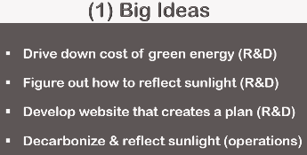
Our Strategy
It is our intent, to apply The Petraeus Method, to climate.

Step #1 -- Big Ideas
{Pic 5x Ideas} The big ideas are:
- Drive down the cost of green energy with R&D.
- Figure out how to reflect sunlight with R&D.
- Develop a website that calculates what needs to be done, and when, to achieve an objective.
- And conduct decarbonization and reflectivity operations, at reasonable cost.

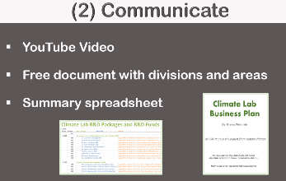
Step #2 -- Communicate
With communications, {Pic 4x Com} we have:
- Videos at this YouTube channel.
- A free document that describes 8 divisions within a proposed laboratory, each with about 7 focus areas.
- And a free summary spreadsheet that helps people figure out what they want to do, within each division.

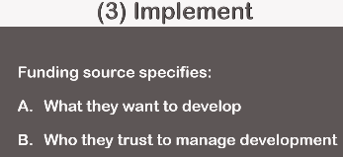
Step #3 -- Implementation
To implement,
{Pic 3x Imp} we need wealthy individuals to specify:
A, what they want to develop,
and B, who they trust to oversee development.
For example, someone might choose to put X dollars into area Y,
Z dollars into area P,
and have organization so-and-so oversee the development.
{Pause} So that's it.
That's our strategy.

MIT Needs to Do Better
{Video: scientists / 181369_teacher_standing_and_talking} MIT teaches scientists, and engineers,
{Video: scientists / 6196117_Siting_Serious_Looking} how to solve problems.
But when it comes to climate, they need to do better.
{Video: Earth / Forest fire / 708889_Drone_Austria} They need to focus less on the trees,
{Video: Earth / Forest fire / 313364_Lake_Cars_High} and more on the forest.
{Video: scientists / scientist-thinking} More specifically, they need to identify the R&D that can solve the entire problem — to the extent needed — {Video: earth / primal / primal-earth-images-sunrise-volcanis} to prevent runaway climate change.
Our lab business plan is one example of how this could be done.

Calling on MIT Alumni Worldwide
{Video: government / businessman-and-retail} A lab that solves the entire climate problem would involve
{Video: scientists / 6280834_Office_Man_Time} tens of thousands of scientists and engineers.
{Video: government / businessman-meditating} Many MIT alumni have experience running large organizations,
and are therefore well suited to help set this up.

Calling on MIT Alumni Worldwide - Statement
{Video: activism / 704984_Save_The_Planet (Save Planet sign)} For this reason, we're calling on MIT alumni worldwide, to help us.
{Video: signs / financial-crisis-concept} The situation is dire, yet not impossible
And in future videos, we'll look at how this might be done.
Okay, that's it for me, and I'll talk to you all, real soon.
{Video: signs / the-man-standing-on-a-mountain-top} music fades out -- 5 seconds

Video #2: Tackling Climate with More R&D
Hi, my name is Glenn Weinreb, and today we're going to look at how a
{SLOW} surge in R&D,
could potentially {SLOW} solve,
{Video: smoke stack / 224260_Pollution_Industry_Smoke} the {SLOW} carbon dioxide emissions problem. {Logo}
But what might we develop, that is not already being worked on?
We'll look at that.
But first, let's review the problem.

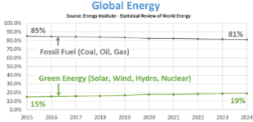
The Prisoner's Dilemma Problem {see 28min video with music}
{Pic 2x} In some cases, {*} the green option costs less {*} than the carbon option, and switching over is easy.
While in other cases, the green option costs more,
and switching over is less popular,
especially at large scales.
In these cases, the additional cost of the green product, {Pic Green P} is referred to as the “green premium.”
And, unfortunately, {Pic woman 2 hands} consumers tend to avoid this so-called premium.
This is because they do not benefit from
{Video: house / BBQ / 603914_Cooking_Skewers} {SLOW} reducing their own emissions.
They are {VERY SLOW} too small.
{Video: smoke stack / 568237_Chimney_Smoke} Instead, harm comes from the {SLOW} collective emissions
{Video: activism / 98801_pedestrians_and_traffic} of our planet's {SLOW} eight billion people.
{Video: activism / successful-business-man-with-megaphone}
For this reason, {SLOW} each person, wants {SLOW} everybody else, to reduce.
{Video: scientists / 41273 man} Economists refer to this as a “prisoner's dilemma problem.”
And, according to economic theory, our fundamental strategy,
{Pic pressure} of using social pressure, to solve the climate problem, will not work.
{Video: activism / thoughtful-woman-contemplates (first 3 sec)} All of this might seem strange,
{Video: scientists / businessman-analyzing} however, we can see evidence of it, in real data.

The History of Decarbonization
{Pic 8x global energy graphs} Globally, the share of total energy that doesn’t emit carbon dioxide,
has only increased from 15%, to 19%, over the last decade.
This is all energy, not just electricity.
And this is the entire world, not just one nation.
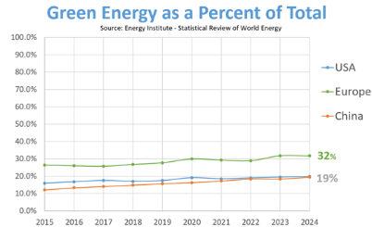
At this pace, reaching full decarbonization,
would take about 200 years.
Far too long, to solve the climate problem.
{Pic graph-2} We can also look at the U.S., Europe, and China.
The U.S. is on track to decarbonize over 200 years,
Europe over 125 years,
and China over 100 years.
{Pic graph-3} It is worth noting,
decarbonization {circle} during conservative administrations is similar to that of
{circle} liberal administrations, even though liberals focus more on climate.
This is because key energy policies were similar, and market forces changed little.
{Video: power / solar / solar-panels-produce} For example, they both had a 30% subsidy on building solar farms,
{Video: fossil fuel / gas / burning-on-natural-gas} and they both had natural gas, costing
{Video: fossil fuel / coal / pile-of-coal} less than coal.
In other words, policy differences, between liberals and conservatives, tend to be small,
{Video: earth from space / realistic-planet-earth-seen-from-space} relative to {SLOW} the size of the problem {View Earth}.

Tackling Climate in Lowest-Cost Order
Lawmakers sometimes ask, "Why spend 200 dollars to reduce carbon dioxide emissions by one ton,
when we can do it, for 20?"
For this reason, they often favor decarbonizing, in lowest-cost order.
In other words, easiest first, followed by, the more difficult.
{Video: city / power / special-effects} Roughly one-third of carbon dioxide comes from electrical power generation,
{Video: fossil / oil-r / aerial-view-of-vaporizing} roughly one-third from industrial processes that make chemicals & materials,
{Video: city / highway / futuristic-urban-architecture} and roughly one-third from transportation.
{Pic 3x} Electrical power is the easiest to decarbonize,
followed by chemicals,
followed by transportation.
Electrical power, is currently being decarbonized,
{Pic Construction} by building solar farms, and wind farms.
However, industrial processes and transportation, has seen little decarbonization, relative to total.
Again, nations tend to tackle climate, in lowest-cost order.
And they often do it slowly, in part, due to The Prisoner's Dilemma.
In other words, it is in a nation's best financial interests,
{Video: signs / money / money-makes-the-world-go-round} to minimize costs,
{Video: activism / Moscow-Russia-August} while putting on a show,
{Video: activism / businessmen-talking-into-a-megaphones} and encouraging others, to act.
And, for the most part, this is what happens.

The Climate Solution
There is a field of study called Energy Economics,
and it examines our society's behavior with energy.
If you {Pic Yergin} want to learn more about it, consider reading The New Map, by Yergin.
There are basic principles within this field,
and if you accept them,
and if you want to solve the Prisoner’s Dilemma problem,
there's only one solution.
And that is to drive down the cost of 24/7 green energy,
so that it’s cheaper,
than carbon-based energy.
And in theory, {Pic girl R&D} more R&D can make this happen.
Fortunately, this would cost little, relative to the cost of brute-force decarbonization,
and relative to the cost of climate harm.
However, this R&D would need to produce results quickly.
Which means it would need to focus on key areas,
with known technologies,
and favorable cost models.
And this applies to the 3 big areas, {tick fingers}
which are, again, electrical power,
the making of chemicals and materials,
and transportation.
Let's run through an example, to get a better sense of this.

Cheap Green Electrical Power
Let's say we want to
{Video: city / transmission /high-voltage-electric-power} quickly decarbonize electrical power,
{Video: power / nuclear / aerial-view-to-nuclear} with low-cost nuclear fission reactors.
It typically takes decades to commercialize reactors that are still in development.
Therefore,
we would need to COPY an existing design,
that is currently operating commercially,
and then build many.
The safest reactor in the world, is HTR-PM.
It does not melt-down, when not cooled.
And its reactor vessel and heat exchanger cost little.
Instead, {Pic nuclear construction} most of the cost, comes from, site construction.
And, {SLOW} for little money, we could do rough designs, of custom machines, that automate that construction.
In other words, for small money,
we should be able to identify how {Pic transmission lines} to produce 24/7 green electrical power,
at a cost less {Video: smoke stack / 645065_Factory_Pollution} than carbon-based power.
Okay, so why has this not been done?
The problem is, engineers typically build one nuclear reactor at a time,
instead of building many, low-cost reactors.
And a laboratory tasked with solving the entire climate problem,
would focus on doing the R&D that supports many.

Cheap Green Chemicals & Materials
Ok, so that's electrical power.
Now let's {Pic Chemicals} look at making chemicals, {Pic Metal} and materials.
We want to do this {tick fingers} without emitting carbon dioxide,
and we want to do it for less money,
than the carbon-based approach.
This can probably be done by using heat, directly from, a cost-reduced nuclear reactor.
More specifically, we could pump steam, molten salt, or molten lead
{Pic Pipes} through pipes, from a nuclear reactor, to a nearby, industrial processes.
To further reduce costs,
a new transportation system could be developed that transports
platforms of chemical processing equipment from factory, to site.
{Pic Big railcar} For example, we could develop {*} a double-rail system, that moves
{Pic Tank on car} large and heavy loads, over land and water.
{Pic Platform on rail} Also, {*} multiple railcars, could move {*} large platforms of industrial processing equipment,
{Pic Side-by-side} and place them side-by-side, near {*} a nuclear reactor. {*}
Typically, 66% of the energy produced by nuclear power, is lost to the environment as unused heat.
However, this could potentially be used by nearby industrial processes, to further reduce costs.
{Pic R&D} Developing the standards that define how this fits together, plug-and-play,
would cost little, compared to costs
{Video: power / nuclear / nuclear-power-plant-aerial} typically associated with nuclear power.
We'll talk more about this, in future videos.
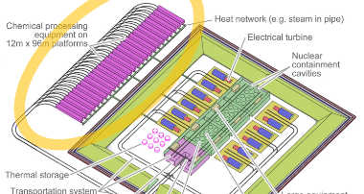
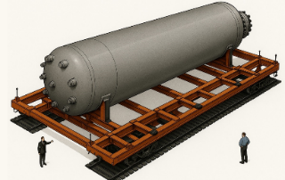
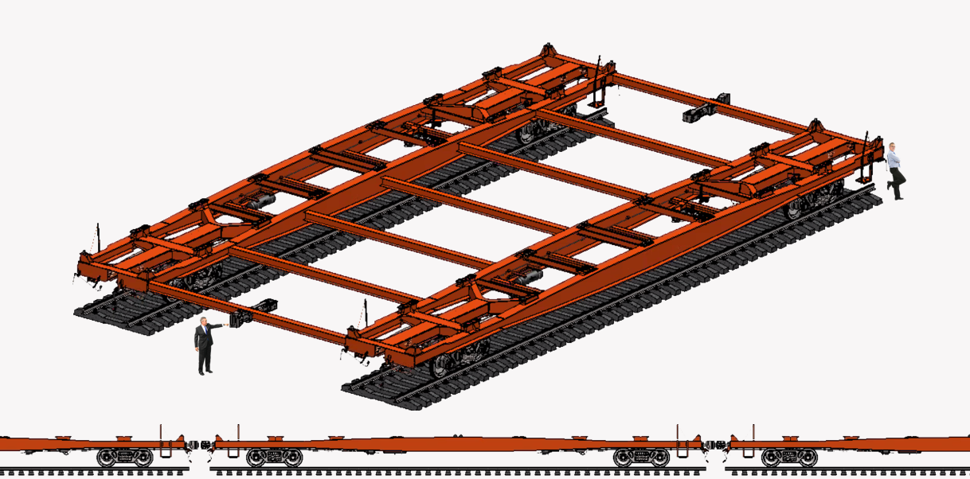
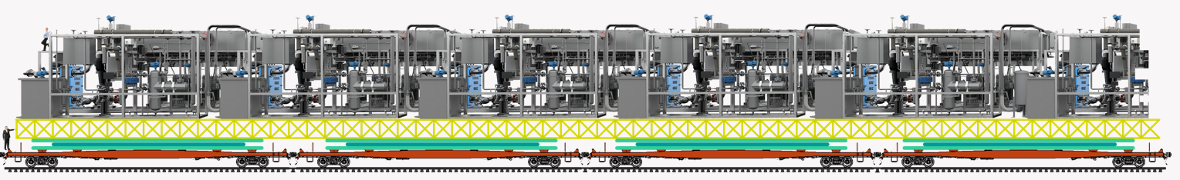

Cheap Green Cars
Okay, now let's look at cars.
We want cars that,
{Pic smoke} do not emit carbon dioxide,
{Pic gas car} cost less than gas cars,
{Pic fun car} and are, as convenient as, gas cars.
{Video: city / EVs / charging-station-for-electric-cars} Are we currently doing this, with electric vehicles?
Nope.
{Video: city / EVs / businessman-using-smartphone} They are not convenient.
Okay, so how might we do better?
Currently, {Pic traditional EV battery} proprietary batteries are built into EVs,
{Video: city / EVs /charging-electric-car-electric-vehicles} and charged periodically.
{Pic swappable battery} Alternatively, EVs could use a standard plug-in battery,
where all cars use the same form,
and swap with a fresh battery in several minutes.
Car owners would pay for electricity consumed, and for wear on the battery.
And they'd pay less, when using lower-cost batteries.
Today, {Pic small batteries} mechanical and electrical standards define batteries,
and allow us to power many products, at a low cost.
In theory, this could also be done with EVs.
In other words, a standardized battery, similar to the Tesla EV battery,
could be used by multiple manufacturers.
{Pic swap station} And batteries, sitting in swap stations, could charge at any time, over multiple days.
This would reduce costs for multiple reasons. {tick fingers}
- One, batteries could charge {Video: Reflect Sunlight / 526435_Space_Stars_Sky_Lake} at night when electricity is cheap.
- Two, batteries could {Video: Power / Solar / Ecology-solar-power … SBV-338678956-HD} charge when solar farms and
{Video: Power / Wind / 124751_wind_turbine} wind farms are producing power.
- Three, batteries could charge slowly, {Video: city / EV / electric-vehicle-charger} and avoid expensive fast-charging hardware.
- And four, competition {Video: city / EV / lithium-ion-battery} between battery manufacturers, would drive down costs.
In other words, we could get favorable costs, and favorable convenience.
Which is what we need to go green with cars.
Okay, so why has this not been done?
This problem is, lawmakers delegate to auto companies,
and auto companies focus on their own financial interests, not {SLOW} fixing the planet.
To move this forward, someone would need to support
{Video: scientists / close-up-of-engineers-team} the development of {SLOW} standards that
{Pic 3x} define how this fits together mechanically, {*} electrically and {*} with communications.
More specifically, climate money would probably need to build this up to the point of
{Pic blue car} working prototypes, {Pic DWG} and give the designs away for free.
We'll talk more about this in later videos.

Building Automation & Control
{Pic automation} To fully automate buildings, we would need to put a microprocessor into every device,
and then connect them together with reliable communication.
Devices would include light switches, light sockets, HVAC equipment, appliances,
dampers in ducts, fans, occupancy sensors, temperature sensors, etc.
This could save money, improve comfort, and cut energy use in many ways.
For example, it could help control each room’s temperature,
and move heat from one room to another.
In theory, a new lab could develop the standards that define how this fits together — plug-and-play.

Fusion Moonshot
Currently, scientists are exploring {Video: power / fusion / artist-recreation-fusion-reactor-SBV-306186467}
how to generate energy with a hot plasma inside a donut-shaped chamber.
This is referred to as “fusion,” {Video: activism / irritated-woman-shows-blah-blah}
and some scientists believe it will not be commercially available for another 20 years.
However, a multi-billion-dollar R&D initiative,
overseen by the world's top fusion scientists, could potentially speed this up.
In 1961, {Video: power / fusion / JFK-speech-man-landing-on-the-moon}
President Kennedy stated he wanted a man on the moon, by the end of the decade.
In response, {Video: power / fusion / NASA-vehicle-assembly-building} a program was set up, and funded.
In theory, a government or foundation leader could do the same with, nuclear fusion.
For example, {Pic Fusion Moonshot} they could state they want to generate electricity with fusion,
at a cost less than natural gas-based electricity,
and they want this done,
within a handful of years.
Engineers would then focus on a published design, that achieves this objective.
{Pic Volpe Paper} It turns out, such a thing exists {Reference: Volpe 2024 paper},
and we'll do a deep dive on what this means,
in later videos.
In closing, much can be done with additional R&D, in key areas.
And, for each of these areas, it costs little money, to assess technical and economic feasibility.
Okay, that's it for me, and I'll talk to you all, real soon.

Video #3: The Climate Lab Strategy
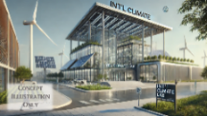
Hi, my name is Glenn Weinreb,
and today we’re going to explore how a {Pic lab building}
new R&D laboratory could potentially tackle,
the climate problem.
{Pic Graph} {SLOW} Our planet's temperature, is currently accelerating upward.
{Video: scientists / two-men-with-the-tablet} {SLOW} This suggests, past R&D efforts have been insufficient.
{Pic Thinking} {SLOW} So what might we do differently?
{Pic light bulb} {SLOW} We'll look at that.
But first, let's do a quick review, of typical methods, for handling R&D.

Big R&D
{Video: city / Univ / Princeton} Universities typically focus on professors-sized projects.
{Video: city / office building / Paris-France} While companies typically focus on projects that
provide a return on investment,
within a reasonable amount of time.
But there's another type that is often overlooked.
This is what Bill Gates {Pic Big R&D} refers to as “Big R&D.”
These are large-scale projects, that exceed the capabilities of a university, or a company.
Examples include
The Manhattan Project during World War II, and
{Video: scientists / Apollo / full-shot-of-an-astronaut (kick leg up)} the U.S. program that landed a man on the moon.
Each started with a goal, broke the problem down into parts, and pushed forward.
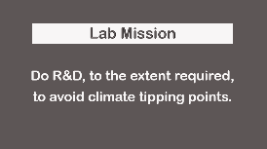
And each involved multiple teams, and multiple organizations.
In theory, the same could be done, for climate.

Lab Mission - Statement
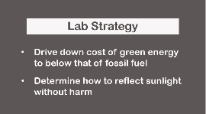
More specifically, a new laboratory {Pic mission}, could do R&D,
to the extent required,
to prevent runaway climate change.
To achieve this objective, {Pic 3x strategy} the lab could

Lab Strategy - Statement
Drive down the cost of 24/7 green energy, to below that of fossil fuel,
and determine how to reflect sunlight, at reasonable cost, and without harm.

Lab Mission - SLIDE
Do R&D, to the extent required, to prevent runaway climate change.

Lab Strategy - SLIDE
- Drive down the cost of 24/7 green energy to below that of fossil fuel.
- Determine how to reflect sunlight at reasonable cost and without harm.
{Video: city / office / 605055_Clouds_Cityscape} Big R&D is often avoided by Companies, due to excessive risk.
{Video: city / university / 6308217_Diversity} It is often avoided by Universities, due to a reliance on professor-sized projects.
{Video: gov't / capitolus-dc-11032019} And it is often avoided by Governments, unless they are under extreme pressure.
In theory, these barriers can be overcome with a unique organizational structure,
that coordinates multiple foundations, universities, and funding sources.
Yet how might this be organized?
And what would it take to get it started?
Let’s take a closer look.

Spending Money Wisely
Big R&D might sound expensive; however, feasibility can often be verified with relatively little money.
More specifically, one typically spends small money before medium money,
and medium money before big money,
and only advances if technically and economically feasible.
Small typically involves developing rough designs, building cost models, and writing proposals.
This is sometimes referred to as “Phase One R&D.”
Medium typically entails, detailed engineering, and prototype development.
While Big typically involves setting up factories, and supporting large volumes.

Sources of Funding
There are two main sources of R&D funding: Climate Money and Investment Money.
Climate Money hopes to save the planet from climate change,
{Video: signs / money / successful-businessman-counting} whereas Investment Money hopes to make more money.
Each has constraints.
For example,
Investment Money avoids projects that are too complex, too risky, or lack consumer demand.
While Climate Money often requires results to be shared openly,
to maximize climate benefit, per dollar spent.
{Pic 6x} Open sharing brings reals advantages.
It maximizes use of developed technology.
It encourages peer review.
It promotes development of interconnection standards.
It reduces exaggerated claims.
And it lessens dependency on researchers and institutions.
Typical sources of Climate Money include governments, foundations, and individual donors.
While Investment Money typically comes from companies and investment funds.
Companies and universities, often prioritize their own financial interests, over climate interests.
For example, they often avoid sharing information, since it can interfere with
{Video: signs / money / a-patent-application-document} securing patents,
{Video: scientists / medium-top-shot-of-group-of-diverse} developing proprietary products, and
{Video: signs / money / coins-stack-increase-with-business} attracting further investment.

The Climate Lab
{Pic sleep} The public is tired of hearing about climate.

{Pic 3x cost to fix} For the most part, they have 3 simple questions:
- One, how much does it cost to fix this?
- Two, who fix this?
- And three, what are they going to do about it?
In theory, a business plan, for a new lab,
can help answer these questions.

Lab Suggestion - Statement
{Pic 4x} For this reason, we encourage Foundations, Governments, and Universities to
task several people,
with writing an R&D plan,
that prevents runaway climate change.

Lab Suggestion - SLIDE
Task several people with developing an R&D plan that prevents runaway climate change.
{Pic BP} For an example of this, click on the link, in the Description below.
Okay, so why is it helpful, for existing organizations, to write this kind of plan?
{Video: signs / money / closeup-of-unrecognizable-female} We can estimate the cost of decarbonization, and climate harm,
and see it's in the range of trillions of dollars.
Therefore, in theory, it's reasonable, to spend additional billions on R&D, to save trillions.
If additional R&D, cost 100 billion dollars over 10 years, for example.
And 500 hundred thousand dollars was spent on each technical person annually,
then this would support 20,000 scientists and engineers.
{Video: city / mit / cinematic-panning-shot-from-helicopter}
This goes beyond what one organization could handle.
{Video: signs / money / dollar-tree-growing-and-flowing}
Therefore, money would need to flow toward many organizations.
And writing a plan, helps them get a sense of what is needed, and how to attract money.
The idea of {Video: city / pedestrians / silhouettes-of-a-crowd} 20 thousand people might seem overwhelming.
But keep in mind,
one can get started with rough designs, cost modeling, and proposal writing --
for small money.

Climate Leadership
{Video: Scientists / Pensive-scientists-thinking} The climate problem is difficult to discuss for several reasons.
{(Remove glasses in video)} One, it's upsetting.
{Video: activism / silhouette-of-tired-businesswoman} Two, it's difficult to comprehend significant changes to our planet.
{Video: activism / 230038_Strike_Crowd} And three, many people still believe decarbonization is viable,
{Video: activism / 210009_Weather (overlay wind)} in part, due to decarbonization news reports that appear, almost daily.
{Video: Earth / tipping points / 6313971_Pendulum} Also, a path forward does exist, and in theory,
{Video: scientist / medium-shot-of-middle-aged (podcast)} a lab could help explain this to the public.
This YouTube channel, is an example, of how this might be done.

The Fog of Climate
{Video: earth / primal / aerial-view-of-amazing-rocky} As evidence of a changing planet increases,
support for reflecting sunlight, and decarbonization, also increases.
However, if and when support becomes sufficient,
it’s not clear,
we’ll have enough time to act
— at the scale needed
— to avoid climate tipping points.
In other words, {Video: signs / time-passing} we might have, a timing problem.
Also, if and when support is sufficient,
{Video: signs / money / 94402_Machine_printing} it’s not clear that people with money,
{Video: economics / CEO / businessman-thinking} know what to do with it.
For example, the last US administration spent hundreds of billions of dollars, on climate
— yet these efforts had little impact, on tipping points.
Ok, so how might we spend money differently?
Well, with reflecting sunlight,
{Pic Hansen-Smith} we can put lots of money in the hands of top climate people.
And with decarbonization,
we can focus on large R&D initiatives,
that involve known technologies,
and favorable cost models.
We'll discuss this further, in later videos.
Okay, that's it for me, and I'll talk to you all, real soon.

Video #4: What is Our Climate Plan?
Hi, my name is Glenn Weinreb, and today we're going to examine the following question:

Lab Question
{Pic Question} {SLOW} What is our society's plan, to prevent runaway climate change?
{SLOW} Or, more specifically,
what is our plan to prevent the activation of climate tipping points?
{SLOW} After the first falls over, {Video: signs / dominos-effect-3d} others are likely to follow, like dominos.
{SLOW} So we want to know {Pic finger on domino} what it takes to prevent the first, from tipping over.
{SLOW} We'll look at this.
But first, let's review {SLOW} past decarbonization efforts.

U.S. Electrical Power Decarbonization
Over the last decade,
the United States reduced carbon dioxide emissions
by building {Pic s-h-w-n} wind farms, solar farms, hydro-electric dams, and nuclear power plants.
{SLOW} But what impact did this have?
Let's look at some data.
{Pic 3 smoke} Between 2016 and 2019, conservatives were in control of the U.S. government,
and carbon dioxide, from U.S. electrical power, decreased 11%.
And, several years later, liberals were in control,
and decarbonization was similar.
But liberals spent additional hundreds of billions of dollars on climate.
So why do we see a similar outcome?
To answer this question, {SLOW} we need to look at what drives decarbonization.
{Video: power plant / renewables composite / renewable-energy-drone}
In the United States, electrical power decarbonization is primarily driven by three things.
{Video: gov't / lawyer-attorney-barrister} {SLOW} One, state decarbonization requirements.
{Pic construction} {SLOW} Two, federal subsidies on building solar farms, and wind farms.
{Pic gas} {SLOW} And three, natural gas, costs less, than coal.
These 3 things changed little over the last 8 years,
and this is why decarbonization was somewhat consistent.
Okay, what {Video: signs / money / looping-motion-of-the-printing-press}
about the hundreds of billions of dollars spent on climate?
What did that do?
{Pic professor with hands up} Well, apparently, not much.
As noted in previous videos, the impact of policy is rarely quantified, by anybody,
and this typically leads to wasted time, and wasted money.

Increase U.S. Solar Construction 5-Fold?
Okay, let's forget the past, and focus on the future.
Let's say someone is nervous about climate, and they want to increase {SLOW}
{Video: power / solar / medium-shot-of-three-workers} the annual construction,
{SLOW} of solar farms, {SLOW} in the U.S., {SLOW} by a factor of 5.
And let's assume we do this with
{Pic require} {SLOW} a federal law, that requires power companies, to buy more solar power,
{Video: signs / money / unrecognizable-wealthy-Caucasian} {SLOW} and pass additional costs,
{Video: city / neighborhood / suburban-surrounded (neighborhood of houses/trees)} or savings, onto customers.
Okay, so how much would a 5-fold increase {SLOW} in U.S. solar construction, {SLOW} help the planet?
When {Video: power / solar / aerial-view-of-large-solar} building solar farms,
one eventually gets to the point,
{SLOW} where they produce enough electricity,
to satisfy {SLOW} all customers,
when sunny.
{SLOW} If one builds further,
electricity is simply discarded because supply is exceeding demand.
This is referred to as “solar saturation,” and at this point, solar construction stops.
In other words, {Video: power / solar / 566719_Panels_Renewable}
there is a limit, to how much carbon dioxide you can reduce, by building solar farms.
{Video: power / wind / tracking-shot-of-energy} The same applies, to wind farms.
Okay, so back to our original question.
What would happen, if the United States increased solar farm construction 5-fold?
The answer is, the U.S. would get to solar saturation {slow} 5-times sooner.

Solar Saturation in the U.S.
Okay, so what impact would U.S. solar saturation
{Video: smoke stack / chimney-smoke} have on global carbon dioxide emissions?
Well, let's quantify.
The sun burns bright about 6 hours, out of every 24,
which means we can get roughly 25% of our electricity from solar power.
And, roughly one-third of carbon dioxide emissions are from electrical power.
And, roughly one-sixth of global carbon dioxide emissions, are from the United States.
{Pic 1.5%} Therefore, building U.S. solar farms, until saturation,
would decrease global carbon dioxide emissions,
by approximately 1.5%.
1.5% = ¹/₄ ✖ ¹/₃ ✖ ¹/₆
Okay, so what impact would this have on the planet?
Unfortunately, it would be negligible, since 1.5% is a small number.
But how do we quantify the impact this has on global warming?
The best method, is the {Pic 0.03°C, $8/ton carbon tax} MIT climate solutions simulator.
Within this software,
one can add an $8 per ton tax on carbon dioxide, to decrease emissions by roughly 1.5%.
And, according to the simulator,
this would lower the average global temperature,
at the end of the century,
{*} by zero POINT zero-three (0.03) degrees Celsius.
{*} And, we still get, runaway climate change.
{1.5% x 40 billon tons = 0.6B ton/yr reduction, 0.6B x 75 years = 45B ton reduction over 75 years}
{$8/ton carbon tax, we drop net accumulated CO₂ ~0.9% and see temp drop 0.9%, 5993 - 5938 = -55M tons, -0.03C}
{Net emissions per year = 48.5/47.5 = 2%-year 2100, and 43.5/43.0 = 1%-year 2040}
Increasing solar construction 5-fold might seem terrific.
However, it would do little to help the problem.
It's worth noting,
nations that spend {Pic ball on hill} heavily on climate,
typically have little impact on tipping points.
Furthermore, energy policies promoted by conservatives, {emphasis} and
energy policies promoted by liberals,
are both {emphasis} too small to
{Video: earth / glacier / aerial-view-of-Perito-Moreno} influence tipping points, in either direction.
Put differently, {SLOW} {Pic Earth} planet Earth is big, and
{SLOW} {Pic Gov't} government policy, relatively speaking, is typically small.

What is Our Plan?
Okay, so let's go back to our original question.
{Pic Question} {SLOW} What is a plan that prevents runaway climate change?
Surprisingly, this has never been presented.
Yet, theoretically, any university, government or foundation could create a plan.
So why don't we see these?
One problem is the disconnect between national behavior, and global outcome.
For example, the U.S. could decarbonize to zero carbon dioxide emissions, over 30 years,
while the rest of the world continues with business as usual;
and the U.S. effort would have a negligible impact on the planet.
So, if you want a U.S. plan that prevents runaway climate change, it's not clear what that is.
And, according to the math, we need to do more than
{Video: smoke / 536923_Chimney_Pollution} just reduce {SLOW} global carbon dioxide emissions.

Plan Creation Website
Okay, {Video: scientist / close-up-of-business-woman-thinking} so how do we resolve this conundrum?
The best we can do,
{SLOW} is build a website,
{SLOW} that creates a national climate plan,
{SLOW} based on requirements,
{SLOW} specified by the website user.
This would allow policymakers, researchers, and concerned citizens, to get a better sense of how this works.
For details, {Pic proposal} click on the link, in the description below {website reference}.

Sunlight Reflectivity Plan
Okay, so how might this website deal with reflecting sunlight?
In theory, {SLOW} the user could select a climate model,
{SLOW} and specify how many more years,
{SLOW} they expect the world,
{SLOW} to continue, emitting carbon dioxide.
The climate model, would then estimate, changes to the planet, over the coming decades,
and determine whether or not tipping points are expected to activate.
If activation is predicted, the climate model could estimate {Video: reflect sunlight / aerial-4k-view-stunning}
{SLOW} how much sunlight,
would need to be reflected,
back into outer space,
to block the first tipping point.
{Pic 1%} A typical number might be 1%, of sunlight.
{Pic compare} This website could also compare, reflecting sunlight, with {slowly} not reflecting sunlight.

Decarbonization Plan
{Pic 3x plan} A comprehensive climate plan would include both a reflectivity plan, and a decarbonization plan.
The decarbonize plan would also be based on {SLOW} requirements specified by the website user.
For example, a user might want {SLOW} to {Pic 30 years} decarbonize a nation over 30 years, in lowest cost order, without taxes, {SLOW} without subsidies, {SLOW} and with additional costs, {SLOW} passed onto consumers.
Each decarbonization {SLOW} initiative can be summarized with {Pic, 4 slides} {SLOW} three key parameters. These are the cost to society, the amount of carbon dioxide reduced, and cost per ton.
In theory, {Video: scientists / workflow-in-office-where-likable-} energy economists can estimate these parameters for each proposed decarbonization initiative, and this can help determine, {SLOW} how to decarbonize, at the lowest cost.
Will discuss this more, in later videos.

National Climate Plan
Ultimately, a national climate plan {Pic 4x components} would have 3 components.
The first would refer to actions taken by the nation,
{SLOW} the second would refer to actions assumed, to be done, by other nations,
{SLOW} and the third would estimate changes to the planet.
{SLOW} And yes, there is a disconnect between what a nation does, and global outcome.
For this reason, some nations
{Video: activism / Moscow-Russia-August} might put on a show of concern,
{Video: signs / money / Closeup-of-unrecognizable-female-hands} while minimizing climate costs,
{Video: activism / businessmen-talking-into-a-megaphones} and encourages others to act.
You might not like this, but this is how the world works.
So, what can be done? {SLOW}
Well, if the green option costs less, consumers will buy it, to save money.
And well managed R&D can, in theory, reduce the cost of green products.
In other words, consider moving brute-force decarbonization money, to R&D.

Policy Making Tools
{SLOW} In conclusion, the climate problem is {slow} large,
{SLOW} and so far, our society’s response, has been {slow} small.
In summary, {SLOW} national leaders need policy-making tools, {SLOW} that can help them
understand options, costs, and global impact.

Lab Goal - Statement
{Pix 4x} {SLOW} For this reason, it is our intent to develop a website,
{SLOW} that creates national climate plans,
{SLOW} based on requirements, specified by the website user.
We'll talk more about this in future videos.
Okay, that's it for me, and I'll talk to you all, real soon.

Lab Goal - SLIDE
Develop a website that creates national climate plans based on requirements specified by the website user.

Video #5: What does a Climate Plan Look Like?
Hi, my name is Glenn Weinreb, and today we're going to explore what a
national climate plan might actually look like.
{Pic plan} A plan is essentially a list of actions designed to achieve a specific goal.
In the case of climate, {Pic goal} a reasonable goal,
is to prevent runaway climate change.
{Pic 4 cell table} Reaching this goal requires two major efforts.
One is decarbonization, and the other is
reflecting sunlight back into outer space.
Each of these efforts primarily involves two areas. One is R&D, and the other is Operations.
So, when talking about costs, {Pic 4x '$'} we’re looking at four categories.

Climate Plan Budget
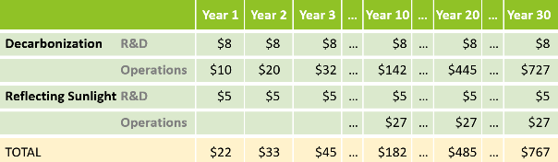
These categories {Pic table} can be laid out in a four‑row budget table, an example of which is displayed here.
In this table, years are shown in columns.
And values, are in units,
of dollars cost, per American, per year.
As one can see, the first two rows cover decarbonization, while the last two rows,
focus on reflecting sunlight.
In this example, the left side shows the early years, while the right side shows the later years.
If decarbonization is done in the lowest‑cost order, the early years would be relatively easy.
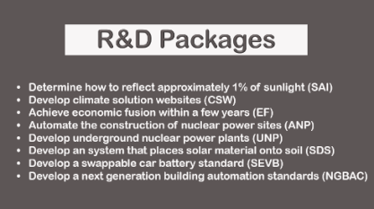
And, with additional R&D, in theory,
{circle} the later years, could be easy too.

Additional R&D
Additional R&D can be broken down into multiple categories,
where each is referred to as an "R&D Package".
For example,
one R&D package might focus on {Pic fission} nuclear fission,
while {Video: power / geo / geothermal-power-station} another focuses on geothermal.
Each R&D package can further be divided into focus areas,
where each area, is supported by an R&D fund.
{Pic Packages} Shown here is an example list of R&D packages.

{Pic R&D fund} And, shown here, is an example list of R&D Funds, inside of, one R&D Package.
Within a climate plan, an R&D Budget Table can show the cost of each R&D Package, over time.
And a budget table for each R&D Package, can show the cost of each R&D Fund, over time.
{Pic BP} Our lab business plan suggests eight R&D packages, with roughly seven R&D funds in each {BP}.
This document is open-source, which means anyone can edit for free,
and define their own packages, and funds.
Also, a funding source can focus on any of these, at any level,
and have any organization, within reason, manage the development.
R&D that solves the entire climate problem would be too much for one organization to handle.

Lab Goal - Statement
Therefore, we need to {*} develop a system, that coordinates
multiple {*} universities, foundations and governments {*} to do R&D,
to the extent required,
to prevent {*} runaway climate change.

Lab Goal - SLIDE
Develop a system that coordinates multiple universities, foundations and governments to do R&D, to the extent required, to prevent runaway climate change.
We'll discuss this more in later videos.

Decarbonization Operations
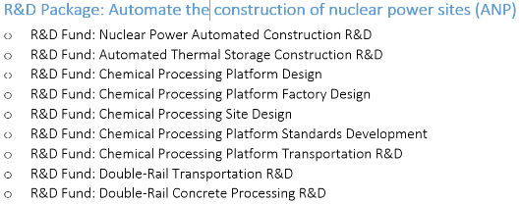
In some cases, the green option costs less than the carbon-based option; while in other cases, the green option, costs more.
When the green option costs less, decarbonization is easy, and it moves forward in a natural manner.
However, when the green option costs more, government intervention is often needed.
This includes subsidies, taxes, and/or requirements.
Unfortunately, we rarely see this at large scales due to multiple factors, as discussed in previous videos.
From a plan's perspective, Decarbonization Operations can be broken down into multiple areas. These include {Pics 3x} electrical power, transportation, and industrial processing. And these can be broken down further into multiple categories, where costs are estimated for each.
Also, each of these category can be broken down into cases where the green option costs less,
and where it cost more, and government intervention, is needed.

Reflecting Sunlight
A plan that prevents runaway climate change would need to support R&D
that determines how to reflect sunlight at reasonable cost, and without harm.
This would cost little, relative to other climate costs.
Sunlight involves the entire planet, not just one nation.
Therefore, a national climate plan, would need to specify what share of global total,
is covered by that nation.
For example, if total operations is 30 billion dollars per year,
and the U.S. paid half, then the U.S. would pay 15 billion annually.
And this would show up in the Reflecting Sunlight Operations row, of the Summary Budget Table.

Problem Size
To understand the challenge we face, it helps to look at the size of the problem.
We already know how much energy the world consumes each year.
And we also know how much energy a single large {Video or Pic, Hoover} facility — like Hoover Dam — can produce annually.
To get a sense of problem size, {Pic kid abacus} we can divide these two numbers to calculate how many Hoover Dam equivalents, would be needed, to replace global energy.
{Pic 17k hoover} The math works out to roughly 17,000 Hoover Dams equivalents.
That’s how much construction, would be needed, worldwide, spread over several decades.
Currently, green energy construction activity does not come close to this.
{Pic question} So the question is: How do we handle, a problem, of this size?
It is possible, perhaps probable, the only solution is additional R&D,
to the extent required,
to drive down the cost of 24/7 green energy,
to below that of fossil fuel.
Yet if this cost-reduction did occur, what might happen next?
To get a better sense of this, let's look at an example case.

China's 2024 Solar Construction Spree
In 2024, China faced {Pic coal} a coal shortage that drove up the price of coal‑based electricity.
At one point, it costs roughly twice as much, as electricity, from solar farms.
To reduce coal demand, lower coal prices, and save money, the Chinese built an astonishing {Video: power / solar / silhouette-of-engineers-working-at-solar} 280 gigawatts of solar power, in one year.
For perspective, 1 watt of nuclear power produces the same amount of electricity as 4 watts of solar power.
This is because solar is good for roughly 6 hours a day, while nuclear supports 24.
Therefore, electricity production, from 280 gigawatts of solar, is similar to that of 70 gigawatts of nuclear.
Now, compare that to the United States, which built only 3 gigawatts of nuclear power, over the last 30 years.
In other words, China built 25-times more nuclear power equivalents in one year,
than what the U.S. did, over 30 years.
China's solar construction spree shows us that speed and scale are possible
— even likely
— when green energy costs less than carbon-based energy.
And {Pic R&D} a surge of R&D, in key areas, could theoretically make this happen.
{Pic 4x} {VERY SLOW} Key areas include nuclear fission, nuclear fusion, geothermal, and solar.

Political Strategy
One might be discouraged by the
{Video: gov't / congressman-with-colleagues} fact that many lawmakers are not willing
{Video: gov't / financial-data-accounting} to spend much money on climate.
However, one can argue, this is not a problem.
This is because many of the things we typically do for climate are either too small to matter.
Or, they are not cost‑effective, and therefore not helpful, or not scalable.
Instead, we need to put relatively little money, in key areas.
In other words, {Pic growing list of coins} do more, for less.
And a plan generation website, that estimates outcome,
given plan,
would help identify these areas,
and help {Video: signs / money / throwing-wad-of-dollar-bills-on-the-paper-trash} {slow} waste less money.
Okay, that's it for me, and I'll talk to you all, real soon.

Video #6: The Climate Acceleration Problem
Hi, my name is Glenn Weinreb, and today we’re going to look at why,
the climate problem,
seems to be {SLOW} accelerating.
But before we begin, let's do a quick review of {SLOW} past decarbonization efforts.

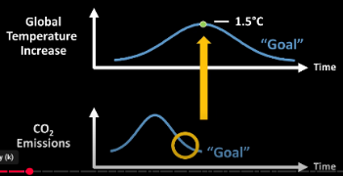
The Failure of Decarbonization
A few decades ago, {Video: scientists / 412738_Man_Presentation}
scientists warned
the world must {Pic 1.5C} avoid warming
more than 1.5 degrees Celsius
above pre‑industrial levels,
{Video: activism / silhouette-of-tired-businesswoman} or “bad things” will happen.
{Pic 8x graphs} They implied we are {*} to crest {*} at 1.5 degrees,
{*} and then drop back down.
{*} Instead, {*} we breached {*} 1.5 in {*} 2023, and we are not cresting.
{*} Instead, we are warming rapidly.
To actually bring temperatures down, {*} carbon dioxide emissions would need to be
{*} near zero, at the {*} time of cresting.
{*} Instead, emissions are {*} at record highs {*} —and still rising.
{*} Reaching {*} zero emissions {*} takes decades. {*}
Therefore, to be at zero today, {*} the world would have had to initiate decarbonization at least 30 years ago.
In other words,
{activism / thoughtful-woman-contemplates} our society failed to decarbonize,
{(shake head)} {SLOW} starting several decades ago.
Put in simpler terms, {Pic Simplify}
to solve the climate problem with decarbonization,
we would have had {*} have done this,
instead {*} of that.

The Tipping Point Problem
Now that 1.5 has been breached,
we need to deal with {SLOW} climate tipping points.
{Video: earth / turmoil / global-warming-climate} These are critical thresholds in Earth's systems that,
once crossed, {SLOW} trigger abrupt changes.
{Video: signs / dominos-falling}
Like a row of dominoes,
the toppling of one tipping point,
can unleash a cascade of effects, {Video: global warming / thermometer / temperature-rising}
accelerating the pace of climate change,
beyond our control.
This is sometimes referred to as runaway climate change and it could lead to
{Video: ocean / sea level rise / large-waves} rising seas,
{Pic dry corn} less food production,
{Pic packed crowd} mass migration, etc.
{Pic OECD table} Tipping points are triggered by higher global temperatures, as shown in this table.
{Pic 3 sad kids} Therefore, more warming, puts us at risk of {SLOW} tipping point activation. {End of section, silence}

The Acceleration Problem
Now that many different systems are in motion,
carbon dioxide is no longer our biggest problem.
Instead, our biggest problem is {SLOW} accelerating changes.
{Pic acceleration} Acceleration is when the rate of change {SLOW} increases over time.
Unfortunately, we see this with {Pic ocean} ocean currents,
{Video: Earth / permafrost / 177653_dead_trees} thawing permafrost,
{Video: ocean / ice / crashed-ice-floating} sea ice,
{Video: Earth / primal / time-lapse-moving} and global warming itself.
{Video: earth / monitor / ice-camp} This is observed with actual measurements, so we know it's real.
Due to acceleration,
{Video: earth / primal / primal-earth-images-Rangipo} the next 30 years will see significantly more change,
{Video: earth / storm / 6262762_Monsoon} than the previous 30 years.
{Video: earth / primal / 6171405_Norway_Lofoten} And a rapidly changing planet
{Video: earth / desert / 461670_Hikers_Jordan_North_Arabia} is a bad planet, since it means we have less time to adjust.

The 0.3°C Jump
Here's an example of acceleration.
{Pic 4x 0.3C} In 2022, the average global temperature,
was about 1.2 degrees Celsius above pre-industrial levels.
Two years later, in 2024, it hit 1.5 degrees.
So it jumped 0.3 degrees, in 2 years.
{Pic 3x 0.18/decade} For comparison, {*} from 1970 to {*} 2010,
the long‑term warming rate {*} was 0.18 degrees per decade.
Therefore, {*} a 0.3 degree increase, over several years, is unusual, and concerning.

Is This Noise?
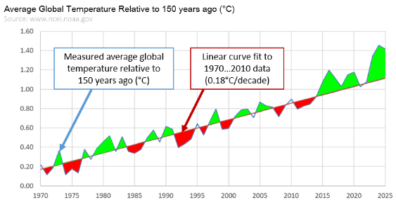
Okay, is this random noise?
Or, are we outside of noise?
{Pic 4x noise} Let's look at the data.
{*} The blue plot shown here is the average global temperature, relative to, 150 years ago.
{*} And the red line is a linear curve fit between 1970 and 2010.
{*} As one can see, deviations above, and below the red line are similar, during {*} the 1970 {*} to 2010 era.
{*} In other words, before 2010, {*} we see noise of similar size on top of constant rate warming.
{*} But after 2010, {*} deviations above the red line, seem larger.
This suggests global warming is accelerating, and not due to noise.

Why Accelerate?
The recent acceleration was not forecasted by {slow} climate models,
which suggests their understanding,
of the planet,
is incomplete.
This, by itself, is a profound concept.
It means scientists do not know when truly bad things will occur.
Which means we cannot calculate what needs to be done, and when, to avert disaster.
Not knowing what is going on is referred to as "climate uncertainty",
and it will be discussed further in videos 7 and 8.
Okay, back to the issue of global warming acceleration.
Why is this happening?
{Pic Hansen} Top climate scientist, James Hansen believes this {Video: smoke / 536892_Factory_Chimney_Pollution_Sky} is in-part due to less sulfur-based air pollution, and in-part due to an {Pic 2025 Paper} underestimate of Earth's sensitivity to carbon dioxide.
{Pic reflect} Sunlight reflects {*} off sulfur-based air pollution, and back into outer space,
offsetting warming, with cooling.
Therefore, reducing sulfur in fuel, to reduce pollution, causes more warming.
And we know sulfur reduction occurred over the last 10 years, {Pic Ships} especially in fuel, used by ships.
{Pic refinery} So, ironically, as we’ve reduced sulfur-based pollution,
{Pic man coughing} to clean the air we breathe,
{Video: earth / tipping points / 6201038_Newtons_Cradle_Metal_Balls_Swinging} we’ve also sped up, global warming.
{Pic perplexed woman} Yea, I know it's crazy.

Prepare to Panic
Some scientists {Video: earth / tipping points / acceleration / beautiful-stream}
believe global warming is accelerating—
and that climate tipping points may arrive sooner than expected.
If they’re right, this will probably be confirmed, by the wider scientific community,
within the next few years.
If and when that happens, urgency among world leaders will surge.
The problem is, many decarbonization efforts are either ineffective, or not cost-effective.
Therefore, expanding them, is not likely to have a significant impact.
{Video: Scientists / 736527_Man__Math} This suggests we need to identify cost-effective solutions today,
{Pic panic} so that when we panic tomorrow,
{Video: signs / money / 94405_Piggy_bank_full} we don't run out of money,
{Video: signs / money / close-up-hands-of-businesswoman} before making significant progress.
{Pic 4x Prepare to Panic LIST} Fortunately, preparing to panic is relatively inexpensive since it only involves
developing policy making tools,
decreasing the cost of green energy with R&D,
and determining how to reflect sunlight without harm.
We'll talk more about these items in future videos.
Okay, that's it for me, and I'll talk to you all, real soon.

Video #7: The Science of Global Warming
Hi, my name is Glenn Weinreb,
and today we're going to examine the science of global warming.
The main organization that {Pic 3x IPCC report} studies this is called the IPCC,
and they publish summary reports,
every few years.
The centerpiece {Pic Ar6 Fig 7.6} of their most recent report is shown here.
{0.54+0.21+0.41=1.16}
{https://www.ipcc.ch/report/ar6/wg1/figures/chapter-7/figure-7-6}
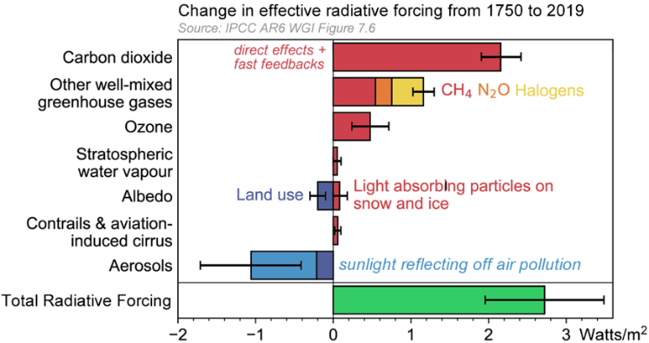
It breaks global warming down into individual components called "radiative forcing's".
Some of which make the planet warmer,
while others,
make it colder.
Together, they combine, to produce a net effect, which is shown with a green bar.
{Pic: red blankets} In a sense, the red bars are like blankets that wrap around the planet,
where the thickness of each blanket, is proportional to the length of each bar.
This is not exactly what's happening, but close enough.
{ALL IMPORTANT PARAMETERS:
https://www.tandfonline.com/doi/epdf/10.1080/00139157.2025.2434494?needAccess=true}

1% of Sunlight
{Pic: axis on graph} The horizontal axis refers to the amount of additional heat,
that hits each square meter, of Earth's surface, on average, over a year.
{SLOW} This additional heat, warms the planet, and increases, the average global temperature.
{Pic: 340W/m²} For reference, the total incoming energy from the Sun, is about 340 watts per square meter.
Hundreds of years ago, this was balanced by an equal amount of outgoing heat radiation.
Put differently, the amount of warming, was the same, as the amount of cooling,
and the Earth's climate was stable
{Pic: 1% labeled on graph} Today, however, an extra 2.8 watts per square meter, is warming, the planet.
That’s about 1% of sunlight, since 2.8, divided by 340, is roughly 1%.
{Pic: atmosphere, 1% = 3.4W/m²} Therefore, in theory, roughly 1% of sunlight,
could be reflected back into space,
to offset the additional warming,
and {SLOW} prevent runaway climate change.
{Pic 4x white bars} To get a sense of what 1% looks like, we placed a white bar in this image, and then made it 10% transparent, followed by 1%.
As one can see, 1% is barely visible, to the naked eye.

Fast Changes Due to CO₂
{Pic 7x sun} Sunlight warms the planet's surface after passing through carbon dioxide in atmosphere.
The planet then emits infrared heat radiation back into outer space.
Carbon dioxide in atmosphere absorbs the outgoing infrared radiation more than it absorbs the incoming visible light.
And this causes the planet, to become warmer.
Also, additional warming is caused by fast side-effects that unfold over days to months.
An example is water vapor in atmosphere. More heat causes more vapor, which traps more heat.
So, the {Pic top red bar} top bar refers to more absorption of heat due to carbon dioxide,
plus fast side-effects due to greater temperatures.
{Pic girl at blackboard} The length of this bar is determined by a formula.
Now I know many people would rather
{Pic dentist} visit the dentist than work with calculations, so we’ll keep this quick.
{Pic CO₂ forcing = 5.35 x ln (ppm/280)} The details of this formula are not important,
other than to say, more carbon dioxide, means more warming.
CO₂ forcing = 5.35 x ln (ppm/280) (Hansen uses 5.65, IPCC uses 5.35)
CO₂ forcing for 425 ppm = 5.35 x ln (425/280) = 2.23 W/m²
Okay, we're done. {GSW Wave hands}

Slow Changes Due to CO₂
The previous formula refers to warming that occurs quickly, due to additional carbon dioxide.
Also, there are things that occur slowly, {SLOW} due to higher global temperatures.
These are called {SLOW} {Pic wiki slow feedbacks} slow climate feedbacks and some of them take decades, or even centuries, to unfold.
An example {Video: Ocean / sea ice / frozen-arctic-melting-ice} is melting sea ice.
Elevated temperatures, from initial warming, cause sea ice to melt, {Video: ocean / sea ice / mother-polar-bear} which leads to more sunlight being absorbed by ocean water, which leads to more warming.
It can take many years for this to occur, due to the thermal inertia of ocean water.
Therefore, melting sea ice is considered to be a {SLOW} slow feedback.
Other slow feedbacks {Pic permafrost} include the release of greenhouses gases from thawing permafrost;
{Video: reflect sunlight / 6397313_Clouds_Nimbus} and the darkening of clouds over decades.
With slow feedbacks, roughly one-third of additional warming occurs within the first five years,
another third over the next 100 years,
and the final third over the following 1,000 years.
{https://susanpcrawford.substack.com/p/james-hansen-says-were-underestimating}
This delayed response {Pic annoyed kid} means the full effect of today’s carbon dioxide will not be felt for many generations.
Also, this implies a significant amount of future warming {Pic annoyed kid} is already “locked in” {SLOW} due to past emissions.
{Pic En-roads} This is one reason why the MIT climate solution simulator is so gloomy.

Earth Climate Sensitivity (ECS)
{Pic 4x CO₂ ppm} Hundreds of years ago, atmospheric carbon dioxide levels were about 280 parts per million.
Today, they're around 425, and they're projected to reach 560, by the year 2075.
In other words, roughly 50 years from now, the concentration of carbon dioxide in atmosphere is expected to be twice that of pre-industrialized levels.
If we double the concentration of carbon dioxide, and hold it steady,
then after a 1000 years,
slow climate feedbacks will eventually stabilize,
and the average global temperature will settle on a new value.
The amount of eventual temperature increase, after doubling carbon dioxide,
is referred to as the Earth climate sensitivity constant, or “ECS.”
Some scientists believe ECS is 3 degrees Celsius,
whereas others think it is closer to 5.
A higher value would be bad, since it would mean tipping points {SLOW} will activate sooner.

Outgoing Heat Radiation
{Pic entire graph no markup} There's an additional component that we need to discuss.
It's outgoing heat radiation,
that cools the planet,
{Pic circle green RF bar} and offsets the Radiative Forcing's.
We asked {Pic AI Heat Radiation} AI to illustrate this, and here’s what it came up with.
{Gsw makes funny face} Okay, not bad for a computer.
{Pic Outgoing heat radiation = Current_Temperature x 3.71 / ECS}
Outgoing heat radiation is roughly proportional to the average temperature of the planet,
and inversely proportional to the Earth climate sensitivity constant.
Outgoing Heat Radiation Anomaly (W/m²)
= Current Temperature x 3.71 / ECS
Outgoing Heat Radiation Anomaly (W/m²) for 1.5°C temperature and 4.5°C ECS
= 1.23 W/m² = 1.5°C x 3.71 / 4.5°C

Global Warming Rate (°C/decade)
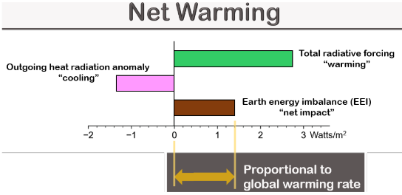
Earth’s temperature is mostly controlled by two energy flows:
{Green bar at bottom of graph} One that warms the planet,
{Earth with rays outward} and one that cools it.
{Pic EEI bars} These offset each other to produce net warming, or net cooling.
{Pic EEI = RF - IR formula} This net effect is referred to as the earth energy imbalance,
and it's roughly proportional
to the global warming rate.
The global warming rate {Pic 0.30°C/decade} is currently at 0.30 degrees Celsius per decade.
Outgoing Heat Radiation (W/m²) = 1.23 W/m² = 1.5°C x 3.71 / 4.5°C
--------------------------------------------------------------------------------------------
IPCC Ar6 Figure 7.6 has Total Radiative Forcing at (W/m²) = 2.8 W/m²
--------------------------------------------------------------------------------------------
EEI = Total Radiative Forcing (W/m²) - Outgoing Heat Radiation (W/m²)
= 2.8 - 1.23 = 1.57 W/m²
{Hansen's Aug 6, 2025 memo has EEI approximation of 0.77W/m https://www.columbia.edu/~jeh1/mailings/2025/ForestTrees.06August2025.pdf}
{ChatGPT discussion: https://chatgpt.com/g/g-p-679d2bb5b304819198acec1a2830d008-energy-and-climate/c/6892b750-8b84-8328-82de-0899e6df72a5}
{Seeing the Forest for the Trees, 0.30°C/decade warming, Aug 6-2025, By Dr. James Hansen}

Earth's Set Point Temperature
There's a feedback mechanism,
built into the planet,
that causes it to eventually settle on an “equilibrium temperature”,
which is sometimes referred to as the set point temperature.
{Pic set point formula} The set point is determined by the concentration of carbon dioxide in atmosphere,
as shown by this formula.
In summary,
the set point increases,
when the concentration of carbon dioxide increases.
Set point temperature anomaly (°C) = ECS x log₂ (ppm/280)
{Pic warming in pipeline formula} If we subtract the current temperature from the set point,
we get warming, that has not yet been, realized.
Not yet realized temp increase (°C) = Set point temperature (°C) – Current average global temperature (°C)
As noted previously, it takes about a 1000 years, for warming to stabilize,
{slow} after adding carbon dioxide.
Therefore, we can calculate how much additional warming would occur,
if we pegged the concentration of carbon dioxide at its current level.
According to one estimate,
the amount of {Pic 1.2°C} unrealized warming is currently 1.2 degrees Celsius.

Thermostat 101
To understand Earth’s climate, it helps to think {Video: house / HVAC / woman-using} about the household thermostat.
{Pic 5x Thermostat variables} This device works with two key variables.
One is temperature, and the other is energy flow.
Temperature is often represented in units of degrees Celsius,
while energy flow is often represented in units of Watts.
{Pic 5x Thermostat energy flows} The energy flows can be broken into two primary components.
One is external and somewhat constant,
while the other is variable and maintains the temperature of a system.
In a house,
{Video: house / HVAC / winter-landscape} the external energy flow comes from the outdoors through the walls,
{Video: house / HVAC / mounted-Hvac} while the variable energy flow comes from the heating and air conditioning system.
After these two combine, a net energy flows into, or out of, the system.
If energy flows in, the system gets warmer; and if energy flows out, the system gets colder.
{Video: signs / antique-golden} If the energy that flows in, matches the energy that flow out, then the net energy flow is zero, and the temperature remains constant.
It follows that the net energy is roughly proportional to the warming rate,
which is the change in temperature over a period of time.
{Pic 4x EEI formula} In the case of the planet,
the net energy is like the earth energy imbalance,
the outdoor energy is like the radiative forcing's,
and the HVAC system is like the Earth's outgoing heat radiation.

Earth's Thermostat
If we {Pic EEI = RF - IR} take the earth energy imbalance equation, {Pic substitute} and substitute in other formulas, {Pic EEI = 5.35 x ln (ppm / 280) – Current Temp x 3.71 / ECS} we get an equation that describes Earth's thermostat.
Earth energy imbalance “warming” (W/m²)
= Total radiative forcing (W/m²)
– Outgoing heat radiation anomaly (W/m²)
------------------------------------------------------------------
Earth energy imbalance “warming” (W/m²)
= 5.35 x ln ( ppm / 280)
– CurrentTemp x 3.71/ECS₂₂
The details are not important, other than to say, if the current global temperature is less than the set point, energy flows in, and warms the planet.
To get a better sense of this, we can look at an example scenario that begins 150 years ago,
before global warming.
At this time, the {Result} earth energy imbalance, which refers to warming,
is zero, and the {term 1} first term equals {term 2} the second term.
Now let's assume {ppm} the concentration of carbon dioxide in atmosphere increases by 10 parts per million.
The {temp} temperature has not yet changed,
{Result} but we now have some energy imbalance,
which means energy flows in,
and causes {temp} the temperature to increase.
{Result} Warming occurs until the set point is reached,
at which time,
the {term 1} first term would equal {term 2} the second term,
and {Result} warming would stop.
This equation is another way of saying the concentration of carbon dioxide,
in atmosphere, sets the average global temperature,
{Pic Nest therm.} in a manner similar to that done with a home thermostat.
The impact {Video: reflect sunlight / carbon-dioxide-co2-molecule} of this tiny molecule, on our planet, {Pic skeptical girl} might seem crazy, but this is how it works.
Okay, that's it for me, and I'll talk to you all, real soon.

Video #8: The Uncertainty of Climate Change
Hi, my name is Glenn Weinreb,
and today we're going to look at things climate scientists are not sure about,
{SLOW} by their own admission.
Scientists refer to as "uncertainty", and it's bad.
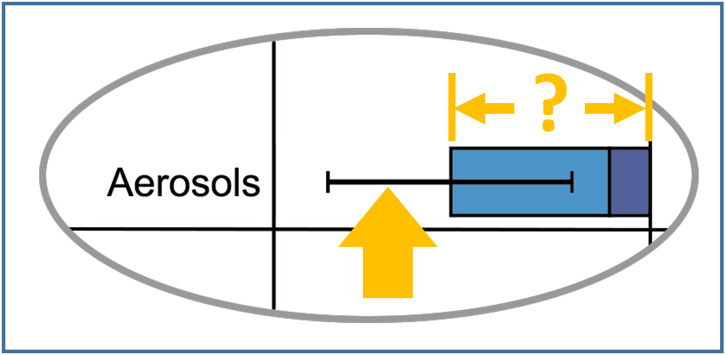
It's bad because we would like to know when disaster will occur,
{SLOW} so we can assemble a list of things we need to do,
{SLOW} between now and then,
{SLOW} to prevent it.
{Pic Video 7 and 8} This video is a continuation of our previous video,
and therefore assumes,
the viewer is familiar with,
basic principles of climate science.

Air Pollution Uncertainty
We begin by focusing {Pic reflect} on sunlight that reflects off air pollution,
and back into outer space.
As noted in Video 7, this offsets global warming, with cooling.
In review, {Pic RF graph} the length of {Pic blue bar} the blue bar, in this illustration,
is proportional to the amount of cooling from air pollution.
{Pic 3x error bar} What is most interesting about this bar, is the error bar.
This means scientists do not know if this is small, or large.
{Pic arrows on error bar} This value is unknown, because it has {SLOW} never been measured.
{SLOW} Only estimated.
In science, this is referred to as {SLOW} a “free variable.”
This might seem like a minor detail; however, it is {SLOW} of profound importance.
It means scientists cannot calculate, with certainty,
when very bad things will happen to our planet.
And this makes it difficult for national leaders to respond appropriately.
{Pic arrows on error bar} Now let's compare the size of this error bar to
{Pic compare} the top red bar,
which is roughly proportional to the total carbon dioxide emitted over 150 years.
The red bar is not from one year of activity.
Instead, it reflects 150 years of carbon dioxide emissions.
As one can see, the amount of cooling uncertainty,
is about the same size,
as 100 years of carbon dioxide emissions. {(3.48-1.96)/2.16}.
In other words, {Pic confused scientist} the degree to which scientists do not understand global warming,
based on their own admission,
{SLOW} is enormous.

ECS Uncertainty
As noted in our last video,
the amount of eventual temperature increase,
after doubling carbon dioxide,
is referred to as the Earth climate sensitivity constant, or “ECS.”
ECS is essentially a way to quantify, the size of slow climate feedbacks,
{Video: ocean / ice / crashed-ice-floating} such as melting ice sheets,
{Video: earth / storms /aerial-view-of-amazing-rocky-mountains} and long-term cloud changes.
Some scientists estimate ECS at around 3 degrees Celsius, while others think it is closer to 5.
A higher ECS would mean the planet is more sensitive to carbon dioxide
—and that climate tipping points would activate sooner.
Put differently, some scientists,
think the climate problem is bad,
while others think,
it’s worse than bad.

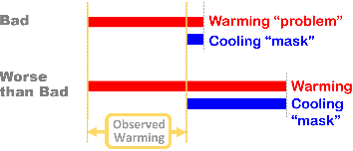
The Climate Mask
In theory, we should be able to estimate ECS,
by observing the correlation,
between the concentration of carbon dioxide in atmosphere, and planetary changes.
However, there is a flaw in this strategy.
We do not know how much warming, is hidden by cooling.
In other words,
cooling is {Video: signs / sad-serious-woman} a mask of unknown size,
that hides the {SLOW} true extent of global warming.
{Pic 7x masks} If the mask is small,
{SLOW} the problem is only slightly larger than what we see.
Alternatively, if the mask is large,
the problem is much {SLOW} larger,
than what we see.
Two Climate Scenarios
 | “Worse than Bad” | “Bad”
Air pollution cooling | More | Less
Tipping point activation | Sooner | Later
0.3°C global temperature jump | Explained | Not understood
Earth Climate Sensitivity (ECS) | ~5°C | ~3°C

{Pic table with two scenarios} To make this easier to understand,
we can look at two possible scenarios.
{*} One with larger ECS, {*} and one with smaller.
In the larger ECS scenario, {*} tipping points will activate sooner,
while in the smaller ECS scenario, {*} we have more time.
Unfortunately, {Video: activism / depressed-girl-sitting-on-kitchen-floor} recent observations suggest ECS is large.
{Pic 4x climate summary} Put differently, there is evidence,
the climate problem, is worse, than previously considered.

The Pollution Problem
Unfortunately,
{Pic blue bar} cooling due to air pollution,
presents us,
with an additional problem.
If we stop {Video: smoke stack / chimney-smoke} emitting carbon dioxide 100% tomorrow,
{Pic pollution} most air pollution would go away,
{Pic arrow} along with its cooling effect,
{Pic green lengthen by blue} and the green bar,
would lengthen by the size of the blue bar.
{Pic green grow} Also, if the green bar grows,
{Pic EEI grow} the earth energy imbalance would also grow.
Which means {Pic double warming rate} the global warming rate would also increase,
possibly from {*} .3 degrees per decade, to roughly {*} .45
{Seeing the Forest for the Trees, 0.30°C/decade warming, Aug 6-2025, By Dr. James Hansen}
{~1W/m² for aerosols, (2.6W/m² ÷ 1.6W/m²)*(0.3°C/decade) = 0.45°C/decade new warming, increase 50%}

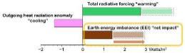
After carbon dioxide is dumped into the atmosphere,
it stays there for hundreds of years.
Therefore, {Video: smoke stack / 224260_Pollution_Industry_Smoke}
if we stopped carbon dioxide emissions 100% tomorrow,
cooling from air pollution would vanish quickly,
however, {Pic top red bar} the top red bar would shrink {SLOW} very slowly.
In other words, the warming rate would surge,
and the temperature of the planet would {SLOW} continue to increase,
{SLOW} for many decades.
Long story short, {Video: activism / contemplative-man-thinking} global warming is complicated.

Can we Extract CO₂ from Atmosphere?
Okay, what about removing carbon dioxide,
from the atmosphere,
{Pic top bar} to shrink the top red bar?
Would that help?
This is called "Direct Air Capture",
and we can run some numbers,
to get a better sense of this.
It cost roughly 1000 dollars to extract 1 ton, of carbon dioxide, from air,
and we have roughly a thousand gigatons,
of additional carbon dioxide,
in atmosphere.
{Pic top bar} Therefore, for one trillion dollars,
we could reduce,
the length of the top red bar,
by roughly .1%.
{Pic DAC bad} This is another way of saying,
direct air capture, is {SLOW} prohibitively expensive.
Subsequently,
national leaders would probably favor
{Video: reflect sunlight / a-jet-airliner-flying-through} airplanes that spray reflective gases,
for tens of billions of dollars a year.

The State of our Planet
Okay, let's summarize the situation.
{Pic warming rate} One, the global warming rate recently jumped from .18 to .30
{Pic 0.3°C in 2yrs} Two, our planet seems to be more sensitive, to carbon dioxide, than previously considered.
{Video: ocean / sea ice / 623099_Iceberg_Ocean} Three, we are at risk of North Pole sea ice collapse,
{Pic 0.60°C} which would increase the average global temperature,
by 0.6 degrees Celsius.
{Pic 3x En-Roads} {*} Four, according to the MIT simulator,
{SLOW} if we increased the global cost,
{SLOW} of fossil fuel, 4-fold, {SLOW} with taxes,
{*} we would still get,
{SLOW} {*} runaway climate change.
{Video: gov't / washington-dc-circa-august-2017-a-long-slow} And lastly,
even when governments spend hundreds of billions of dollars on climate,
they tend to waste,
almost all of that money.
In conclusion, {Video: activism / two-brothers-sit-on-a-park} the situation is gloomy.
So what's an intermediate step,
that might be helpful?
Not a big step, just a little one.
We'll discuss big steps, in our next video.

Reducing Uncertainty
{Pic lab goal} A small step,
might be {SLOW} to design experiments,
that measure how much sunlight,
reflects off air pollution.

Lab Goal - SLIDE
Support experiments that measure how much sunlight reflects off air pollution.
Designing experiments, costs little.
However, {Pic NASA Atom Plane} developing gadgets,
to conduct those experiments,
might cost tens of millions of dollars, ₂
and take multiple years.
And, conducting experiments, might cost hundreds of millions of dollars,
and consume, {SLOW} more years.
{Pic AE} For details, click on the link, in the description below {Example Aerosol Experiment}.
National leaders need to know what will happen, and when, with certainty.
{Pic error bar} And "certainty" entails reducing the size of error bars with measurements.
For this reason,
one might consider this, {Pic M of C} to be the most important
{SLOW} measurement of this century.
Okay, that's it for me, and I'll talk to you all, real soon.

Video #9: Reflecting Sunlight
Hi, my name is Glenn Weinreb,
and today we're going to explore {SLOW} how to prevent runaway climate change,
by reflecting sunlight back into outer space. {Some of this was copied from 27min video}
This is a new field, and {SLOW} therefore requires research.

Science Question - SLIDE
The key question for scientists is,
{Pic 5x Science Question} “How might we reflect,
{SLOW} approximately 1% of sunlight,
{SLOW} back into outer space,
{SLOW} at a reasonable cost,
{SLOW} and without causing harm?”
We're already reflecting sunlight, {Pic reflect} since it {*} reflects off of {SLOW} man-made air pollution.
More specifically, it {Video: fossil fuel / sulfur / sulfur-as-element} reflects off of sulfur.
It's possible, this is a key element, in solving the climate problem.
Let’s take a closer look.

Sulfur 101
{Pic dish} Sulfur is an element {Pic table} on the periodic table, and it is present in
{Video: fossil fuel / coal / pile-of-coal} large amounts within coal
{Video: fossil fuel / oil / global-fossil-fuel} and oil.
Therefore, it is typically
{Video: smoke stack / 536895_Factory_Chimney} emitted, into the atmosphere, when these fuels are burned.
Sulfur is harmful to people, plants, and oceans.
{Video: gov't / flags-of-the-nations} Consequently, governments often require that some sulfur
{Video: fossil fuel / oil refinery / flying-over-oil-refinery} be filtered out before, or after, combustion.
However, even with some filtration, approximately 70 million tons of sulfur dioxide gas are
{Video: smoke stack / 568237_Chimney_Smoke} emitted globally, into the atmosphere, each year.

Sulfur Cools the Planet
After sulfur is emitted into the atmosphere,
it typically combines with water and oxygen to {Pic droplet} form H₂SO₄.
This nucleates, which means it converts to {SLOW} tiny physical particles.
Water sticks to these particles, and causes them to grow into {SLOW} physical water droplets.
{Video: reflect sunlight / 386983_Water (slow 4x and take upper right corner)} These droplets are so small and sparsely distributed that they are often imperceptible to the naked eye.
{Pic droplet reflect} And droplets containing sulfur typically reflect more sunlight, than those without.
Therefore, more sulfur causes more sunlight, to reflect back into outer space,
instead of being absorbed by the planet.
In effect, {SLOW} sulfur cools the planet.
A notable example, {Pic volcano} is the 1991 volcanic eruption of Mount Pinatubo,
which released sulfur dioxide gas into the atmosphere.
And this caused the average global temperature,
to decrease approximately .4 degrees Celsius, for several months.

High Altitude Sulfur is Cooler
As mentioned previously, sulfur is present in coal and oil, and is released during combustion.
In theory, we can
{Video: fossil fuel / oil refinery / 6036894_Chimney_Powerplant} filter more of it out before combustion,
{Video: fossil fuel / oil, truck / semi-truck-entering} transport the harvested sulfur to
{Video: reflect sunlight / passenger-jet-flying} an airplane, and emit it at a high altitude,
{Pic Bus} instead of at ground level.
High-altitude sulfur stays aloft for one to two years,
{Video: smoke stack / smoky-factory} while ground-level sulfur typically stays aloft for only several days.
Therefore, changing the emission site reduces the planet's temperature,
{SLOW} without increasing total sulfur emissions.
The latter point is important, since sulfur is harmful, as noted previously.
Sulfur-based materials are not the only substances with reflective properties.
For instance, {Video: reflect sunlight / man-writes}
calcium carbonate, commonly known as chalk, exhibits similar capabilities.
Further research is needed to understand the benefits and drawbacks of each candidate material.

How Much Does this Cost?
To justify the expense, we would need to compare the
{Video: reflect sunlight / airline-flight-jet-engine (avoid engine fire)} cost of cooling the planet,
{Pic dry soil} with the cost of not {SLOW} cooling the planet.
{Pic $18B} One study suggests large-scale planet cooling would cost approximately 18 billion dollars a year.
For comparison, the total value of {Pic NYC or Video: City / NYC / aerial-view-of-Manhattan (add overlay, see 28min video at 12:17)}
New York City property is 1,400 billion dollars,
and this is just one coastal city, that would be lost to, sea level rise.
{Pic $30} If the U.S. paid half, planet cooling would amount to
about 30 dollars, per American, per year (50% x $18B / 330M).
{Pic Wake Smith} For details, see Wake Smith's excellent 2024 paper.
Increasing the reflectivity of the atmosphere is a new field and there are many things we don't know.
We don't know what to inject, when, where, and how.
And we don't have an accurate assessment of costs, and adverse side effects.
{Video: scientist / nurse-holding-tablet} To resolve unknowns, we need R&D.
This includes developing
{Video: Earth / monitoring / The-Hubble-space-telescope} better instrumentation for measuring atmospheric reflectivity,
{Pic small spray plane} developing equipment that injects small amounts of material for field experiments,
{Video: reflect / airplane-contrail} and developing equipment that injects large amounts of material for full-scale operations.

Three Geoengineering Projects
Geoengineering involves injecting material into the atmosphere,
either intentionally,
or as a side-effect,
of another activity.
An example is the 40 billion tons of {SLOW} carbon dioxide,
and the 70 million tons {SLOW} of sulfur dioxide,
{SLOW} that are emitted into the atmosphere,
{SLOW} each year,
{Video: smoke stack / air-pollution-problems} due to burning fossil fuel.
Also, roughly 7 million tons of sulfur dioxide are considered for injection, each year,
into the upper atmosphere, to {Pic domino block} prevent runaway climate change.
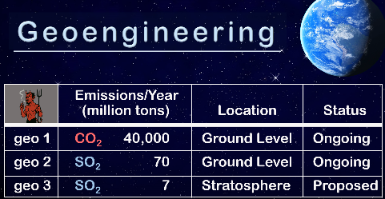
{Pic 8x Geo table} {SLOW} Let's compare these
3 geoengineering activities.
To make this easier to follow,
we will refer to them as "Geo1", "Geo2", and "Geo3".
Geo1 and Geo2 are ongoing operations,
while Geo3 is {SLOW} under consideration.
Also, Geo1 and Geo2 inject material at low altitudes,
while Geo3 targets high altitudes with airplanes.
Geo1 warms the planet, while Geo2 and Geo3 cools the planet.
Geo3 involves 6,000 times less material than Geo1, by weight.
However, Geo3 has a large cooling effect, per gram of material, in part due to its long hover time, as noted previously.
{Video: scientists / four-scientists} Each geoengineering activity can be characterized with multiple parameters,
and these can be quantified by scientists.
{Video: scientists / mathematics-equations} They do this with scientific models,
{Video: scientists / medium-shot-of-two-scientists-watching} laboratory experiments,
{Video: scientists / ice-camp-Barneo-north-pole-arctic} and field experiments.
{Video: scientists / laboratory-hazmat} Lab experiments typically involve measuring properties of gasses,
{Video: reflect sunlight / generic-futuristic-science-fiction} within chambers, inside a laboratory.
An example parameter is increased acidity.
We know how much acidity is caused by each gram of material,
and we know how many grams of material are emitted each year.
{Pic 2x Geo table} From this, we see Geo2 contributes 10 times more acidity than Geo3,
and Geo1 contributes roughly 100 times more than Geo2.
{Reference: https://chatgpt.com/c/6899ecb8-a8b8-8326-8517-fc84b8adbd29}
{Reference: https://chatgpt.com/c/68941787-f5c0-8332-94b0-f02170e6c942}
{Pic 40,000, new paragraph} We can also look at size by weight.
For instance, Geo1 is enormous.
To get a sense of this, we can look at what happens
{Video: ships & planes / airport-Frankfurt} when an A380 airplane flies from New York to Tokyo.
This one flight injects roughly 1 million pounds, or 500 metric tons, of carbon dioxide, into the atmosphere.
This is about the same weight as 500 small cars.
To get a better sense of this, {Video: city / parking lot / aerial-top-down-view-of-new-cars}
we can view 140 parked cars, which is roughly one-third of 500.
And this is just from one flight, from one airplane.
{Video: ships & planes / extreme-tele} For reference, there are roughly 28,000 commercial airplanes worldwide,
and airplanes are responsible for just 3% of total carbon dioxide emissions.
{Pic table, circle rows} In other words, {*} Geo1 is massive. And, in {*} comparison, Geo3 is tiny.
However, for the most part {Video: activism / woman-points-at-herself}, the public does not like Geo3,
even though it could {SLOW} potentially be helpful.
This is likely to change,
{Pic hot man} as the risk of runaway climate change becomes {SLOW} more evident.
{Video: activism / bottom-view-of-eco} Most climate activists
{Video: power / wind / 204551_Wind_farm_Environment} prefer decarbonization.
However, {Pic Four Videos} as noted in previous videos,
the climate problem has progressed beyond point
{Video: power / wind / aerial-view-of-a-large-scale} where decarbonization, by itself, is sufficient.

Preventing Runaway Climate Change
The first tipping point to activate
{Video: ocean / sea ice / 159423_large_pieces_of_ice} would probably be North Pole sea ice.
{Video: ocean / sea ice / 159433_pieces_of_ice_floating} After this melts,
{Pic 5x 1st tipping point} sunlight would be {*} absorbed by water, instead of being {*} reflected by sea ice.
To get a sense of what this would do,
one can {Pic Hand} hold their hand up to the sun,
and feel the warmth.
This is the amount of additional heat we would get,
times the surface area of North Pole sea ice.
This is not a small chunk of ice.
It has a {Pic 5M skm} surface area of 5 million square kilometers,
which is half the size,
of the United States.
Loosing this reflector {Pic 0.6C} would increase the average global temperature by 0.6 degrees Celsius.
And this would trigger other tipping points.

Lab Goal - Statement
{Pic lab goal} Therefore, we would like to prevent the first tipping point from activating.

Lab Goal - SLIDE
Prevent activation of first tipping point.
This entails {Pic girl calculating} calculating the percentage of sunlight that needs to be reflected,
and the year that full-scale operations would need to commence.
And this entails putting together a {Pic 4x Reflectivity Plan} reflectivity plan with 3 primary phases.
These include {*} R&D, {*} construction, and {*} full-scale operations.
{*} R&D would involve field experiments.
Construction would involve {*} building a fleet of airplanes, and {*} supporting airport infrastructure.
And full-scale operations would {*} involve flying airplanes.
Public support for this is currently low,
in part due {SLOW} to a lack of understanding,
{SLOW} of what would happen,
{Video: ocean / sea ice / primal-earth} if sunlight was {SLOW} not reflected.
However, this is not necessarily a problem.
This is because initial R&D,
can be funded by forward-leaning foundations and governments,
and therefore does not need {SLOW} broad support.
However, public support would eventually be needed, for activities such as
{Video: reflect / team-of-aircraft-mechanics} construction and
{Video: reflect / 6446245_Clouds_Airplane} full-scale operations.
{Pic SAI pdf file} For details on initial R&D, click on the link, in the description below {Example SAI Experiment}.
Okay, that's it for me, and I'll talk to you all, real soon.

Video #10: Can Air Pollution Save the Planet?
Hi, my name is Glenn Weinreb,
and today we're going to look at how air pollution could potentially save our planet.
We can solve the carbon dioxide problem
{Video: fossil fuel / coal / coal truck} by replacing fossil fuel
{Video: power / wind / windmill-electric-power} with green energy.
However, this alone probably will not solve the climate tipping point problem.
We seem to be approaching these critical thresholds too quickly.
Therefore, we probably need to {Pic 1%} reflect approximately 1% of sunlight back into outer space,
to cool the planet.
There are several ways to do this, {Pic SAI} one of which is called
“stratospheric aerosol injection”, or SAI for short.
This {Pic spray plane} involves spraying reflective gases, or liquids, into the upper atmosphere, using airplanes.

Sunlight Reflectivity Strategy
{Pic 3x atmosphere} The two primary layers in the atmosphere are
referred to as the troposphere, and the stratosphere.
To make this easier to follow, will refer to these,
as the lower atmosphere,
and the upper atmosphere.
Stratospheric aerosol injection involves inserting material with reflective properties
into the upper atmosphere.
The altitude needed to access this layer depends on position.
{Pic 2x ASL} For example, at the equator, the upper atmosphere starts at a 20 kilometer altitude,
whereas near the North and South Poles,
it starts at a 12 kilometers altitude.
{Pic existing airplanes} Existing aircraft can reach the upper atmosphere, over the Polar Regions,
making it possible to cool {*} them using currently operating airplanes.
{Pic existing airplanes} However, cooling the {*} entire planet would require {*} injecting material at the equator,
at altitudes around 20 kilometers.
And, unfortunately, we don't have large airplanes that fly to that height.
Therefore, to cool the entire planet with SAI,
we would need to develop new aircraft,
which takes time and money.
For this reason, {Pic 3x phases} SAI would probably involve two phases.
Phase I would cool the Polar Regions with existing airplanes,
to prevent tipping points associated with those regions.
And Phase II would cool the entire planet, at a later date, with newly developed aircraft.
{Pic strategy} And each phase would probably be built up gradually.
For example, one could operate at one ten-thousandths of full-scale operations,
look for harm, and advance if none was detected.
¹/_{10,000} ¹/_{1,000} ¹/₁₀₀ ¹/₁₀ ¹/₃ ²/₃ 1

Sulfur Dioxide (SO₂)
One possible injection material is {video: fossil fuel / sulfur / video} sulfur dioxide gas.
Sulfur occurs naturally {Pic coal and oil} in coal and oil, and is therefore
{Video: smoke / chimney-smoke-from-enterprise} emitted into the atmosphere when these fuels are burned.
In principle, {Pic filter} it could be extracted before combustion, {Pic planes} moved to an airplane, {Pic planes} and emitted into the upper atmosphere {Pic bus exhaust} instead of being emitted at, ground level.
Stratospheric sulfur stays aloft for one to two years, while sulfur emitted at low altitudes typically stays aloft for only hours to days. Therefore, shifting the emissions site reduces the temperature of the planet, while not increasing total sulfur emissions.

Sulfur Cools the Planet
{Pic 3x Earth Side View} Sulfur injected into {*} the {SLOW} upper atmosphere,
follows a different path than sulfur injected into {*} the {SLOW} lower atmosphere.

Sulfur in the Upper Atmosphere {Pic Slide}
Sulfur in the upper atmosphere is rare; however, it is made {Pic Pinatubo} possible with volcanic eruptions and SAI. When sulfur dioxide gas enters the upper atmosphere, it chemically reacts with water and oxygen to form liquid H₂SO₄. {Pic droplets} This combines with water to produce microscopic droplets that are typically 50% H2SO4 and 50% water. {*} These droplets last for one to two years, while reflecting sunlight back into outer space.

Sulfur in the Lower Atmosphere {Pic Slide}
Significant quantities of sulfur are already present in the lower atmosphere, primarily due to {Video: smoke stack / air-pollution-problems} fossil fuel combustion. However, this sulfur typically remains airborne for only hours to days because of rainfall and gravity. {Pic droplets} In humid conditions, tiny sulfuric droplets grow into cloud droplets consisting of more than 99% water. {Video: reflect sunlight / 6397313_Clouds_Nimbus} Clouds with sulfur reflect more sunlight than clouds without, and therefore offset global warming, with cooling.

Moving Air Pollution to Save the Planet
Air temperature varies with {Pic 8x graphs} altitude in unobvious ways, as shown in this graph.
This has altitude on the vertical axis, and air temperature on the horizontal axis.
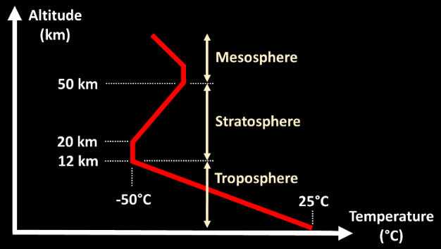
As one can see, the atmosphere is relatively warm at ground level, and gets colder as one goes up.
However, this reverses after one enters the upper atmosphere, since ozone in this region absorbs solar radiation, and causes temperatures to become warmer as one goes higher.
In other words, there is a layer of relatively cold air in the bottom of the upper atmosphere, and a layer of warmer air above it.
Also, warm air rises, which means material injected at the bottom of the upper atmosphere will go up, and not quickly fall to Earth due to gravity.
Therefore, one gram of sulfur injected into the upper atmosphere will cool the planet significantly more than one gram injected at ground level.
This is why {SLOW} moving one gram sulfur, from the lower atmosphere, to the upper atmosphere, cools the planet, and does not increase total sulfur emissions.
In other words, SAI involves moving sulfur, not adding it.

Three Physical Areas of Operation
Increasing the reflectivity of the atmosphere involves {Pic 4x AO} three physical areas of operation. These are polar research, cooling the Polar Regions, and cooling the entire planet.
Polar research involves a spray plane that injects material into the upper atmosphere, and then monitoring that material for days to weeks (ref). Monitoring entails flying below the material, above the material, and through the material.
{Pic SAI pdf} For details, click on the link in the description below.
Cooling the Polar Regions involves {Video: reflect sunlight / klm-boeing-777-landing-touch-down} approximately one-hundred Boeing 777 airplanes {Pic: polar injection} that inject material close to the {*} North and South Poles, to block tipping points associated with those regionsref.
{Pic Wake Smith} For details, see Wake Smith's 2024 paper.
And cooling the entire planet involves approximately one-hundred large, custom-made, high-altitude aircraft that {Pic: equator injection} inject material near the equator, {*} to block all climate tipping points (ref1, ref2).

Sunlight Reflectivity Risks
Reflecting sunlight, at the scale needed, and the timeframe needed, is not easy to do.
It does involve risks.
Two that stand out, are site security risk, and undercapitalization risk.
Site security risk involves protecting reflectivity operations from physical attack. This is important, since, in theory, any "grumpy" national leader could key the coordinates of reflectivity infrastructure into a missile guidance system, and press a button.
There are multiple reasons why they might do this,
one of which is they perceive it as harmful.
This is a complex topic, since the magnitude of harm could vary in both time and place.
And, we would want to weigh it against the harm of {SLOW} doing nothing.
Ultimately, this could get complicated, {Video: activism / fighting-men} and lead to fighting.
Also, there is undercapitalization risk.
This is {SLOW} when financial support, for initial research, {SLOW} is insufficient,
{SLOW} followed by a panicked national leader,
{SLOW} that pushes forward, at large scales;
{SLOW} before scientists had measured side-effects, at small scales.
There are many potential problems, and these are just a few that stand out.

Sunlight Reflectivity Laboratory
To minimize risks, exhaustive field testing would be needed to evaluate different candidate materials, in different locations, with different monitoring instruments.
Experiments such as these have not been conducted,
even though,
changing the emissions site of sulfur,
is of profound importance.
For this reason, it is our intent to support sunlight reflectivity field experiments.

Lab Goal - SLIDE
Support sunlight reflectivity field experiments.
{Pic video 9} For details, see Video #9.
Okay, that's it for me, and I'll talk to you all, real soon.

Video #11: Low-Cost Nuclear Power
Hi, my name is Glenn Weinreb, and today we're going to look at how to tackle
{Pic nuclear at night} the climate problem, with low-cost, nuclear power.
{Pic nuclear construction} Our society currently builds several nuclear fission reactors, at a time,
and this has close to no impact {Video: earth / storms} on global warming.
Instead, to have a measurable impact,
we would need to build {SLOW} thousands.
In theory, {SLOW} this could be made possible by {SLOW} reducing the cost,
of extra-safe reactors, {SLOW} that don't melt down, when not cooled.
Again, we're looking at reducing the cost of extra-safe nuclear power.
It turns out, this should be easy to do, as we will explain, in this video.

Automated Site Construction
Costs can be reduced by relying on factory-made components, and by developing a new transportation system that moves large subassemblies, from factories, to power plants.
The nuclear reactor vessel, and its internal gadgetry, account for only 2% of total nuclear site costs. Most of the costs, come from excavation, installing rebar, and pouring concrete. And these costs could be reduced, by developing equipment, that automates site construction.
Also, nuclear waste could be reduced with more processing, at a small, additional cost {Ref 5 to 15%}.

Design One, Build Many
Engaging in a lengthy nuclear reactor design, and certification process, is unnecessary.
Instead, one can copy an existing design.
{Pic HTR-PM} China's HTR-PM is a reasonable candidate since it is probably thesafest commercially operating nuclear reactor in the world.
In particular, it does not melt down, if not cooled.
Its helium gas coolant, is not radioactive.
And, its fuel and coolant do not react with air or water.
In the event coolant is lost, the fuel radiates heat outward, to the metal containment vessel, which then radiates heat to the concrete containment chamber, which then conducts heat to bedrock.
In other words, you can stop cooling the fuel, and it will not melt down.
This advanced design took 20 years to develop, and repeating this process is unnecessary.
China has constructed many nuclear reactors over recent decades, gaining expertise that allows them to build at relatively low costs. Conversely, the United States and Europe, have been less active, resulting in less proficiency, and higher costs. However, this lack of experience is not permanent.
If nuclear power, was used to solve the carbon dioxide problem, more nuclear construction, would result in more proficiency, and lower costs.
Also, if construction was automated, this would naturally occur first in regions that are comfortable with nuclear power, such as China, and eventually spread, elsewhere.

The Nuclear Solution
{Pic 1K/1M/1G} Large nuclear power facilities typically host between three and six reactors, with each reactor producing about one billion watts of electricity. Given that an average U.S. household, consumes about 1,000 watts, a single nuclear reactor can supply electricity to roughly one million homes.
We know how much energy is consumed worldwide each year, and we know how much is produced by a large 1-gigawatt nuclear reactor. To get a sense of decarbonization problem size, we can divide these two numbers to calculate how many 1-gigawatt nuclear reactors would be needed, to replace global energy. {Pic 9000 GW} The math works out to about 9,000 gigawatts of nuclear power.
In other words, we would need to build 9,000 large nuclear reactors, worldwide, to fully replace coal, oil and natural gas.
{Pic 150 GW/yr} If nuclear power decarbonized half of global energy, {SLOW} over the next 30 years, {SLOW} then 150 gigawatts of nuclear power, {SLOW} would need to be built, {SLOW} each year {50% × 9,000 GW_{e} ÷ 30 years}.
{Pic GW Table} This would entail building 41 gigawatts per year in China, 23 gigawatts per year in the U.S., and 19 gigawatts per year in Europe. Compared to today, that’s a six-fold increase in China, a 150-fold increase in the U.S., and a 100-fold increase in Europe.
Again, this is what it would take to replace half of global energy, worldwide, over 30 years.

Nuclear Economics
{Pic $2/W, $6B/3GW} In China, new nuclear reactors currently cost about $2 per watt of capacity ($2/W). For example, a 3-gigawatt plant in China costs around 6 billion dollars to build. And this produces electricity at a cost similar to that produced with fossil fuel.
{Pic Nuclear Plant at Night} The cost to build nuclear power plants in the U.S. and Europe are much higher than 2 dollars per watt. However, if construction volumes increased, they would likely approach Chinese levels.
If global nuclear construction, reached 150 gigawatts per year, automated construction could probably keep costs, in the vicinity of, $1 to $2 dollars per watt.
{Pic 300=150x2} At 2 dollars per watt, 150 gigawatts-per-year construction
would cost 300 billion dollars annually.
For comparison, {Pic $4T} current global fossil fuel spending is about 4,000 billion dollars annually.
This includes 2,500 billion for oil, 1,000 billion for coal, and 500 billion for natural gas.
While nuclear isn’t a perfect substitute, the comparison is striking.
{Pic $300B vs. $2000B} We're looking at 300 billion dollars per year for new nuclear reactors,
versus 2,000 billion per year for half of fossil fuel.
{Pic Et10} For details, click on the link, in the description below.
{APlanToSaveThePlanet.org/et10,
eetcs10_energy_calculations.xlsx,
https://drive.google.com/drive/folders/1ofsxLZ6Bdz-31k73_DJTdnk2Pu3AZrWP?usp=drive_link
https://drive.google.com/drive/folders/1ofsxLZ6Bdz-31k73_DJTdnk2Pu3AZrWP?usp=sharing

Cheap Green Chemicals & Materials
Nuclear reactors are typically used to make electricity.
However, they could also be used to make {Pic Chemicals} chemicals, {Pic Metal} and materials.
And, to move this forward, we would need the green method to cost less than the carbon-based approach.
In theory, this could be done by moving heat directly from a nuclear reactor, to an industrial process,
less than 1000 meters away.
And this could be implemented by {Pic Pipes} pumping steam, molten salt, or molten lead through pipes.
To further reduce costs,
a new transportation system could be developed that transports
platforms of chemical processing equipment, from factories, to power plants.
{Pic Big railcar} More specifically, we could develop {*} a double-rail system, that moves
{Pic Tank on car} large and heavy loads, over land and water.
{Pic 12x24 railcar} For example, 12 by 24 meters railcars could transport {Pic configurations} bins of concrete, concrete forms, rebar subassemblies, and large automated construction equipment.
{Pic Platform on rail} Also, {*} multiple railcars, could move {*} large platforms of industrial processing equipment,
{Pic Side-by-side} and place them side-by-side, near {*} a nuclear reactor.
This processing equipment could support the {Video: fossil fuel / oil refinery / aerial-view-of-vaporizing} production of common chemicals, {Video: fossil fuel / h2} including hydrogen gas, {Video: fossil fuel / nh3} and liquid ammonia.
Typically, 66% of energy produced, {Video: power / nuclear / Nuclear-Power-Plant-Aerial} by a nuclear reactor, is lost to the environment, as unused heat. However, this could potentially be used by nearby industrial processes, to further reduce costs.
{Pic chemical processing yard} Chemical processing platforms 12 by 100 meters in size could potentially be positioned side-by-side, as shown here. In this illustration, platforms are shown in green, pipes carrying heat from the nuclear reactors are shown in blue, underground tunnels that support pipes in between platforms are shown in light violet, and underground tunnels that support moving material into and out of the chemical processing platforms are shown in light purple.
{Pic R&D} Developing the standards that define how this fits together, plug-and-play,
would cost little, compared to costs, typically associated with nuclear power.

Speed and Scale
As noted in previous videos, solving the carbon dioxide problem requires both {slowly} Speed and Scale.
Speed is not working with an experimental reactor that takes 20 years to commercialize;
and instead is copying an operating unit that has already completed the certification process.
And {slow, emphasis} Scale is not building several reactors,
and is instead building thousands.
The only way to move this forward is significant cost reduction.

Lab Goal - Statement
And the only way to do that is to develop custom machines that automate site construction.

Lab Goal - SLIDE
Develop custom machines that automate nuclear site construction.
{Pic Video #3} For details on how this might work financially, see Climate Lab Video #3.
Okay, that's it for me, and I'll talk to you all, real soon.

Video #12: Automated Nuclear Power Construction
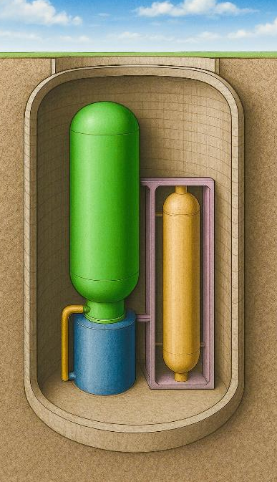
Hi, my name is Glenn Weinreb, and today we're going to look at how to significantly reduce,
the cost of nuclear power,
via automated construction.

Rethinking Nuclear Fission
Nuclear power plants typically require significant amounts of concrete and rebar, in part because they need to withstand attack from missiles and airplanes.
In principle, these costs could be reduced {Pic chamber} by placing the reactor vessel underground, inside a concrete-lined chamber, surrounded by bedrock.
Achieving this affordably would probably require the development of specialized machines that automate {Tick fingers} excavation, installation of concrete lining, and assembly of reactor components.
{Pic railcar} And this might require a new transportation system that moves large and heavy loads, from factory to site, an example of which is shown here.

The Case for Going to Ground
It typically cost more to build underground.
However, this might not hold true for gas-cooled,
nuclear fission reactors,
that are built with custom machines.
Traditional reactors are cooled with pressurized water; however, several advanced designs instead use helium gas. {SLOW} Gas carries less heat, per unit volume, compared to water, and therefore gas-cooled reactor vessels are physically larger than their water-cooled counterparts.
{SLOW} Consequently, their nuclear fuel is more spread out, which helps them not melt, when not cooled.
More specifically, {SLOW} in the event coolant is lost, in a gas-cooled reactor, {SLOW} decay heat is moved via radiation to concrete chamber walls, and then to bedrock.
Alternately, water-cooled reactors are dependent on external systems that must be protected against attack, {SLOW} and this drives up costs.

Excavation, Rebar and Concrete
A cost-effective underground approach would probably involve developing specialized machinery that excavates in bedrock, and installs a concrete lining.
{Pic rebar} Rebar assemblies could be prefabricated in a factory,
{Pic move} transported to the site,
{Pic Hole} lowered into the excavated cavity,
{Pic concrete lining} and then filled with wet concrete.
There are two primary methods for excavating bedrock: blasting and mechanical excavation.
{Video: nuclear site / robot-drill-makes-hole} Blasting uses explosives to fracture rock,
{Video: nuclear site / an-excavator-hydraulic-rock} while mechanical excavation uses machinery
to cut and remove material in a more controlled manner.
Costs can vary significantly, reaching up to approximately $250 per cubic meter of rock. However, based on our calculations, this would cost less than 2% of total site costs.
{Pic Et13} For details, click on the link, in the description below.
{eetcs13_calculations.xlsx
https://drive.google.com/drive/folders/1xfonXYiZA5TZzR0nqF25brhJOGPTlrHZ?usp=sharing
{Pic 5x custom machines} As noted previously, custom machines are needed to break rock, remove rock, install rebar, pour wet concrete, and install subassemblies.
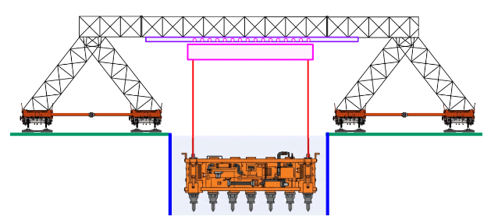
{Pic Et13} This would probably require a gantry-like crane system that lowers custom machines into an excavation, an example of which is shown here.
{Pic AI excavation} We asked AI to render this.
Okay, not bad for a computer.
The primary functions of the containment structure are to withstand physical attacks and to contain radiation under pressure.
{Pic dome} To hold pressure, a dome-shaped seal could be bolted down, close to the top.
{Pic blast door} And, to protect against attack, a retractable concrete block could be placed above it.

Support Equipment
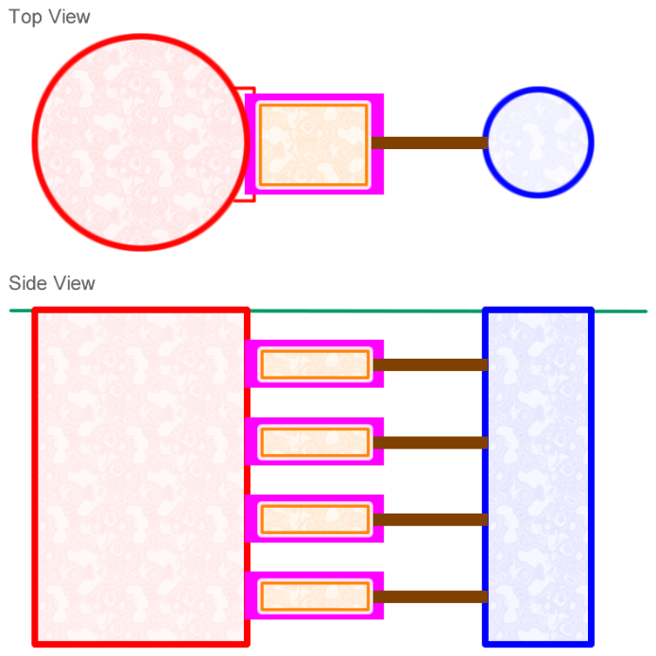
Nuclear reactors require various support systems, including pumps, electrical power generators, monitoring instruments, control systems, and nuclear fuel storage.
{Pic 2 excavations} In theory, some of this could be housed in {*} a separate “equipment excavation,” {*} while the reactor vessel and heat exchangers are {*} kept in a “power excavation.”
{*} Custom machines could excavate {*} rectangular chambers {*} and tunnels that lead to reactor components.
{*} Also custom machines could install concrete linings to insure wall integrity.
{Pic three boxes} Support systems could then be preassembled within factory-made metal enclosures
{*} that are transported to the site,
{*} and installed as needed.

Site Design
{Pic site design} To reduce costs, multiple power excavations could be positioned around a single central equipment excavation, as shown here.
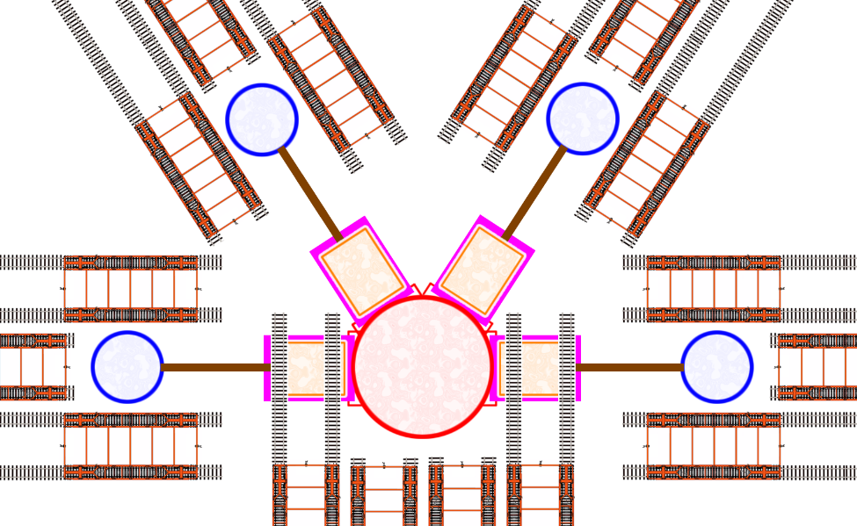
A preliminary estimate finds this approach would consume 9-times less concrete-per-unit-electricity {Pic 2x reactors} than Vogtle 4, and 26-times less concrete-per-unit-electricity {*} than Hinkley C.
In other words, less concrete is needed when mission-critical infrastructure is kept close to gas-cooled reactors.
{Two fission chapters} For details, click on the link in the description below.
The cost to automate construction would probably be small,
relative to costs,
typically associated with nuclear power.
In other words, if we put R&D money in the right places,
we should be able to get 24x7 green energy,
at a cost less than fossil fuel.
{Pic Video 13} For details on how this works financially, see Video Number 13.
{Pic web} And for more climate solution videos, see www a plan to save the planet dot org.
Okay, that's it for me, and I'll talk to you all, real soon.

Video #13: How to Make $10 Trillion Dollars
Hi, my name is Glenn Weinreb, and today we're going to look at how to make {SLOW} $10 Trillion dollars.
Let's begin, by looking at {SLOW} the amount of money that is spent {SLOW} worldwide,
{SLOW} each year,
{SLOW} on energy, electricity and chemicals.

Energy, Electricity and Chemicals
{Pic *} Fossil fuel costs roughly $4 trillion dollars, each year.
This includes 2.5 trillion for oil, 1 trillion for coal, and a half trillion for natural gas.
{Pic *} Out of the 4 trillion for fossil fuel,
roughly one trillion is used to make electricity,
and roughly 1 trillion is used to make chemicals.
And, an additional $5 trillion is related to non-fuel chemical making.
In other words,
making electricity,
and making chemicals,
costs the world, approximately $7 trillion dollars,
each year.
{Pic *} Also, companies that do this, are typically worth 1.5 times their {SLOW} annual revenue.
Therefore, if they were replaced,
the new companies would be worth roughly {SLOW} 10 trillion dollars.
$10 trillion corporate value = $7 trillion/year revenue
* 1.5 typical revenue-to-value ratio

Big R&D
In theory, this could be done by developing custom machines,
{SLOW} that automate the construction of,
{SLOW} next generation,
{SLOW} nuclear power sites.
This would drive down the cost of the green option,
to below that of the carbon option.
And customers would then buy green, to save money.
{Pic *} For details on automated construction, see Videos 11 and 12.
Roughly one-third of carbon dioxide, comes from making electricity,
and roughly one-third comes from making chemicals and materials.
Therefore, if these areas were decarbonized, carbon dioxide emissions would decrease 3 to 1.
And this could be done, without asking someone, to do something, they don't want to do.
In other words, we don't need to ask regions, to incur additional costs, and become less competitive.
Okay, so why has this not been done?
The problem is, investors avoid projects that are too complicated,
and automating nuclear site construction, {SLOW} falls in this category.
{*} Bill Gates refers to this as {*} the "The Big R&D Problem".
In response,
he set up a venture capital firm {*} called Breakthrough Energy Ventures,
that focuses on {SLOW} large projects.
However, automating site construction is probably too big, even for them.

Climate Money
To move this forward, initial R&D would probably need {SLOW} climate money.
This is money that is {SLOW} not looking for a return on investment,
and is instead looking to save the planet,
from climate change.
Sources of Climate Money include high-net-worth individuals, foundations, and governments.
{Pic *} For details, see Video #3.
Okay, so what might climate money do?
Well, they would pay engineers, to do rough designs, of facilities that produce electricity and chemicals.
And estimate costs, based on different assumptions.
For example, they could assume construction is automated,
as suggested in previous videos,
and see if they can make electricity and chemicals at a cost less than,
the traditional fossil fuel-based approach.
And, they could build databases of possible site locations, worldwide,
and have the computer design facilities at each location.
In essence, they could look for ways,
to take market share away from existing suppliers.
{Video: activism / businessman-throwing-out-money}
Entrepreneurs and investors could then use this information to gain wealth.
{Video: activism / happy-children-holding-hands} And, as a side-effect, carbon dioxide emissions {SLOW} would decrease.
This is how one uses capitalism, to tackle the climate problem.
In theory,
national climate plans could be developed that show how to solve the entire climate problem,
at low cost.
More specifically, a website could be built that creates climate plans,
which include designs of green energy production facilities.
{Pic *} For details, see Videos #4 and #5.

Working Prototypes
To move this forward, engineers would need to build prototypes,
of machines that automate site construction.
At some point, {SLOW} risk to investors {SLOW} would become tolerable,
{SLOW} and they could then build,
{SLOW} on top of,
initial efforts.
{New Para} Working prototypes might cost 100's of millions of dollars, to several billion.
{Pensive} This might seem expensive.
However, this is small money, relative to costs, {SLOW} typically associated with climate.
In summary, if you want to reduce carbon dioxide emissions 3 to 1,
without pushing on someone to do something they don't want to do,
consider Big R&D,
supported by,
climate money.
{Pic web} For details on how this might work,
visit www dot a plan to save the planet dot ORG.
Okay, that's it for me, and I'll talk to you all, real soon.

Video #14: Fusion Moonshot
Hi, my name is Glenn Weinreb, and today we're going to look at what it would take, to accelerate the development of fusion energy.
[Pic Fusion] Typical fusion systems maintain a hot plasma within a donut-shaped structure, as illustrated here.
Fission vs Fusion
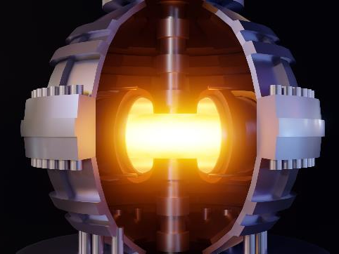
[Pic 3x Fission vs. Fusion] There are primarily two types of nuclear power: fission and fusion.
[Video: power / fission / aerial-drone-view-of-Doel-nuclear] Fission is the traditional form that generates electricity with uranium fuel. [Pic 5x fission problems] However, this is not popular due to meltdown risk, nuclear waste, proliferation risk, and cost.
Fusion, on the other hand, does not have these issues; however, it is still in development.

Economic Fusion Moonshot
{Pic Solve Emissions Problem} To solve the carbon dioxide emissions problem, with fusion,
{*} electricity produced with a fusion machine {*} would need to cost less than,
{*} {SLOW} electricity produced with fossil fuel.
{Pic fusion definition} This is theoretically referred to as “economic fusion,”
and it would {*} entail {SLOW} low-cost, {*} continuous operation, without failure.
{EMPHASIS} If green energy were cheaper than carbon-based energy,
nations would decarbonize, {SLOW} to save money, {SLOW} to be competitive.
However, to globally decarbonize over several decades,
economic fusion, would need to be achieved, within a handful of years,
and then {EMPHASIS} thousands of machines would need to be built quickly.
This would require R&D funding that goes beyond current levels.
{Pic $4T fossil fuel} The world currently spends 4 trillion dollars, a year on fossil fuel,
{Video Earth / storm / 6262762_Monsoon_Rain_India} and harm from climate change is
expected to reach trillions of dollars annually.
{Pic $ Billions/Trillions} Therefore, it's reasonable to spend
{*} additional billions on economic fusion, in an effort to
{*} save trillions in climate-related costs.
{Video: power / fusion / JFK-speech-man-landing-on-the-moon}
In 1961, President Kennedy stated he wanted a man on the moon, by the end of the decade.
{Video: power / fusion / NASA-vehicle-assembly-building} In response, a program was set up, and funded.
In theory, a similar approach could be applied to economic fusion.
But how might it gets started? Let's explore.

Tokamak vs. Stellarator
{Pic 3x t/s} The tokamak and the stellarator are two fusion designs that could potentially produce large amounts of electricity in the near future.
{*} The tokamak features a donut-like shape,
{*} while the stellarator is more bumpy.
According to cost models, electricity from a stellarator cost less than electricity from a tokamak.
Therefore, the stellarator, is likely to be favored.
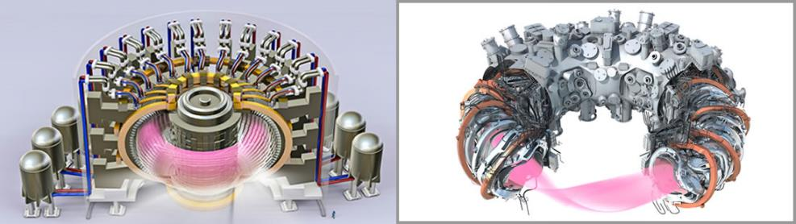
To produce electricity at a low cost,
the energy output from the plasma must exceed the energy input,
and the electrical power generated by the site, must exceed that, consumed by the site.
This requires powerful magnets and adequate plasma confinement,
both of which, are well understood, by scientists.

Heat Removal
{*} Hot plasma, inside the donut shaped chamber,
{*} radiates heat outward,
{*} and causes the internal surface of the chamber {*} to become hot.
{Pic Outward} This heat must be moved outward,
{Video / power / nuclear /dynamic-fog} to create steam,
{Video / power / nuclear / close-up-of-balancing-steam-turbine} to press on fan turbine blades,
{Video / city / power / high-voltage} to create electrical power.
The easiest way to do this, {Pic plasma} is to pump molten metal, {*} toward the hot plasma, {*} and then outward.
There are two ways to do this.
{Pic Plasma} One involves having {*} liquid metal flow in front of the internal surface plate,
{*} and the other involves flowing liquid behind the plate.

Liquid Metal Wall
{Pic LMW} Flowing liquid in front is referred to as "liquid metal wall."
{Pic Abdou} This is illustrated here, with the liquid metal shown in red.
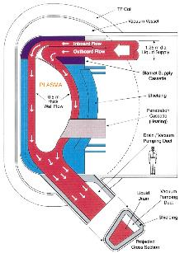
To get this to work, magnets would need to push the molten metal outward,
toward the metal plate,
while it flows,
and removes heat.
[Ref: 2001 paper by Dr. Mohamed Abdou]

Internal Cooling System
{Pic Plasma} The alternate cooling method is to expose a {*} 2mm thick metal plate {*} to plasma radiation, {*} and cool it by flowing molten metal along its back surface, within channels.
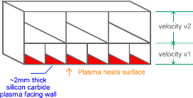
However, radiation from the plasma will eventually damage the metal plate,
requiring replacement.
This involves machine disassembly, which is VERY expensive.
Therefore, it is more cost-effective to protect the metal plate with {Pic internal flow} flowing molten metal, and only assemble the machine once during its lifetime.
In other words, liquid metal wall, might be required, to achieve, economic fusion.
Also, this is a new technology, and more experiments are needed to verify feasibility.

Next Generation Magnets
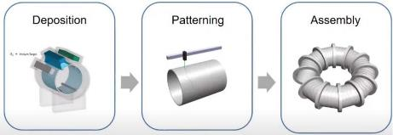
Stellarators require irregularly shaped magnets to confine plasma, and these are expensive to fabricate using traditional methods.
{Pic Next Gen Magnets} In theory, costs could be reduced by placing alternating layers of superconductor and “insulator” onto a rotating tube via an additive process.
However, this is a new technology, and therefore needs more experiments.
{Reference: https://snf.ieeecsc.org/files/ieeecsc/slides/Usoskin_annotated_presentation.pdf
https://indico.cern.ch/event/1347361/contributions/6343455/attachments/3030055/5348844/0312_CCA_CERN.pdf
https://indico.cern.ch/event/1376314/contributions/5841412/attachments/2837695/4959197/BUTTERWORTH_20240416_HTS%20for%20Stellarator.pdf
https://renfusion.eu/}

Economic Fusion by Design
Researchers can design a fusion machine entirely on paper,
and calculate the cost for that machine to generate electricity.
{Pic Volpe paper} This has been done, and a design that achieves economic fusion was published in 2024.
This design reduces costs with liquid metal wall, and next generation magnets.
It took scientists many decades to produce a machine that, by design, achieves economic fusion.
This, by itself is a {Emphasis} remarkable achievement.

Current Fusion Efforts Will Not Solve the CO₂ Emissions Problem
The U.S. government currently supports fusion research with hundreds of million dollars of annual funding.
However, they do not "pick winners and losers."
This means they support many different approaches, instead of focusing on one design.
This will not solve the climate problem, since that entails a surge of funding into one machine, that by design, produces low-cost electricity.
There is only one company
{Pic RF} that is working on this, and it is called Renaissance Fusion.
However, their funding is probably 10 to 100 less, than that needed, to achieve economic fusion, in a handful of years.
The fusion company with the {Pic CFS} most money is called Commonwealth Fusion Systems.
{Pic ARC} They hope to build a machine in the 2030s that generates electricity.
However, their machine would be subsidized by investors,
which means it would not produce power,
that is a cost competitive,
in an electricity market.
In other words, do not expect Commonwealth to solve the climate problem.
Furthermore, climate is not their responsibility.
Instead, it is to increase their own value for shareholders.

A Surge of Funding in Key Areas
So how might we solve the carbon dioxide emissions problem with fusion?
A good place to start,
would be a surge of funding,
in technologies needed by machines,
that achieve economic fusion,
by design.
In other words, more R&D money for liquid metal wall, and next generation magnets.
{Pic Fusion chapter} For details, click on the link, in the description below.
{Pic website} And for more climate lab videos, visit www dot APlanToSaveThePlanet dot org
Okay, that's it for me, and I'll talk to you all, real soon.
{Subscript 2: ₂}

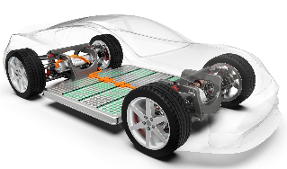
Video #15: Swappable EV Battery
Hi, my name is Glenn Weinreb, and today we're going to look at how a
{Pic 4x std swap EV battery} {SLOW} standardized, {SLOW} swappable, {SLOW} EV battery, {SLOW} could potentially help decarbonize automobiles.
{tick 3 fingers} We are looking for cars that,
{SLOW} {Video: city / EVs / smoke-over-the-city} do not emit carbon dioxide,
{SLOW} {Video signs / money / frustrated-businessman-making-losses} cost less than gas cars,
{SLOW} {Pic fun car} and are ***as*** convenient.
{SLOW} {Video: city / EVs / electric-vehicle-charging} Are we currently doing this with EVs?
{SLOW} I don’t think so.
{Video: city / EVs / businessman-using-smartphone} They’re not convenient.
Okay, so how might we do better?

Standardized Swappable Battery
Currently, {Video city / EVs / Ev-battery-pack} proprietary batteries are built into EVs,
{Video: city / EVs /charging-electric-car-electric-vehicles} and charged periodically.
Alternatively, they could {Pic swappable battery} use a standard plug-in battery,
and swap, as needed, in several minutes.
Car owners would pay for electricity consumed, and for wear on the battery.
And pay less, when using lower-cost, batteries.
Today, {Pic small batteries} mechanical and electrical standards define batteries,
and allow us to {Video: city / EVs /robot-and-child-boy} power many products, at a low cost.
In theory, this could also be done with electric vehicles.
In other words, the **same** standardized battery, similar to what we see in EV’s today,
could be used by **multiple** manufacturers.
{Pic swap station} And batteries sitting in swap stations, could charge any time, over multiple days.
This would reduce costs, for several reasons. {tick 4x fingers}
- One, batteries could charge {Video: Reflect Sunlight / 526435_Space_Stars_Sky_Lake} when the electricity price was low.
- Two, batteries could {Video: Power / Solar / Ecology-solar-power … SBV-338678956-HD} charge when solar farms and
{Video: Power / Wind / 124751_wind_turbine} wind farms were producing power.
- Three, batteries could charge slowly, {Video: City / EV / Dayton-Ohio} and avoid expensive fast-charging hardware.
- And four, competition {Video: city / EV / lithium-ion-battery} between battery manufacturers, could drive down costs.
In other words, this could potentially get us favorable costs, and favorable convenience –
which is what is needed, to go green, with cars.
To move this forward, someone would need to support
{Video: scientists / close-up-of-engineers-team} the development of {SLOW} standards that
{Pic 3x} define how this fits together mechanically, {*} electrically and {*} with communications.

Fast-Charging Is Expensive
Many electric cars {Video: city / EVs / 612375_Woman_Charging_Electric} support fast-charging in 30-minutes.
However, this is expensive since it involves
{Video: city / power meter / analog-electricity-meter} moving large amounts of energy.
More specifically, fast-charging **capability** drives up the
{Video: city / EVs / technician-working-on-Ev} cost of batteries,
{Video: city / EVs / mechanic-working-on-electric} the cost of electronics inside the car,
{Video: city / EVs / side-view-of-tesla-supercharger} and the cost of electronics outside the car.
This leads to undersized hardware, at fast-charging stations,
which leads to slower charge times,
{Video: city / EVs / woman-struggling} which leads to less convenience.
Swap-stations, on the other hand, {SLOW} would avoid expensive fast-charging hardware;
{SLOW} while providing service, {SLOW} in several-minutes.
Also, regions {Video: fossil fuel / oil / liquid-cargo-transporter} that import oil, {SLOW} such as China and Europe, {SLOW} would find this especially appealing, since it would help them
{Video: fossil fuel / oil / middle-east-Israel} reduce dependence on foreign oil.

Swap Tricks
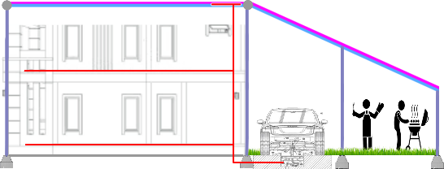
Now, what might be done with a fleet of standardized batteries?
{Pic Driveway Picture} Well, homeowners could install swap chambers in their driveway, as shown here. In theory, these could help power homes, {SLOW} and charge slowly when cheap green electricity was available.
Also, drivers could install a battery type, into their car, that fits their needs. For example, those who drive little each day, {SLOW} could swap-in a low-cost, low-range battery, and charge slowly at home. These might cost 5-times less per mile driven, {SLOW} than fast-charge batteries, with more range.

Standards Development
It turns out, cars with swappable batteries, already exists.
For example, a company in China, {Pic Nio} called Nio, makes hundreds of thousands, of EVs each year, with swappable batteries. However, their technology is propriety, and we instead are looking at multiple manufacturers, sharing batteries and swap stations.
This requires standards that define {tick 3 fingers}
{Finger 1} how batteries mechanically and electrically, attach to cars and swap stations,
{Finger 2} how batteries communicate with cars, and
{Finger 3} how cars communicate with swap stations.
Automakers are not inclined to invest in a swappable system controlled by a competitor. Therefore, a neutral entity would probably be needed to
{video city / Ev / female-and-male-engineers} oversee design,
{video city / Ev / two-male-automotive-designers} prototyping and
{video city / Ev / cinematic-real-life-car} testing of a standardized system.
Also, to encourage widespread, global adoption,
developed technology {video / signs / open-source} might need to be disseminated freely.
{Pic Swap chapter} For details, click on the link, in the description below.
{Pic website} And for more climate lab videos, visit www dot APlanToSaveThePlanet dot org.
Okay, that's it for me, and I'll talk to you all, real soon.

Video #16: Next Gen Building Automation
Hi, my name is Glenn Weinreb, and today we're going to look at how a next generation,
{Pic 4x automation} building automation system,
could potentially {*} reduce carbon dioxide emission, {*} reduce cost, and {*} increase comfort.
For example,
more automation could allow us to
{video house / Hvac / woman-using-app} control the temperature of each room;
{Pic More air control} and help move heat, from one room, to another.

A Chip in Every Device

To fully automate buildings, we would need to
{Pic uProcessor} place a microprocessor chip in every device,
{Pic network} and connect them together, with reliable communication.
Devices include things {Pic 6x devices} like light switches, {*} light sockets, {*} HVAC equipment, {*} window thermal covers, {*} appliances, {*} motorized dampers in ducts, {*} fans in ducts, {*} occupancy sensors {*} temperature sensors, {*} and fire detectors.
To facilitate global acceptance, and ensure bug-free operation,
the same {Video signs / open-source-handwriting} free and open,
operating system software,
would probably be needed on all devices.
This is easy to do, since free software, such as this, is readily available.
{Pic BB} An example is building bus, which was developed
{Pic Ma2} by my non-profit organization, several years ago.

Reliable Communication
{Pic 5x Light switch to bulb} When one flips a physical wall light switch,
the communication between the switch,
and the ceiling bulb,
works correctly more than 99.999 percent of the time.
{Pic Five 9’s} This is commonly referred to as 'five nines reliability',
and it is important,
since {Video activism / annoyed-Asian-woman (last 3sec)} occupants will not tolerate less reliability.
{Pic Bad Reliability} Unfortunately, {*} wireless and {*} power-line communication {*} do not provide the needed five 9’s.
Therefore, {Pic Data Wire} a communications data wire,
probably needs to be ** added ** to power cables, embedded in walls.
And this could be done {Video house / construction / wooden-beams} at the time of original construction,
at close to no additional cost.

Light and Heavy Devices
To reduce costs, devices could be divided into two categories: 'Light' and 'Heavy'.
{Pic 5x Light} 'Light' might consume less than 20 watts and include bulbs, switches, sensors, and small motors;
{Pic 5x Heavy} while 'Heavy' supports 110 or 220-volt AC outlets, HVAC equipment, and appliances.
{Pic 3x L/H} From a cabling perspective,
'Light' might be supported by 48 volts DC power and one communications data wire;
while 'Heavy' is supported by 110- or 220-volts AC power, and two data wires.

Most devices in a building are 'Light' and could save money with multiple techniques.
These include smaller cables, less conduit, fewer safety requirements, and less expensive electronics.

Standards Development
To support plug-and-play operation, standards would be needed that define how devices connect electrically, mechanically, and with data communications.
Before standards are proposed,
devices would need to be {Pic girl} designed,
{Video scientist / pcb / technician-engineer} prototyped,
{Video scientist / pcb / view-of-Womans-hands} tested,
{Video scientist / pcb / African} debugged, and improved.
And this might cost, tens, of millions, of dollars.
So, who might fund this, and how might it be structured to meet the satisfaction of the various participants?
Well, nation’s resist being controlled by external entities, and therefore might
{Video signs / open-source-software} require new standards be based on free and open technology.
{Pic Coins} Companies cannot afford to give their money to their competitors,
{Pic Gov’t} and governments rarely provide technical leadership.
Therefore, a foundation or high-net-worth individual, looking to save the planet from climate change, might be needed, to move this forward.
The Gates Foundation is uniquely suited, since {Pic Bill Gates} Bill Gates has experience developing operating systems, devices, and standards.
{BP building automation chapter} For details, on how to develop a next generation building automation system,
click on the link, in the description below.
{Pic website} And for more climate lab videos, visit www dot APlanToSaveThePlanet dot org.
Okay, that's it for me, and I'll talk to you all, real soon.

Video #17: Next Gen Solar Farms
Hi, my name is Glenn Weinreb, and today we're going to look at how we could potentially reduce the cost of green electricity, with a new technique for building solar farms.
But first, let’s review, how much material, is used by the different methods, of making electricity.

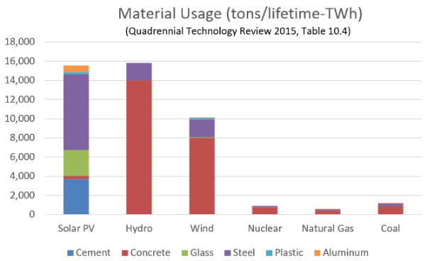
The Materials Problem
{Pic graph} This graph shows the weight of material, per electricity generated,
for each method of producing
electrical power.
As one can see,
{*} solar farms,
use about as much material,
as {*} hydroelectric dams.
{video power / solar / 566719_Panels_Renewable} This is because solar farms are spread out,
over a very large surface area.
In theory,
we should be able to build these with less material,
to reduce cost,
{Pic smoke} and reduce **emissions**, {Pic metal} associated with, material making.

Solar Material Rolled Directly onto Land
The traditional solar farm, uses {Pic cell} silicon solar cells, to convert light, to electricity.
These are delicate, {Pic glass} and are therefore protected by a sheet of glass.
The glass is heavy, and therefore {Pic big frame} requires a metal structure, to hold it in place.
And, the structure must be strong,
{Video earth /storm / palm-trees} to handle high winds,
during a storm.
{Pic sunset} Unfortunately, this consumes a lot of material.
{Pic flex 1x1.5m} **Alternatively**, flexible thin-film solar material
could be unrolled directly onto soil, in a manner
{Video power / solar / woman-rolling} similar to unrolling a carpet, onto a surface.
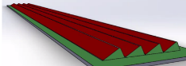
{Pic Bed} For example,
4 rows of flexible solar could be set up,
with each row measuring,
2 meters wide,
by 100 meters long.
Prior to unrolling,
the land could be shaped with
{Pic 2 Machines} earth-moving equipment,
under computer control.
{Pic Flex 1x2meter} Thin-film solar,
mounted on 2-millimeter-thick plastic,
{Pic Roll of Black Tape} is rollable,
{Video Earth / Storms / Large-Hailstones} resistant to hailstones,
{Video Power / Solar / Washing-Solar-Panels} and does not need glass protection.
Also, it has lower conversion efficiency,
and degrades faster over time.
However, what really matters is,
the cost-per-unit electricity generated,
and not electricity-generated-per-square-meter of land.
To hold flexible solar in place,
an installation machine would
{Pic side view} install a
{*} lower-anchoring-layer,
{*} perhaps 20 inches below the surface.
This underground layer might {*} be a metal mesh,
{Video power / solar / tractor-plow} that is held down with soil,
and connected
{*} to the top-solar-layer,
{*} with metal links.
Ultimately, the weight of the soil,
would hold it together, during a storm.

The Installation Machine
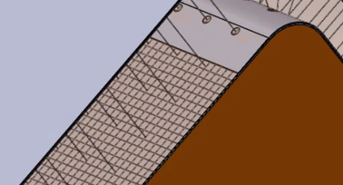
The installation machine {Pic layers} would need to
{*} unroll both layers,
{*} place soil in-between,
{*} and connect the layers,
with metal links.
This so-called, solar tractor, might be similar {Video power / solar / close-up-of-a-tractor} to what we see on today’s farm.
{Pic Grok Images} We asked Grok to generate some images,
and this is what it came up with.
{Pic ChatGPT Images} We also queried ChatGPT,
and it produced a different concept.
Ok, not bad for a computer.

Roll-to-Roll Fabrication
The solar material would need to be fabricated in a factory
{Video power / solar / big-roll-of-Aluminium} with a low-cost,
roll-to-roll process.
Low-cost is important,
since we need,
solar-plus-batteries,
to cost less than,
fossil fuel.
Fortunately,
roll-to-roll manufacturing with plastic,
is easier,
than working with delicate silicon solar cells.

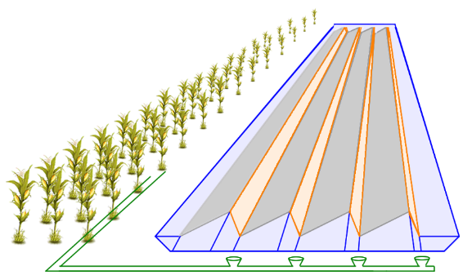
Keeping it Clean
{Pic erosion} As you might recall,
“erosion” is a process, by which particles of soil,
are moved by flowing water.
To prevent this from happening under the flexible solar,
a drainage system would be needed,
that controls rain water.
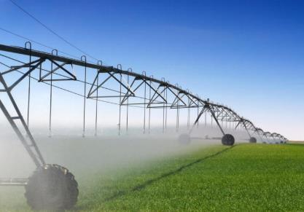
{Pic control} For example, water might
{*} flow in troughs,
{*} into a drainage pipe,
{*} and then to a {*} collection area.
Accumulated water,
could potentially help clean the flexible solar.
{Pic large sprayer} For example,
it could be sprayed,
under pressure,
by a custom machine,
that looks similar to,
farm irrigation equipment.

Getting Started
Okay, so how might this, get started?
Investors would consider this too complex, and too risky.
Therefore, initial support would be needed from, Climate Money.
This does not seek a return on investment,
and instead,
aims to save the planet,
from climate change.
Sources include high-net-worth individuals, foundations, and governments.
{Pic *} For details, see Video #3.
Okay, so what might climate money do?
Well, experimental beds of flexible solar,
would be built by hand,
and monitored over time.
And, custom machines would be designed, prototyped, and debugged.
This includes machines that
{Video power / solar / factory-plastic} fabricate rolls of flexible solar in a factory,
{Video power / solar / close-up-of-an-industrial} install beds in the field, and
{Video power / solar / center-pivot} keep the material clean.
Eventually, risk to investors would become tolerable,
and they could then build on initial efforts,
made by,
climate money.
{Pic solar direct to soil chapter} For details, click on the link, in the description below.
{Pic website} And for more climate lab videos, visit www dot APlanToSaveThePlanet dot org.
Okay, that's it for me, and I'll talk to you all, real soon.

> Illustrations
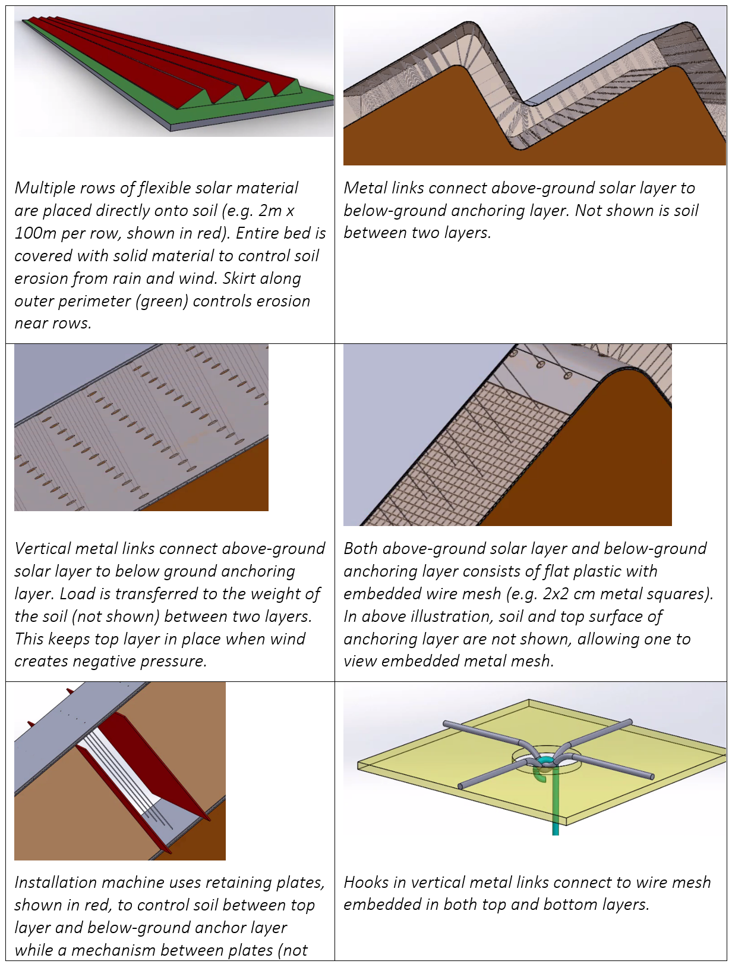

> Videos
Solar Cell
https://www.storyblocks.com/video/stock/solar-cell-layers-green-energy-generation-solar-panel-347034424
Water Spayer to Clean Material
https://www.storyblocks.com/video/stock/center-pivot-irrigation-system-watering-a-lush-green-field-on-a-sunny-day-353045889
Tractor Plow
https://www.storyblocks.com/video/stock/tractor-plow-through-farmland-soil-long-shot-slow-motion-4k-347238273
https://www.storyblocks.com/video/stock/aerial-view-of-a-tractor-ploughing-at-a-farm-in-brandenburg-germany-347685225
Road Roller
https://www.storyblocks.com/video/stock/a-road-roller-is-compacting-a-fresh-paved-road-hoqm9ktr5wj7i19met
https://www.storyblocks.com/video/stock/footage-of-a-road-roller-leveling-a-soil-substructure-for-a-new-walkway-in-an-urban-settlement-346778577
Roll-to-Roll Manufacturing
https://www.storyblocks.com/video/stock/plastic-sheeting-production-machine-347220527
https://www.storyblocks.com/video/stock/factory-plastic-line-machinery-in-action-347220543
https://www.storyblocks.com/video/stock/big-roll-of-aluminium-foil-sheet-rolling-on-industrial-machinery-equipment-working-in-factory-processing-raw-material-business-manufacturing-production-camera-moves-up-syb5klz0ikbtjsx1i

> Conversations with AI Regarding COST
- ChatGPT https://chatgpt.com/g/g-p-679d2bb5b304819198acec1a2830d008-energy-and-climate/c/6931f3dc-8ed0-832c-9c50-53835ff64d30
- Grok https://grok.com/c/d522d70f-aa5f-4aa7-88fa-c179aaf40ebc?rid=48fc40a3-68be-4585-998d-ced2dfc02e22
- Gemini https://gemini.google.com/app/e2dc8f7566a3bf45

> Conversations with AI Regarding VIDEO
- ChatGPT https://chatgpt.com/g/g-p-679d2bb5b304819198acec1a2830d008/c/69371c87-33ec-8331-82ce-ef7a16cfc249
- Grok https://grok.com/c/cf4d9afc-107c-4f38-99b6-42c49e84ef89?rid=c39d13ae-d390-4460-a93e-45f1c4f3455d
- Gemini https://gemini.google.com/app/7636cef38cbf7ac5

Video #18: Climate Change Economics
Hi, my name is Glenn Weinreb,
and today we're going to look at the economics associated with climate change.
But first, let’s review basic concepts of, electricity.

Electrical Power Fundamentals
{Pic kWh} On most home electric bills, {*} electricity use is measured in units of kilowatt-hours.
{Pic vacuum} For example, when a guy vacuums for his wife, for an hour, he's consuming approximately
{city / power meter / analog-electricity-meter} one kilowatt-hour of, electricity.
{Pic 4x house} The typical U.S. home {*} consumes 10,000 kilowatt-hours each year,
{*} at 14 pennies per kilowatt-hour, for a {*} total of 1,400 dollars, per year.
This is retail cost, and it covers electricity generation, and distribution.
{Video / power plant / coal / fossil-fuels-coal} Generation refers to making electricity at the power plant,
{Video / city / power / high-voltage-electrical} while distribution refers to the network of power wires
between generation plants, and consumers.
{Pic 4x $.14/kWh} Typically, {*} 7 cents per kilowatt-hour goes to generation,
and {*} 7 cents to, distribution.

Residential Decarbonization Costs
{Pic s-w-h-n} Green electricity, which is produced without emitting carbon dioxide, sometimes cost 1 penny more, per kilowatt-hour than electricity from fossil fuels. This is without subsidies, and without taxes.
{Pic 3x 60/40%} Currently, roughly {*} 40% of U.S. electricity is green, which means {*} 60%,
still needs to be decarbonized.
If we decarbonize 60% over 12 years, 5% would be decarbonized, each year.
{Pic 5x $10} According to the math, 5% of 10,000 at an additional 1 penny, is $5 per year.
{Pic 4x $10-$20-$30} Therefore, the additional cost per household, would be $5 in the first year,
$10 in the second year, $15 in the third year, and so on.
So, while costs grow gradually, they start out surprisingly low — just $5 per year in the beginning.

Houses are Bad at Tackling Climate Change
{Pic 2x solar} Electricity from solar panels, installed on a house, typically costs
about three times more, {*} than electricity from a solar farm.
{Voice up, question} Why the difference?
It comes down to overhead.
At the household level, each installation
{house / solar / realtors-work-with-clients} involves marketing costs,
{house / solar / no-people-shot-of-paper (5sec)} mechanical and electrical design,
{house / solar / African-American-engineer (6sec)} city permits,
{house / solar / full-shot-of-photovoltaic-installer} installation,
and, final inspection.
{Video: power / solar / medium-shot-of-three-workers} Alternatively, at a solar farm,
these costs are not incurred, every 15 solar panels.
In other words,
{Video: power / solar / 566719_Panels_Renewable} it cost much less to decarbonize by building solar farms,
{video house / solar / solar-panel-installation-on-private} than to place solar panels. on unique structures.
Perhaps a more interesting question is {slow} Why is this rarely discussed? {Pull finger to face, eyebrows in}
The problem is, no one benefits {video house / Bbq / 603914_Cooking_Skewers} from reducing their own carbon dioxide emissions. They are too small. Instead, one only benefits when {video city / ped / 98801_pedestrians} the other 8 billion people on the planet, reduce their emissions.
For this reason, no one seems to care, how much carbon dioxide they reduced, per dollar spent.
Furthermore, {SLOW!!} there is no mechanism,
that causes us, to decarbonize, at the lowest cost.
And this puts us at risk,
{video signs / money / unrecognizable-wealthy} of running out of money,
before achieving,
significant progress.
{Video: city / office building / Paris} Okay, let's move on from homes, and look at companies.

Companies are Bad at Tackling Climate Change
We often encourage companies to reduce their carbon dioxide emissions.
But in practice, they face two choices.
They can either decarbonize for real, at high cost.
Or they {Video: activism / nervous-cute-preadolescent} can appear to decarbonize, at less cost.
{Video: economics / stocks / stock-market-broker} For publicly traded companies,
spending more on climate action, usually means lower profit, which can push stock prices down.
{Video: economics / CEO / portraiportt-of-confident-black} But CEOs are expected to do the opposite.
{Video: economics / stocks / 3d-motion-graphics} They are expected to increase profit, and increase stock price.
So many respond {Video activism / woman-contemplating-a-purchase} with token climate efforts, designed to look good,
while keeping costs low.
One common approach is to buy carbon offsets. In theory, these pay for projects, that reduce carbon dioxide emissions.
{Video: activism / portrait-little-girl-with-concerned} But in many cases, they do not deliver, as promised.
For example, if an offset
{Video: house / lumber / forester-carrying} blocks tree farmers from harvesting on one parcel of land,
{Video: house / lumber / talented-lumberjack} and trees are instead harvested elsewhere,
{Video: signs / a-young-brunette-woman (wag eyes)} there’s no benefit.
{Video: econ. / CEO / thoughtful} Ultimately,
many CEOs need to select either
more decarbonization and less profit,
**or** less decarbonization and more profit.
{Video: activism / silhouette-of-tired-businesswoman} Too often, they choose the latter option —
in part {Video: activism / thoughtful-woman (last 4sec)} because their decarbonization claims are rarely verified.

Power Companies are Good at Tackling Climate Change
So, homes and companies, are bad, at tackling climate change.
However, this is not a problem.
This is because we only need {Video: city / power / special-effects}
power companies to take care of this,
especially during the early years.
More specifically, we only need a one sentence law, to decarbonize 1/3rd of carbon dioxide emission,
within a 30-year decarbonization. This is:
{Pic Law} Power companies, are required to decarbonize electrical power, over 10 years, in lowest-cost-order, and pass additional costs, or savings, onto, consumers.
Nations know about this sentence;
yet they refrain from participation,
since they don’t want additional costs,
to make them less competitive.
This is consistent with economics,
which states {Video signs / money / female-hands-counting} consumers, mostly buy, at the lowest cost.
The only way to get around this, is to do R&D, to the extent required, to drive down the cost of 24/7 green energy, to below that of fossil fuel. {Pic Videos 11…16 /drd} For details, see climate videos 11 through 17.
Additionally, we have a global warming problem, and to resolve that, we need to figure out how to reflect sunlight back into outer space, at reasonable cost, and without harm. {Pic Videos 9...10 /rsv} For details, see climate videos 6 through 10.
Okay, so what is the world currently doing about climate change?
Let’s examine this, though the lens of, economics.

Solar and Wind Economics
{Video: global warming / cloud-sky} Some regions are more-sunny,
{Video: global warming / hurricane-force-winds} while others are more-windy.
{Video: power / solar / solar-panels-produce}
As one might imagine, it costs less to generate electricity, with a solar farm, in a sunny region,
{Video: power / wind / 204551_Wind_farm}
and, it cost less to generate electricity, with a wind farm, in a windy region.
Yet by how much?
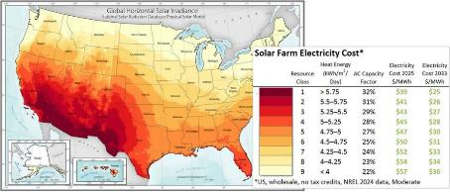
{Pic solar map} This table shows the wholesale cost of electricity, from solar farms, {*} built in the year 2025, and {*} projected costs, for the year 2033.
These costs are estimated by the U.S. government’s National Renewable Energy Laboratory.
The units shown here are megawatt hours,
which are 1000-larger than kilowatt-hours.
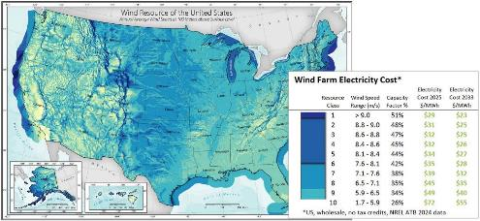
{Pic wind map}
Wind energy tells a similar story.
It’s often windy at higher altitudes, so windmills are technically feasible in many areas.
But, because of audio noise and other concerns, they cannot be placed too close to people.
That’s why wind farms are typically set up in remote areas.
For example, windmills for U.S. east coast cities, are likely to reside 200 miles inland.

Fossil Fuel Economics
We currently have facilities that produce electrical power by
{Video: fossil fuel / gas / burning-on-natural-gas} burning natural gas
{video fossil / coal / pile-of-coal} or coal.
{video power / coal / aerial-view-shows} These plants have already been built and paid for;
and they are needed,
{video power / solar / midnight-landscape} for times when the sun does not shine,
{video power / wind / windmills-generate} and the wind does not blow.
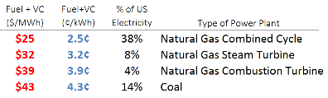
Therefore,
to go green,
solar and wind electricity costs,
need to be less than the
{Pic table} incremental cost incurred at the nearby fossil fuel-based power plant,
which {*} are shown here in red.
In other words,
the cost to decarbonize,
{*} is a green electricity cost,
{*} minus an incremental fossil fuel cost.
In many cases, solar and wind decarbonization costs, are favorable, yet not always.

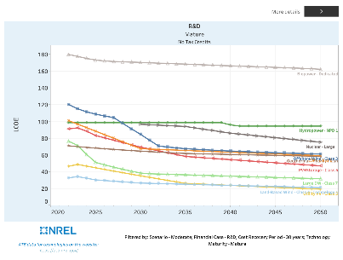
Green Electricity Cost Projections
Okay, so how might green energy costs,
change over the next 30 years?
{Pic 30-year projection} The United States government provides an estimate, as shown here.
In summary, solar and wind are expected to be somewhat competitive with fossil fuel.
However, the more reliable forms of green energy — such as those available 24/7 — are projected to remain more expensive, for many decades.
{Reference: https://public.tableau.com/app/profile/dana.stright1689/viz/2024LandingMultiple/LandingMultiple
https://atb.nrel.gov/electricity/2024/index
https://atb.nrel.gov/electricity/2024/data }

Decarbonizing in Lowest-Cost Order
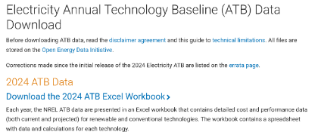
US government, green electricity cost projections, {Pic NREL ATB Download} can be download for free, and one can use this data to predict what would happen,
if U.S. electrical power was decarbonized,
in lowest-cost order.
{Pic www.APlanToSaveThePlanet.org/usa} We did this, and one can get a free copy of our analysis by clicking on the link, in the description below.
We looked at reducing U.S. carbon dioxide {Pic 1/30th/year} emissions 1/30th per year,
over 30 years, to get to zero emissions, 30 years from now.
And we looked at doing this in, lowest-cost order.
We found decarbonization costs would be close to zero, for the first 5 years, and then go up.
In other words, decarbonization would be easy at first, and then less easy.
And, in theory, a surge of R&D in key areas, could make the later years, easy too.

The United Nation’s Approach to Climate Change
{video gov’t / un / united-nations} The United Nations set up an organization,
{Pic IPCC} called the {*} IPCC, that studies {*} how to decarbonize.
{pause} And {Pic SPM.7, Ar6_WgIII_SummaryReport_Fig_SPM.7.PNG} a summary of their research, is shown here.
{*} Each bar, represents a different way to reduce carbon dioxide emissions,
{*} where the length of the bar, represents the amount of reduction,
{*} and the color indicates the cost.
And, they arrived at the same conclusion, which is that 1/6th of carbon dioxide emissions,
can be avoided, at close to no additional cost.
However, they don’t explain how to tackle the remaining five-sixths,
in a way that is both politically, and economically, feasible.
Okay, so why is decarbonization difficult?
Well, let’s examine several key points.

The Saturation Problem
{video power / solar / aerial-view-of-large-solar-panels} When building up solar power,
the amount of electricity from solar panels eventually exceeds
{video city / neighborhood / suburban-surrounded} the amount of electricity consumed by customers,
when sunny.
If one builds further, electricity is discarded due to supply from solar, exceeding demand.
{Pic solar saturation} This is referred to as “solar saturation,” and at this point, solar construction stops.
Ultimately, there is a limit to how much decarbonization can be achieved, with solar power.
{video power / wind / 204551_Wind_farm_Environment_Renewable_Energ} The same applies to wind power.
So, what impact would global solar saturation have on, global carbon dioxide emissions?
Let's quantify.
{video reflecting sunlight / reaching-for-the-brilliance} The sun burns bright about 6 hours out of every 24,
which means we can get roughly 25% of our electricity from solar power.
{video power / coal / aerial-view-of-a-large-coal} Also,
roughly one-third of carbon dioxide emissions are from electrical power.
Therefore, building up solar, {Pic 1/12 = 1/4 ✖ 1/3} until saturation,
would decrease global carbon dioxide emissions by approximately 8%.
Also, the IPCC came up with the same conclusion. {Pic 1/12 = 1/4 ✖ 1/3} They estimate maximum decarbonization due to {*} solar, to be {*} 4 gigatons out of 60, which is about 8%.
In other words, don’t expect solar, to save us, from climate change.

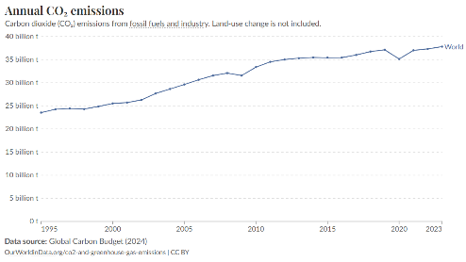
The GDP Growth Problem
{Pic 80% = 1.03²⁰-1} Global GDP growth is {*} approximately 3%-per-year, which works out {*} to an 80% increase,
over 20 years.
{Pic 72% = 80% - 8%} Therefore, if solar was built up to saturation, over 20 years, global carbon dioxide emissions {*} would increase 72%, *if* only influenced {*} by solar construction, {*} and, GDP growth.
{Pic graph} It is worth noting, global carbon dioxide emissions, have {Pic arrow} increased over the last several decades, in part, due to GDP growth.
{GDP Growth vs time Graph: https://data.worldbank.org/indicator/NY.GDP.MKTP.KD.ZG}
{https://ourworldindata.org/co2-and-greenhouse-gas-emissions}

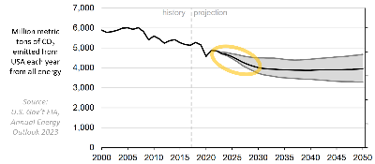
U.S. Government CO₂ Projections
{Pic EIA CO₂ projection} This graph shows a U.S. government projection of carbon dioxide emissions, from the U.S., over the next 30 years.
This includes all energy, not just electricity.
And, this projection is based on basic principles of economics, which assumes, consumers mostly buy, at, lowest cost.
In other words, they are not inclined, to pay more, for green products.
{*} As one can see, annual carbon dioxide emissions fell by about 1.2 billion tons, over the last 20 years. But surprisingly, most of this decline, had little to do with renewable energy, or government policy.
{big voice} Instead, about 80% of the {Pic gas-coal} drop came {*} from natural gas costing {*} less than coal.
{REF: https://www.eia.gov/todayinenergy/index.php?tg=forecasts/projections
https://www.eia.gov/todayinenergy/detail.php?id=55840
https://ourworldindata.org/co2/country/united-states}
https://www.eia.gov/todayinenergy/detail.php?id=61024
{video reflecting sunlight / carbon-dioxide-co2} Due to internal chemistry,
natural gas produces half as much carbon dioxide per unit energy;
therefore, switching over, reduces carbon dioxide emissions.
Okay, that was the past. What about the future?
Well, {Pic 2035 to 2050} U.S. economists expect more decarbonization over the next decade,
driven mainly by {3 fingers} 3 things.
{Video: power / solar / ecology-solar … SBV-338679022-HD} One, low-cost solar farms.
{Video: power / wind / silhouettes-large-wind-turbines} Two, low-cost wind farms.
{Video: fossil fuel / gas / aerial-view-of-an-oil-and-gas-drilling} and three, natural gas costs less than coal.
Also, each of {Video: signs / empty-brick-wall} these, has limits.
Solar and wind can’t be built beyond saturation,
and there’s only a limited number of coal plants. left to replace.
Once these limits are reached, decarbonization will slow —
and, {Pic 2035 to 2050} in the US government’s projection, {*} it basically stops.
Okay, so now what?
Well, additional R&D, beyond what the U.S. government expects,
could potentially change this trajectory.

What is Our Climate Plan?
Our society’s fundamental approach to
{Pic current strategy} climate, is to broadcast the following message:
{*} “Climate is bad. Go do something.”
This is sometimes referred {*} to as “virtual signaling,” and at first glance, it might seem helpful.
However, it leads to wasted time, wasted money, and confusion.
This is because we push on people who do not have the ability to respond effectively.
Instead, we need to calm down,
{video signs / open-notebook} start with a blank piece of paper,
and put together a plan,
that fixes the entire climate problem,
while observing basic principles of economics, science and engineering.
One might think of this as, {Pic engineered} “An engineered approach to climate change”.
{Pic Videos 4 and 5 /cpv} For details on how this might work, see videos 4 and 5.
Okay, that's it for me, and I'll talk to you all, real soon.

Video #19: The Climate Solution is More R&D
Hi, my name is Glenn Weinreb, and today we’re going to look at how to solve the climate problem,
in a way that is both politically,
and economically,
feasible.
But before we begin, let’s review the current strategy.

The History of Decarbonization
As you probably know,
{Pic fossil fuel} the burning of fossil fuel,
{Video reflecting sunlight / carbon-dioxide-co2} causes carbon dioxide gas,
{Video smoke / smoking-factory-chimneys} to be emitted into the atmosphere,
{Video Earth from space / motion-graph-orange} and this leads to, global warming.
Also, in theory, this can be mitigated,
by switching to energy,
that does not emit carbon dioxide,
{Video: Power / Wind / wind-turbines-generating} such as wind,
{Video: Power / Solar / silhouette-of-engineers} solar,
{Video: Power / dam / aerial-view-of-water} hydro,
{Video: Power / nuclear / factory-nuclear} or nuclear.
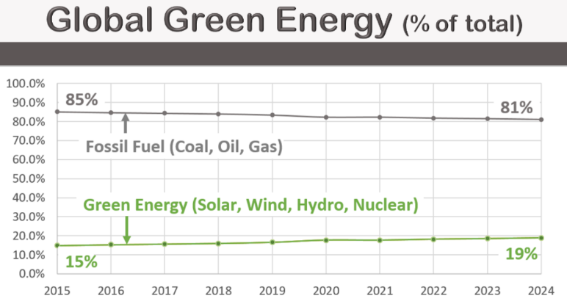
{SLOW} But at what rate, is this currently, being done?
We can assess, by looking at the percentage of total energy,
that is made without emitting carbon dioxide,
and see how it changes,
with time.
This is all energy, not just electricity.
{Pic 3x global energy} And according to the data,
the percentage of global energy,
that is so-called “green”,
has increased {*} from 15%,
{*} to 19%,
over the last decade.
And, at this pace,
it would take the world 200 years,
to reach full decarbonization.
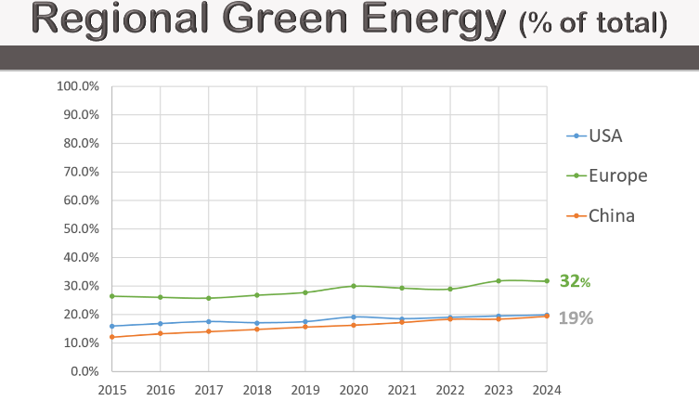
{*} The United States is also on track to decarbonize over 200 years,
{*} while Europe is at 125 years,
{*} and China at 100 years.
{video activism / thoughtful-woman}
And, all of this is too slow, to be helpful.
{video activism / a-tiny-snail} Okay, so why the snail-like pace?
Well, there are several reasons, which we will now review.

Climate Economics
{Pic 3x} In some cases,
{*} the green option costs less
{*} than the carbon option, and switching over is easy.
While in other cases, the green option costs more,
and switching over,
is less popular,
especially at large scales.
In these cases, the additional cost of the green product, {Pic Green P} is referred to as the “green premium.”
And, consumers tend to {Pic woman 2 hands} avoid this so-called premium.

Prisoner’s Dilemma
{Video: house / BBQ / 603914_Cooking_Skewers} This is because they do not benefit from
{SLOW} reducing their own emissions.
They’re {VERY SLOW} too small.
{Video: city / smog / Shenzhen-urban} Instead, harm comes from the {SLOW} collective emissions
{Video: city / ped / 98801_pedestrians_and_traffic} of our planet's {SLOW} eight billion people.
{Video: activism / successful-business-man-with-megaphone}
For this reason, {SLOW} each person, wants {SLOW} everyone else, to reduce.

Macroeconomics (competition)
Furthermore, companies
{Video: city / office bld / 605055_Clouds_Cityscape} need to compete with other companies,
{Video: city / highway / time-lapse-of-automobiles} and regions need to compete with other regions,
and they do not want
{video signs / money / frustrated-businessman} additional costs,
to make them less competitive.
In the end, climate action, is limited by, these economic constraints.
{video signs / money / coins-stack-increase} Okay, that’s **economics**.
Now, let’s look at {SLOW} **politics**.

Climate Politics
{Video gov't / flags-of-the-nations} Nations are dominated politically
{Video city / factory / food-processing-industry} by large industries
{Video activism / people-of-the-world} that employ millions of people.
Examples are,
{Pic 4x} the fossil fuel industry, {*} labor unions, {*} auto makers, {*} and factories.
{Video activism / Unrecogniazble-woman-putting-her-vote} Employees and their friends vote,
{Video economics / mans-hand-transmits} while employees and companies make political donations.
To connect the dots,
{Video gov’t / 166307_People_Business} lobbyists suggest to lawmakers that donations,
are contingent on support, for specific measures.
{Video: activism / 479180_Girl_Holding_Sign_Forest} Climate, in comparison, employs
{Video: signs / glowing-figure-with-info} few people, and is therefore, politically weak.
In a sense, {Pic gorilla} large industries are like political gorillas,
while {Pic monkey} climate is the small monkey.
And, as we know, the strong, sometimes take from, the weak.
For example, the U.S. Inflation Reduction Act
{Video: power / solar / aerial-view-of-large-solar} required builders of solar farms
{Video: power / solar / eco-friendly-solar-panel-manufacturing} to buy U.S.-made solar panels, to qualify for subsidies.
While this created factory jobs, it also raised the cost of solar farms —
ironically leading to higher carbon dioxide emissions.
In other words, labor hijacked the climate issue, for their own purposes.
The hard truth is,
climate is politically weak,
in part,
due to employing relatively few people.

The Global Warming Problem (“The Bathtub”)
Okay, so climate faces both, political and economic constraints.
But {SLOW} what would happen if this was not the case?
For example, what would happen if a $200 per ton, global tax,
was levied on carbon dioxide emissions?
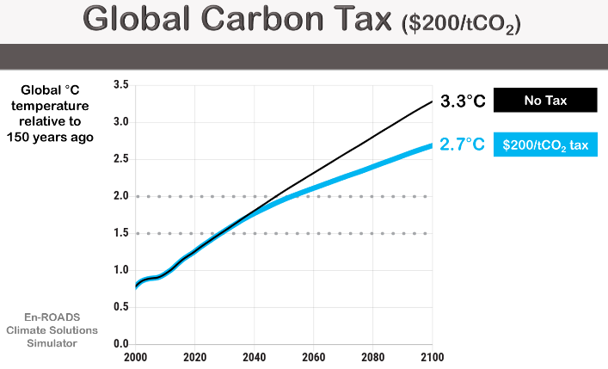
This would cost the world {Pic $5T} roughly 5 trillion dollars annually,
and it is not politically feasible
{En-ROADS shows this}.
Yet let’s ignore that for a moment,
and assess the impact,
this would have,
on the planet.
Well, according to the {Pic 4x En-roads} MIT climate solutions simulator,
we get runaway climate change
{*} both *with* this tax.
{*} and *without* this tax.
In other words, a massive worldwide tax on carbon, would not solve the problem.
This might seem confusing,
since we’ve been bombarded {Pic 4x Climate Message} with the following message:
{SLOW} Carbon dioxide emissions,
cause global warming,
{*} and eliminating these emissions,
{*} will solve the problem.
However, this is only slightly correct.

The Bathtub
Instead, {Pic 5x Causes} global warming is caused by
excess carbon dioxide in atmosphere,
that has been built up over 150 years,
plus methane emissions,
plus declining sea ice,
plus thawing permafrost,
etcetera.
{Pic Bathtubs} The climate problem is like a faucet, with several bathtubs.
{*} The faucet represents annual carbon dioxide emissions,
while {Pic 4 tubs} the water in the tubs represents global warming.
More specifically,
{{Pic circle faucet} the water at the faucet,
is proportional to the amount of carbon dioxide,
that is emitted,
into the atmosphere,
each year.
{Pic 4 tubs} While the combined water, in all the tubs,
is proportional to the increase,
in Earth’s temperature,
each year,
in units of degrees Celsius.
{Pic 1st tub} The water in the first tub,
is due to 150 years of **past** carbon dioxide emissions --
not one year’s emissions.
{Pic no circle} And the water in the other tubs is proportional to
{Pic 2nd tub} warming from methane emissions,
{Pic 3rd tub} warming from declining sea ice, and
{Pic 4th tub} warming from thawing permafrost.
{Pix Four tubs} Ultimately, multiple sources of warming, combine, and increase, the planet’s temperature.
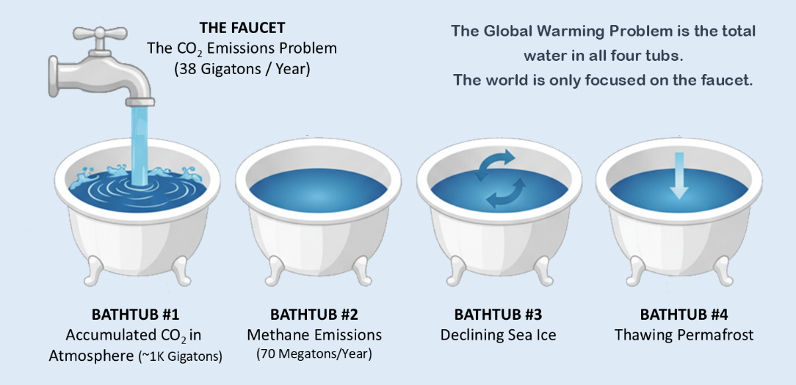

{Video activism / bottom-view-of-eco-activists} Global policy, media, and activism are all obsessed
with slightly turning down the faucet,
while completely ignoring the fact that
water **already** in the tubs, is what’s
{Video global w / city / 496570_Berlin} causing catastrophic global warming.
{Video earth / drought/ clear-skyline} So, while the planet heads towards disaster,
{Pic running} the people responsible for fixing it,
{Pic woman pushing boulder uphill} are trying to solve, the wrong problem.
{glenn\Documents\Manhattan2\projects\The Climate Solution FILM\
Climate Solution - MIT Freshman Feature Film} ALSO, see PowerPoint Slides.

The Climate Solution
{SLOW} Okay, let’s review the key points.
{tick 3 fingers} {f1} One, climate faces economic limitations.
{f2} Two, climate faces political limitations.
{f3} And, three, policymakers, are confused.
{Pic can’t sleep} Now, the situation might seem bad;
{Pic light bulb} however, {SLOW} there is a simple solution.
It is to think of the climate problem, as two problems,
{Pic people at board} and do R&D,
to the extent required,
to resolve each.
One problem,
is {bathtubs, faucet} carbon dioxide emissions,
while {bathtubs, tubs} the other,
is global warming.
We can {SLOW} solve the first problem,
{Pic girl at computer} by doing R&D,
{SLOW} to drive down the cost of 24/7 green energy,
{SLOW} to below that,
of fossil fuel.
Consumers, would then {SLOW} go green, {SLOW} to save money.
{Pic Videos 11…16 /drd} For details, see climate videos 11 through 17.
Low-Cost Nuclear Power [#11]
https://www.youtube.com/watch?v=AIlbovU67wI
Automated Nuclear Power Construction [#12]
https://www.youtube.com/watch?v=afO0cy1l7Qo
How to Make $10 Trillion Dollars [#13]
https://www.youtube.com/watch?v=4gqmKGV1h5Y
Fusion Moonshot [#14]
https://www.youtube.com/watch?v=CvZzGHSugy4
Green Cars: Swappable Batteries [#15]
https://www.youtube.com/watch?v=jY_jNQ77FA8
Next Generation Building Automation [#16]
https://www.youtube.com/watch?v=T_obb_z77co
Next Generation Solar Farms [#17]
https://www.youtube.com/watch?v=3aOSrsZD2MY
And we can solve the second problem, {SLOW} by doing R&D, {SLOW} to determine {Pic Reflect} how to reflect sunlight back into outer space, {SLOW} to cool the planet, {SLOW} to offset warming.
{Pic Videos 9...10 /rsv} For details, see videos 6 through 10.
The Climate Acceleration Problem [#6]
https://www.youtube.com/watch?v=6r3Xag24iOI
The Science of Global Warming [#7]
https://www.youtube.com/watch?v=Por9aWKLdc4
The Uncertainty of Climate Change [#8]
https://www.youtube.com/watch?v=HoqX7uBaeKU
Reflecting Sunlight [#9]
https://www.youtube.com/watch?v=AJ-ddFDiA4w
Can Air Pollution Save the Planet? [#10]
https://www.youtube.com/watch?v=p4O2hv9tSDA
As noted previously, climate involves, both political, and economic constraints.
However, these do not apply, to research and development.
This is because R&D can be funded by a small number,
of high-net-worth individuals,
foundations,
and governments.
And, reflecting sunlight,
would move forward,
if some time in the future,
{Pic 2 piles of money} reflecting,
was considered easier than,
not reflecting.
In other words,
{Video: activism / happy-children-holding-hands} a path forward exists,
{very slow} and it is not blocked, by politics, economics, or confused policymakers.
{Pic /v3} For details, see climate video number 3.
The Climate Lab Strategy [#3]
https://www.youtube.com/watch?v=9UlB_1wgpAo
Okay, that's it for me, and I'll talk to you all, real soon.

Video #20: Do We Need a $10B Climate Moonshot?

Links to Video
Do We Need a Climate $10B Moonshot?
https://www.youtube.com/watch?v=ihTGiOEKrns

Bill, What about getting involved in a Climate R&D Moonshot?
David, Perhaps we need a Climate R&D Moonshot?

https://www.youtube.com/watch?v=ihTGiOEKrns

Introduction
Hi, my name is Glenn Weinreb,
and today we're going to look at how to solve the climate problem,
with a surge,
in research,
and development.
Occasionally,
R&D is used,
to solve a problem.
For example, {Pic: power / fusion / JFK-speech-man-landing (sound off)}
in 1961,
President Kennedy,
stated he wanted a man on the moon,
by the end of the decade.
In response, {Video: power / fusion / NASA-vehicle-assembly-building}
a program,
was set up,
and funded.
In theory,
a so-called **moonshot**,
like this,
could be initiated,
for climate change.
But what might be developed,
and how much,
might it cost?
Well,
that’s what we’re going to look at,
today.

What is a Climate Moonshot?
Before we begin,
we’re going to define,
several terms.
{Pic Definition} We define “Climate Moonshot” as:
Conducting R&D,
to the extent required,
to solve the **entire**,
climate problem.
And, we {Pic …} define, “solving the problem” as,
{Pic …} preventing the collapse of sea ice,
{Pic …} preventing the collapse of ocean currents,
{Pic …} preventing the collapse of the west Antarctic ice sheet,
{Pic curve} and bending the global warming curve,
so that the Earth’s temperature,
peaks,
and then,
drops back down.
To achieve *ALL* of these objectives,
our moonshot does,
*two things*.
One,
it does R&D,
{Pic Green/Fuel} to drive down the cost of 24/7 green energy,
to below that,
of fossil fuel.
And two,
it does R&D,
to determine {Pic Reflect 1%} how to reflect sunlight,
back into outer space,
to cool the planet,
and offset global warming.
Obviously,
we would want to do this,
at a reasonable cost,
and without harm.
It is worthing noting,
{Pic Guy} many people are nervous,
about reflecting.
Also, {Pic bullets}
to prevent runaway climate change,
we probably need to {*} reflect,
approximately 1% of sunlight,
within 15 years,
near the {*} North,
and South poles.
And, in theory, this can be {Pic big spray plane} done by spraying gases,
with reflective properties,
into the upper atmosphere.
{Pic skeptical woman}
But how much might this cost?
{Pic Wake Smith} Well,
according to one study,
reflecting might cost,
tens of billions,
of dollars,
annually.
This might seem expensive,
however,
it might be,
the lowest cost way,
{Pic dominos} to prevent,
runaway climate change.

Moonshot Strategy
An R&D moonshot,
would probably be funded by people,
who want to use their money,
to save the planet,
from climate change,
as opposed to investors,
who seek,
a financial return.
Planet saving,
and investing,
differ,
in multiple ways.
Candidates,
for moonshot sponsorship,
include,
high-net-worth individuals,
foundations,
and governments.
In theory,
sponsors,
could require produced materials,
be placed on the internet,
for open review.
Open-source,
often saves time,
and money,
since it reduces,
inaccurate claims.
{Pic people at board} When doing R&D,
small money,
is spent before medium money,
and medium,
before large.
For example,
within a moonshot initiative,
1 million dollars might support proposal writing,
10 million might support doing detailed design work,
and 100 million,
might support building prototypes.
Ultimately,
{Pic billions} we need to think about how to spend billions of dollars,
to save trillions.
And,
for *no* money,
one person,
or one group of people,
can design a moonshot program,
by putting together,
a list of things,
to develop.
In other words,
they can {Pic Moonshot Question} focus on the following question:
What is a list of things,
{*} that if developed,
{*} solve the entire,
{*} climate problem?
{Pic /bp} For an example list,
click on the link,
in the description below.
It is possible,
perhaps probable,
a climate moonshot,
is the ONLY way,
to solve,
the climate problem.
{Pic /v19} For a video that explores this concept, visit the link, shown here.
The Climate Solution is More R&D [#19]
https://www.youtube.com/watch?v=LGPGiIDZoDA Video
https://ma2life.org/g/video/Video19_Script.pdf Script
What is The World’s Climate Plan? [#21]
https://www.youtube.com/watch?v=9-nU31iTTUo Video
https://ma2life.org/g/video/Video21_Script.pdf Script

Example Moonshot
We’re now going to examine,
an example moonshot,
program.
This is not being done,
however,
it could be done.
{Pic $10B example} Our example costs
10 billion dollars,
over 5 years.
And, it divides the climate problem,
into 10 different research areas,
with roughly 1 billion dollars,
devoted,
to each.
The initial phase,
costs 10 *million* dollars,
and it supports
writing proposals,
designing machines,
and developing experiments.
Now let’s review,
the 10 research areas,
one at a time.

Moonshot Area I: Improve Climate Models
{SLW} We need to calculate,
{SLW} how much sunlight needs to be reflected,
{SLW} from where,
{SLW} and when.
And to do this,
we need *better* climate models.
And to get these,
we need {video reflect / 6397313_Clouds_Nimbus} to conduct,
experiments on clouds,
{Pic Reflect off city arrows} and we need to measure how much sunlight,
reflects off,
air pollution.
{Pic /CSS} For details on clouds, visit the link, shown here.
$250M Cloud Research Surge (PDF)
https://ma2life.org/g/eet/eetcs_plan/decarb_plan/cloud_science_surge_ChatGPT.pdf
{Pic /v8} And for details on pollution, see video number 8.
The Uncertainty of Climate Change [#8]
https://www.youtube.com/watch?v=HoqX7uBaeKU

Moonshot Area II: Conduct Reflectivity Field Experiments
Sulfur occurs naturally {Pic coal and oil} in coal and oil,
and is therefore {Video: smoke / chimney-smoke-from-enterprise}
emitted into the atmosphere,
when these fuels,
are burned.
In principle,
{Pic filter} it could be extracted before combustion,
{Pic truck} moved to an airplane,
{video reflect / passenger-jet-flying} and emitted into the upper atmosphere,
{Pic bus exhaust} instead of being emitted,
at ground level.
Sulfur in the Upper atmosphere,
stays aloft for one to two years,
while sulfur emitted at low altitudes,
typically stays aloft for only hours to days.
Also, sunlight reflects off, sulfur.
Therefore,
changing the emissions site,
reduces the planet’s temperature,
while not increasing,
total sulfur emissions.
To better understand this,
we need to develop airplanes,
that emit material,
into the upper atmosphere,
and then monitor,
that material,
for days to weeks.
{Pic Videos 9...10 /RSV} For details, see videos 6 through 10.

The Climate Acceleration Problem [#6]
https://www.youtube.com/watch?v=6r3Xag24iOI
The Science of Global Warming [#7]
https://www.youtube.com/watch?v=Por9aWKLdc4
The Uncertainty of Climate Change [#8]
https://www.youtube.com/watch?v=HoqX7uBaeKU
Reflecting Sunlight [#9]
https://www.youtube.com/watch?v=AJ-ddFDiA4w
Can Air Pollution Save the Planet? [#10]
https://www.youtube.com/watch?v=p4O2hv9tSDA

Moonshot Area III: Develop Large Automated Spray-Plane
To control global warming,
we probably need large airplanes,
that can emit,
100 tons of material,
every several hours.
And,
to do this at a reasonable cost,
we probably need a system,
that supports automated flying,
automated refueling,
and automated reloading.
And,
we probably need 100 to 200,
of these automated airplanes.
But before we build hundreds of planes,
we need to build 1.
In other words,
{video scientists / 6280804_Engineers} we need to design,
{video reflect / team-of-aircraft} and prototype,
an automated system,
{video reflect / klm-boeing-777} that supports *one* *large* spray plane.

Moonshot Area IV: Automate Nuclear Power Construction
Okay,
so the first 3 billion dollars of R&D,
sets us up,
to reflect sunlight.
Eventually,
{Video gov’t / businessman-meditating} future leaders,
would need to compare,
reflecting,
with,
not reflecting.
**Also**, {video smoke / 568237_Chimney} we have a carbon dioxide emissions problem.
And,
to transition to a green economy,
we need to reduce the cost of 24/7 green energy,
to below that,
{video fossil fuel / coal / truck} of fossil fuel.
Fortunately, this is easy.
We just need to automate {pic nuclear power construction},
the construction,
of nuclear power plants.
More specifically,
we need to develop,
custom machines,
that build these sites.
And,
this would cost little,
{Pic Hinkley} compared to the cost of a nuclear power plant.
{Pic /drd} For details, see videos 11 through 13.

Low-Cost Nuclear Power [#11]
https://www.youtube.com/watch?v=AIlbovU67wI
Automated Nuclear Power Construction [#12]
https://www.youtube.com/watch?v=afO0cy1l7Qo
How to Make $10 Trillion Dollars [#13]
https://www.youtube.com/watch?v=4gqmKGV1h5Y

Moonshot Area V: Co-locate Chemical Processing with Nuclear Power
{pic beakers} To make chemicals without emitting carbon dioxide,
at a cost less than the traditional approach,
we need to co-locate,
{video power / nuclear / chemical-production-facility} chemical processing equipment,
{video power / nuclear / aerial-view-to-nuclear} with low-cost,
nuclear reactors.
More specifically,
we need to develop standards that define how this fits together.
And, to reduce the cost of the processing equipment,
we need to develop a transportation system,
{pic platform} that moves large platforms of chemical processing equipment,
{pic factory} from a shipyard or factory,
{video power / nuclear / factory-nuclear-power} to a nuclear power site.
{Pic /v11} For details, see video, number 11.
Low-Cost Nuclear Power [#11]
https://www.youtube.com/watch?v=AIlbovU67wI

Moonshot Area VI: Achieve Economic Fusion
[Pic 3x Fission vs. Fusion] There are primarily two types of nuclear power: fission and fusion.
[Video: power / fission / aerial-drone-view-of-Doel-nuclear] Fission is the traditional form,
that generates electricity with uranium fuel.
[Pic 5x fission problems] However,
this is not popular,
due to meltdown risk,
nuclear waste,
proliferation risk,
and cost.
{Pic fusion} Fusion,
on the other hand,
does not have these issues;
[Video: science / two-men-with-the-tablet-standing} however,
it is still in development.
In theory, we can accelerate this development,
with a surge in funding.
{Pic /v14} For details, see video number 14.
Fusion Moonshot [#14]
https://www.youtube.com/watch?v=CvZzGHSugy4

Moonshot Area VII: Develop Next Generation Solar Farm
In theory,
we can reduce the cost of solar power,
by developing a technique,
{Pic solar farm} for placing solar material,
directly,
onto soil.
{Pic /v17} For details, see video number 17.
Next Generation Solar Farms [#17]
https://www.youtube.com/watch?v=3aOSrsZD2MY

Moonshot Area VIII: Develop Green Standards
{SLW} In a green new world,
{SLW} we need more standards,
{SLW} that define how things fit together,
{SLW} mechanically,
{SLW} electricity,
{SLW} and with communications.
This includes
{Pic devices} standards for devices in automated buildings,
{Pic EV} standards for swappable EV batteries,
{Pic ship} and standards for ships powered by liquid ammonia.
{Pic /grd} For details, visit the links, shown here.

Green Cars: Swappable Batteries [#15]
https://www.youtube.com/watch?v=jY_jNQ77FA8

Next Generation Building Automation [#16]
https://www.youtube.com/watch?v=T_obb_z77co

Moonshot Area IX: Develop Vertical Tunnel Boring Machine
To extract underground geothermal energy,
at a low cost,
{Pic TBM} we need vertical tunnel boring machines,
{SLW} that operate,
{SLW} at high temperatures.
{Pic /grd} For details, visit the link, shown here.
Geothermal Moonshot (e.g. high temperature vertical tunnel boring machine)
https://ma2life.org/g/eet/eetcs_plan/decarb_plan/geothermal_conversation.pdf

Moonshot Areas X: Develop Policy Making Tools
In theory, we can build
{SLW} a website,
{SLW} that creates climate plans,
{SLW} based on requirements,
{SLW} specified by the website user.
This would allow policymakers,
and concerned citizens,
to get a better sense,
of how to fix climate,
at the lowest-cost.
{Pic Video 4-5} For details, see climate videos 4 and 5.

What is Our Climate Plan? [#4]
https://www.youtube.com/watch?v=aTzmZGHa9EM
What does a Climate Plan Look Like? [#5]
https://www.youtube.com/watch?v=IZLFWarYlbw

Are We Ready for a Climate Moonshot?
{SLW} A surge of R&D,
{SLW} in key areas,
{SLW} can probably solve,
{SLW} the climate problem.
And,
{SLW} it can get started,
{SLW} for roughly 10 million dollars.
{video activism / three-siblings-playing-and-having-fun-in-a-golden-field} Yet most importantly,
a path forward exists,
and it is not blocked,
by politics,
or financial constraints.
Okay, that's it for me, and I'll talk to you all, real soon.

References
Sunlight Reflectivity Field Experiments (PDF)
https://ma2life.org/g/eet/eetcs_plan/decarb_plan/arctic_sai_experiment.pdf

$250M Surge in Cloud Research (PDF)
https://www.aplantosavetheplanet.org/css

Experiments that Measure How Much Sunlight Reflects off Aerosols (PDF)
https://www.aplantosavetheplanet.org/ae

Conversation with AI: Cloud Experiments
The Earth’s albedo changed 1.7W/m² over last 25 years, and the average global temperature changed 0.6°C. James Hansen believes 1W/m² out of the 1.7W/m² is due to cloud changes. Yet the AR5 and AR6 climate models assume clouds change 0.42W/m²/°C, and this is one-fourth of what we observe (1W/0.6°C = 1.6W/m²/°C). In other words, cloud changes exceed that predicted by climate models. What experiments do we need to conduct, to better understand clouds?
Assume you have $250M to spend over 5 years ($50M/yr on average), and you are to improve our understanding of clouds. What would you do?
What might this accomplish?
https://grok.com/c/5461d986-21d1-4fc5-b78d-b35bcf9b970c?rid=a02d9c3e-a29b-4ee8-bcee-bf8b556715c0
https://gemini.google.com/app/4ac7f51c85744772
https://chatgpt.com/c/69554bfe-d75c-832e-980b-88e8ad0a3fc4

Video #21: What is the World’s Climate Plan?

Introduction
{G} Hi, my name is Glenn Weinreb,
and today we’re going to look at the {NG}
{video gov’t / un / Geneva-Switzerland} United Nations’ strategy,
for tackling climate change.
{G} In 1988,
they set up a group of scientists, {NG}
{video scientist / close-up-of-business} to study the climate problem,
and suggest,
solutions.
{G} They named this group {NG}
{Pic IPCC Logo and name} The Intergovernmental Panel,
on Climate Change (IPCC),
{G} and tasked them,
with publishing reports,
every 6 to 7 years. {NG}
{Pic 2 reports} This includes {Pic Science Report} a Science Report,
that estimates,
the average global temperature,
over the next 75 years.
And a {Pic Mitigation Report} Mitigation Report,
that suggests ways,
to reduce,
global warming.
REFERENCE: https://en.wikipedia.org/wiki/IPCC_Sixth_Assessment_Report
{G} The primary method,
is called “Decarbonization”,
and typically {NG}
{Pic Decarbonization} involves replacing coal, oil and natural gas;
which solar, wind, hydro and nuclear power.
{G} The intent of this video,
is NOT to advocate,
for a specific policy,
but instead, {NG}
{Pic 2 report covers} to summarize their reports.
REFERENCE
https://en.wikipedia.org/wiki/Intergovernmental_Panel_on_Climate_Change
Documents\Manhattan2\Non-Profit_Organizations\IPCC\AR6 IPCC Reports\AR6, Working Group 3
https://ourworldindata.org/co2-and-greenhouse-gas-emissions

The United Nations Science Report
{Pic Programmer at keyboard} Climate scientists,
have developed software,
that estimates,
{Pict earth temperature graph} future,
global temperatures,
given,
{Video smoke / smoking-factory} future,
carbon dioxide emissions.
{Pic GCM} This software is referred to as a,
Global Climate Model,
and,
it is the basis,
{Pic Science Report} for their 2400-page,
Science Report.
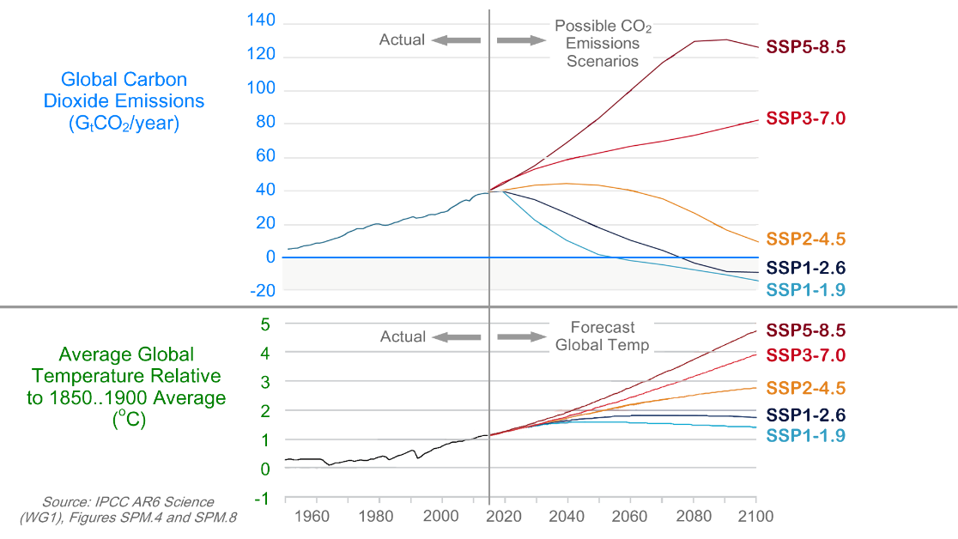
{G} The climate models,
evaluate so-called {NG}
{Pic two graphs} SCENARIOS,
FIVE of which,
are shown here.
Each SCENARIO,
includes,
{*} a carbon dioxide emissions plot,
and,
{*} a global temperature plot.
{*} Carbon dioxide emissions,
are specified in units of,
{*} billions of tons,
of carbon dioxide gas,
emitted into the atmosphere,
each year.
{*} And,
global temperatures,
are specified,
in units of,
{*} degrees Celsius INCREASE,
over the last,
150 years.
{*} As one can see,
global temperatures in three scenarios,
{*} just keep {Pic up} going up,
{*} while two scenarios,
{*} are more,
well behaved.
{G} Good behavior,
involves “bending-the-curve,” {NG}
{*} which refers to,
temperatures {*} that peak,
and {*} then,
drop back down.
{*} This is in contrast,
to {*} temperatures that {*} just,
runaway.
{Pic labels} Each scenario,
is labeled,
and,
as one can see,
{*} scenario 2.6 {*} is good,
while 4.5,
{*} is bad.

Scenario 2.6
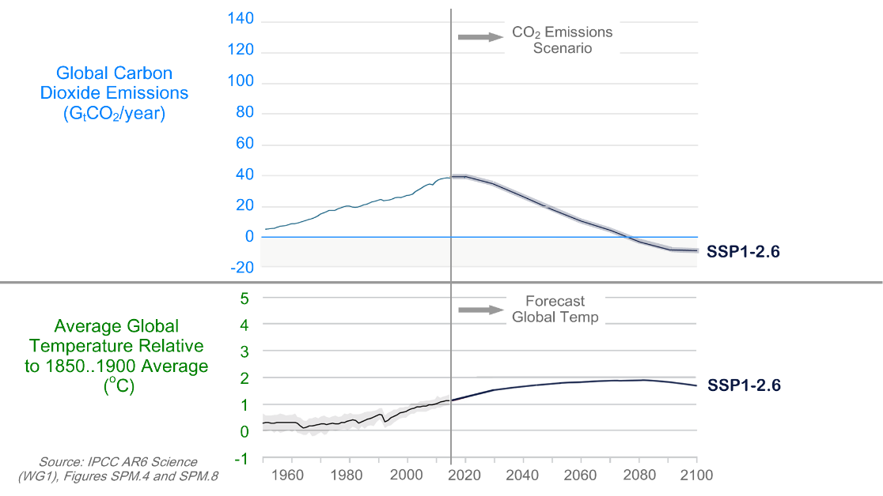
{Pic 2.6} We’re going to focus on 2.6,
since it is the easiest way,
{*} to bend-the-curve.
{*} In 2.6,
{*} carbon dioxide emissions {*} reach {*} zero,
within roughly 50 years,
{*} and then go,
negative.

Direct Air Capture
{*} Negative refers to pulling carbon dioxide gas out of the atmosphere,
{*} while positive,
refers to,
putting it in.
{*} Pulling it out is called,
“Direct Air Capture”,
{*} or D A C,
for short.
{*} Scenario 2.6 suggests,
there are two phases,
when dealing with,
climate change.
{*} ONE is decarbonization,
while {*} the other is,
Direct Air Capture.
{*} And,
the first phase is easier than {*} the second,
since {*} it costs less.

$8T/year DAC
{Pic Girl Calculator} Ok, but by how much?
{*} Well,
{*} this tiny blip,
refers to {*} extracting 8 billion tons,
of carbon dioxide,
out of the atmosphere,
each year.
{Pic $8T math} Removing {*} one-ton,
typically costs 1000 dollars.
Therefore,
{*} removing 8 billion tons a year,
{*} would {**slow**} cost,
8 trillion dollars,
annually.
{Pic Guy scratching head} To make this easier to comprehend,
we will compare this to,
to the global cost of,
fossil fuel.
{Pic fuel} Each year,
the world typically {*} spends 2.5 trillion dollars on oil,
{*} 1 trillion on coal,
and,
{*} a half trillion,
on natural gas.
{Pic $4T} The total {*} is 4 trillion,
{Pic storm girl} which is half the 8 trillion,
needed for,
Direct Air Capture
{G} In other words,
Direct Air Capture,
is probably,
prohibitively expensive. {NG}

The Global Warming Problem
{G} We’ve been bombarded, {NG}
{*} with the following message:
{SLOW} Carbon dioxide emissions,
cause global warming,
{*} and eliminating these emissions,
{*} will solve,
the climate problem.
{G} However,
this is only,
SLIGHTLY correct. {NG}

The Bathtub Problem
{Pic 5x Causes} Instead,
global warming is caused by
the excess carbon dioxide,
in atmosphere,
that has been built up,
over the last 150 years,
plus methane emissions,
plus declining sea ice,
etcetera.
{Pic Bathtubs} The climate problem,
is like a faucet,
with several bathtubs.
{*} The faucet,
represents annual,
carbon dioxide emissions,
while {Pic 4 tubs} the water in the tubs,
represents global warming.
More specifically,
{Pic circle faucet} water flow,
from the faucet,
is proportional,
to the amount of carbon dioxide,
emitted,
into the atmosphere,
each year.
{Pic 4 tubs} While the combined water,
in ALL the tubs,
is proportional,
to the increase,
in Earth’s temperature,
each year.
{Pic 1st tub} The water in the *FIRST* tub,
is due to 150 years of,
**past** carbon dioxide emissions.
Not one year’s emissions.
{Pic no circle} And the water in the other tubs,
is proportional to
{Pic 2nd tub} warming from,
methane emissions,
{Pic 3rd tub} warming from,
declining sea ice,
etcetera.
{Pix Four tubs} Ultimately,
multiple sources of warming,
combine,
and increase,
the planet’s temperature.
{Video activism / street-protest} Global policy, media, and activism are all obsessed
{no circle} with slightly {faucet} turning down the faucet,
{no circle} while completely ignoring the fact that
{4x tubs} water **already** in the tubs, is what’s
{Video global w / city / 496570_Berlin} causing
catastrophic global warming.
{Pic blip} And the water in the tubs,
shows up,
as {*} a tiny blip,
on a graph,
which refers {*} to,
draining water,
from the first tub.

Climate Models Are Not Accurate
{G} As noted previously,
climate scientists,
have developed software that estimates, {NG}
{*} future,
global temperatures,
given,
{*} future,
carbon dioxide emissions.
{G} And,
unfortunately, {NG}
{Video: activism / silhouette-of-tired-businesswoman} this software is NOT accurate.
{G} We know this,
because it does not predict,
what we see, {NG}
{Pic satellites} with instruments.
For example,
{Pic albedo} the amount of sunlight,
that reflects off,
the top of the atmosphere,
{Pic arrow} has changed significantly,
over the last,
25 years.
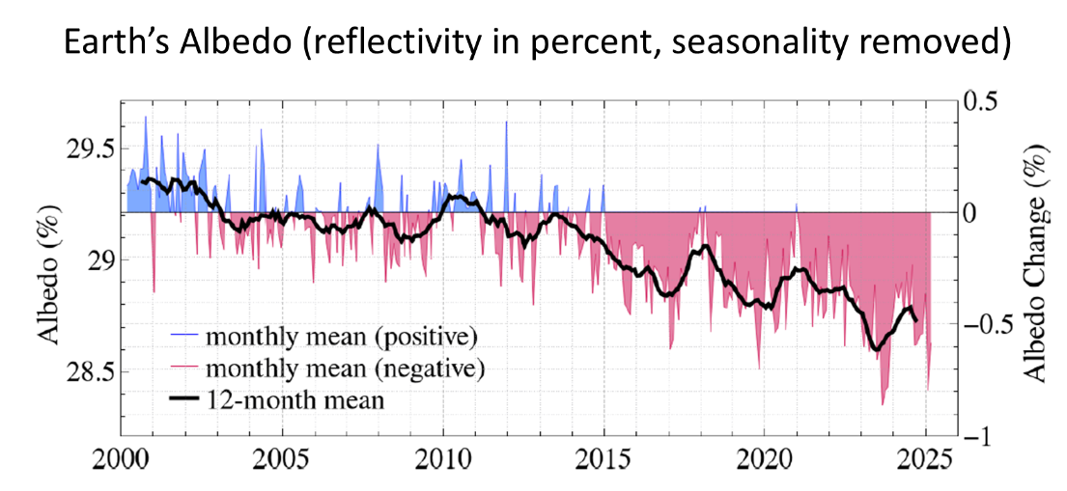
{G} And,
this was NOT predicted,
by global climate models.
More specifically, {NG}
{video signs / clocks-spiral-tunnel} they underestimate,
the speed,
{video primal earth / primal-earth-images} at which our planet,
is changing.
{*} In other words,
producing
{*} this temperature profile,
{*} requires getting to zero emissions,
sooner,
than that shown here.
And {*} requires more,
Direct Air Capture,
than that shown here.

More money for Research
{G} Ok,
so if the climate models are bad,
does that mean, {NG}
{*} the scientists are bad?
{G} I don’t think so.
{G} Instead,
I think
the problem is, {NG}
{video signs / money / money-makes} the lack of financial support,
for key experiments.
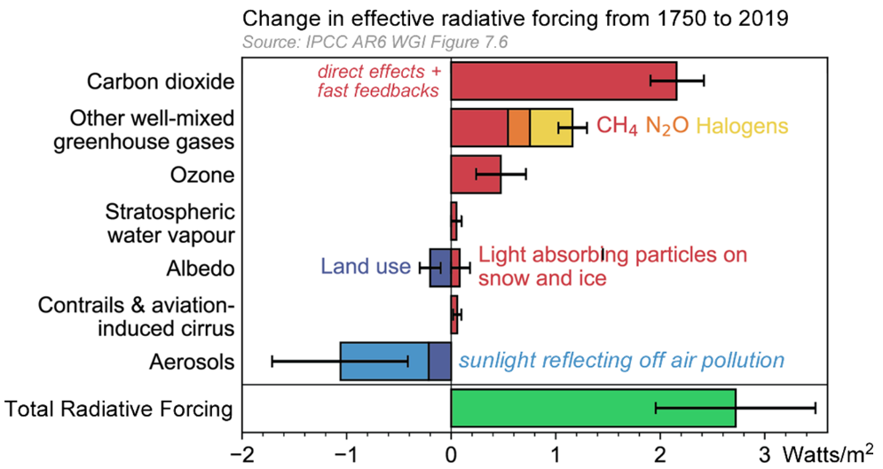
{G} Here’s an example. {NG}
{Pic RF} This graph,
{*} shows components,
of global warming,
that sum together,
to {*} produce,
TOTAL warming.
And, {*} the blue bar,
indicates how much sunlight,
reflects off,
air pollution.
This offsets global warming,
with cooling.
And,
{*} the magnitude of this parameter,
{*} is unknown,
since it has never been,
measured.
Only estimated.
And this is why {*} we see,
the large error bar.
{G} Ok, so what does,
all of this,
mean? {NG}
{video / signs / money / closeup-of-unrecognizable} Well,
it means
we are not quantifying,
global warming.
{*} And this leads to,
{*} inaccurate,
graphs.
{Pic v8} For details, see Video Number 8.
The Uncertainty of Climate Change [#8]
https://www.youtube.com/watch?v=HoqX7uBaeKU

United Nations Mitigation Reports
{G} In 2022,
the United Nations’ Climate Panel,
published a {NG}
{Pic Mitigation cover} 2000-page report,
that lists,
different ways,
to reduce,
global warming.
{Pic SPM.7, Ar6_WgIII_SummaryReport_Fig_SPM.7.PNG} They summarize,
with this chart,
that shows 42 different,
techniques.
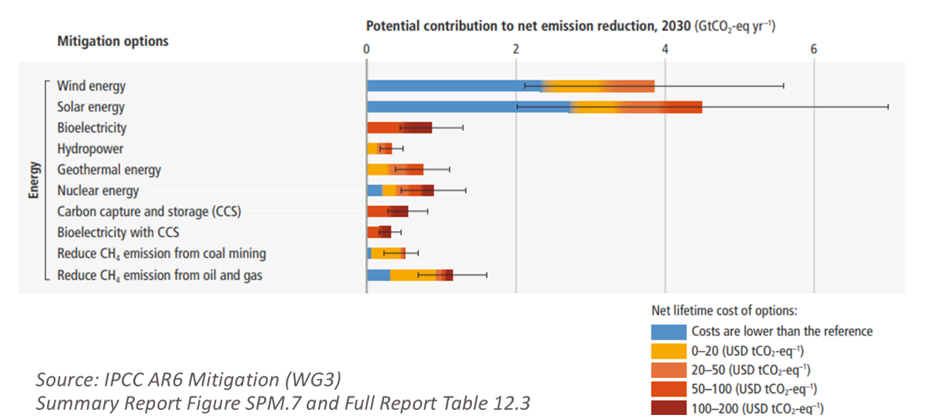
To make this easier to see,
we focus,
on {*} the top,
of their chart.
Each {*} technique,
is summarized with a bar,
{*} where the length of the bar,
indicates,
the maximum possible decarbonization amount.
{*} And,
the color,
indicates,
the cost.
{*} Decarbonization {*} potential,
is specified in units of billions of tons,
of annual,
carbon dioxide emissions,
reduced.
And {*} cost,
is specified in units of,
dollars per ton,
of carbon dioxide.
{*} In the color chart,
{*} blue refers to negative cost,
which means one saves money,
when they reduce,
carbon dioxide emissions.
{*} Yellow refers to,
0 to 20 dollars cost,
per ton,
of carbon dioxide reduced.
{*} And orange refers to,
20 to 50 dollars,
per ton.
{G} Let’s focus on one bar,
to get a better sense,
of how this works. {NG}
{*} Roughly 4 billion tons,
of annual carbon dioxide emissions,
can be ELIMINATED,
{*} by building,
solar farms.
This {*} includes 2.5 billion tons,
at no cost.
And {*} a half billion tons,
at a 0-to-20-dollar per ton cost.
Also,
{*} there is a limit,
to how many solar farms,
one can build.

The Saturation Problem
{video power / solar / Two-Workers} When building up solar power,
{video power / solar / solar-panels-produce} the amount of electricity from solar panels eventually exceeds
{video city / power meter / analog-electricity-meter} the amount of electricity consumed by customers,
{Pic sunny} when sunny.
{G} If one builds further, electricity is discarded, due to supply from solar, exceeding demand. {NG}
{Pic saturation} This is referred to as “solar saturation,” and at this point, solar construction stops.
{video power / solar / something…} Ultimately, there is a limit to how much decarbonization, can be achieved, with solar power.
{video power / wind / 124751_wind_turbine} The same applies, to wind power.
{G} Ok, so what impact would,
solar saturation have on,
GLOBAL carbon dioxide emissions? {NG}
{Video: signs / money / footage-of-young} Well, let's quantify.
{video global warming / cloud-sky-time} The sun burns bright,
about 6 hours,
out of every 24,
{G} which means we can get roughly 25%,
of our electricity,
from solar power. {NG}
{video power / coal / aerial-view-shows} And,
roughly one-third,
of carbon dioxide emissions,
are from,
electrical power generation.
{G} Therefore, building up solar, {NG}
{Pic 1/12 = 1/4 ✖ 1/3} until saturation,
would decrease,
global carbon dioxide emissions,
{*} by approximately 8%.
{G} The Mitigation Report,
came up with,
a similar,
conclusion. {NG}
{*} They estimate maximum decarbonization,
due to {*} solar,
to be {*} 4 gigatons out of 60,
which is about 8%.
{*} And a similar situation exists,
with,
{*} WIND power.
{G} In summary,
solar and wind are helpful,
yet only,
SLIGHTLY. {NG}

30-Year Decarbonization
{Pic Report Cover} The Science Report,
{2.6} suggests we should {*} decarbonize to {*} zero emissions,
and then {*} do,
Direct Air Capture.
{*} While the Mitigation Report,
is {*} telling us,
{*} how much,
this would cost.
We can merge these two,
by {Download} downloading their data,
and plotting,
global decarbonization costs,
vs. time.

Graph Assumptions
{G} This entails,
several,
assumptions. {NG}
{*} One.
We assume decarbonization occurs at {*} a constant rate,
followed {*} by,
Direct Air Capture.
Two.
We assume {*} emissions decrease,
1/30th per year,
{*} to get to zero,
{*} 30 years from now (as shown in below graph).
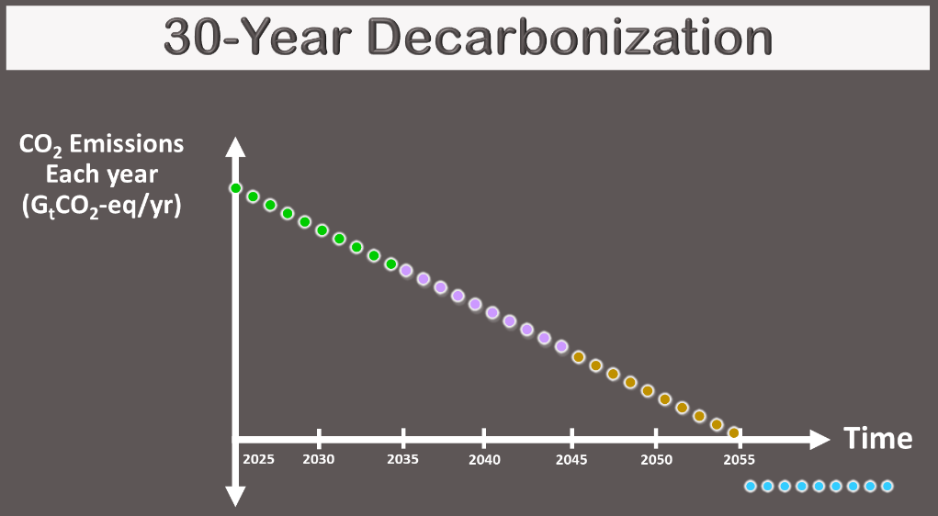
And three.
{*} We assume decarbonization occurs,
{*} in lowest cost order,
with {*} the easiest being tackled first,
followed by,
the,
{*} less easy.
To get a sense,
of how this unfolds over time,
we plot {*} each decade,
{*} with a different {*} color.
{G} Their data covers,
40 billion tons,
out of a possible,
60 gigaton equivalents. {NG}
{*} Which means,
they are {*} giving us cost data,
{*} for the first 20 years,
of a 30-year,
decarbonization.
{*} The resulting,
global costs,
are shown here.
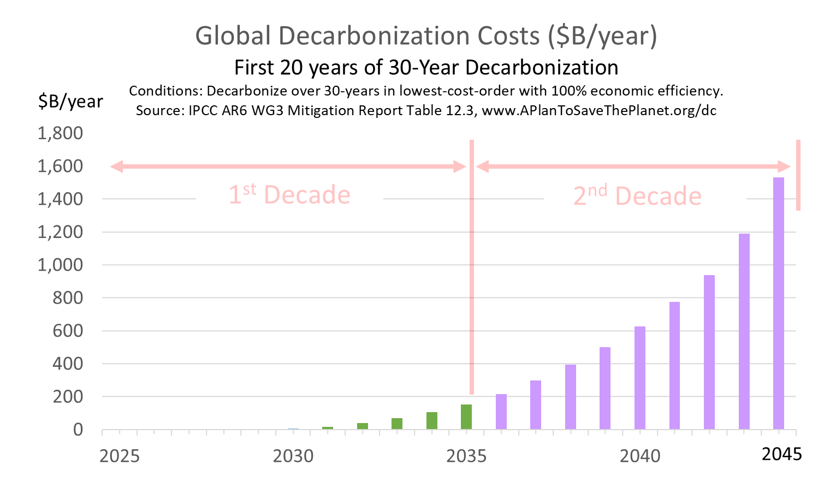
As one can see,
{*} the early years are easy,
while {*} the later years,
are,
less easy.
More specifically,
{*} the first 5 years,
have no cost,
{*} since this is referenced,
in their report.
{*} Also,
as one can see,
{*} costs increase,
EXPONENTIALLY.
{*} This is bad,
and this will be addressed later,
in this,
video.
{G} In theory,
research can reduce the cost of Direct Air Capture,
from,
the current 1000 dollars per ton,
to
400 dollars per ton. {NG}
{*} Therefore,
to get {*} 3rd decade costs,
{*} we can extrapolate,
and limit to 400 dollars.
{*} Followed by,
Direct Air Capture.
The result,
in a sense,
is the world’s,
climate plan.
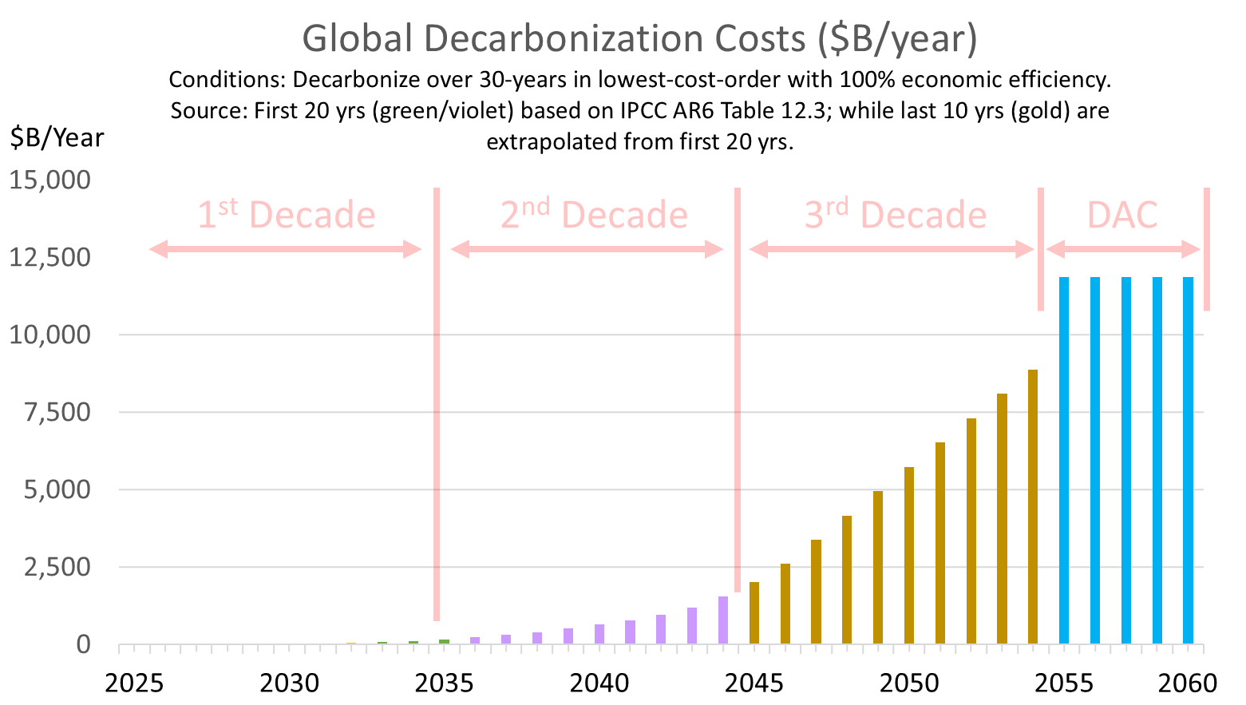
And,
unfortunately,
it has several,
problems.
Problem number 1 {*} is,
these costs,
are prohibitively expensive.
And problem number 2 is,
no one is willing to pay {*} these costs,
even when {*} they are low.
We know this,
{*} because GLOBAL carbon dioxide emissions,
{*} keep going up.
{G} To better understand this,
we need to look at who might pay these costs, {NG}
{Video: signs / money / unrecognizable-wealthy-Caucasian} and WHY,
they might refrain,
from doing so.
{*} There are three primary sources,
of decarbonization money.
These are
{*} individual consumers,
{*} companies,
{*} and governments.
{G} So,
let’s examine,
each of these,
one at a time. {NG}

Individual Consumers
{Video: house / BBQ / woman at grill} Individual consumers,
do not benefit,
{SLOW} from reducing,
their own carbon dioxide emissions.
They are {VERY SLOW} too small.
{Video: city / highway / futuristic-urban-architecture} Instead, harm comes from, the {SLOW} collective emissions
{Video: city / pedestrians / silhouettes-of-a-crowd} of our planet's {SLOW} eight billion people.
{Video: activism / businessmen-talking}
For this reason, {SLOW} each person, wants {SLOW} everyone else, to reduce.
{G} In other words,
we cannot expect individual consumers,
to pay more for green products.
Especially,
at large scales. {NG}

Companies
{G} We often encourage companies,
to reduce,
their emissions. {NG}
{Video: gov't / pensive-senior-businessman} But in practice, they face two choices.
{G} They can either decarbonize for real,
at high cost. {NG}
{Video: activism / irritated-woman-shows} Or, they can appear to decarbonize,
at less cost.
{Video: economics / stocks / motion-graphic-of} For publicly traded companies,
spending more on climate action,
usually means lower profit,
which can push stock prices down.
{Video: economics / CEO / thoughtful-man-look} But CEOs,
are expected,
to do the opposite.
{Video: economics / stocks /business-finance-technology} They are expected to increase profit,
and increase stock price.
So many respond {Video activism / Moscow-Russia-august} with token climate efforts,
designed to look good,
while keeping costs low.

Governments
{Video gov't / world-countries-combine} Nations are dominated politically
{Video city / fuel / oil / aerial-view-of-vaporizing} by large industries
{Video activism / people-of-the-world} that employ millions of people.
{G} Examples are, {NG}
{*} the fossil fuel industry, {*} labor unions, {*} auto makers, {*} and factories.
{Video activism / Unrecogniazble-woman-putting-her-vote} Employees and their friends vote,
{Video signs / money / cartoon-fantasy-100} while employees, and companies, make political donations.
{Video gov’t / the-business-team} To connect the dots,
lobbyists suggest to lawmakers,
that donations,
{G} are contingent,
on support,
for specific measures. {NG}
{Video: wind / portrait} Climate, in comparison, employs few people,
{Video: activism / two-brothers-sit} and is therefore, politically weak.
In a sense, {{Video: econ / gorilla / knuckle-gorilla} large industries are like political gorillas,
while {Video: econ / gorilla / adorable-monkey} climate is the small monkey.
{Video: activism / pro-wrestler} And,
as we know,
the strong,
sometimes take from,
the weak.
For example, {NG}
{Capital} the U.S. Inflation Reduction Act
{Video: power / solar / aerial-view-of-large-solar} required builders,
of solar farms
{Video: power / solar / eco-friendly-solar-panel-manufacturing} to buy U.S.-made solar panels,
to qualify,
for subsidies.
{G} While this created factory jobs,
it also raised the cost of solar farms — {NG}
{Video: reflect / carbon-dioxide-co2} ironically leading to,
higher carbon dioxide emissions.
{G} In other words,
labor hijacked,
the climate issue,
for their own purposes. {NG}
{Video: gov't / congressman-with-colleagues} It turns out,
only a tiny percentage of CLIMATE money,
that passes through GOVERNMENT,
{*} pays for
{*} lowest-cost,
decarbonization.
{G} For example,
the European,
carbon tax,
raises roughly 46 billion dollars a year. {NG}
{video / smoke / smoking-chimneys} And,
their emissions,
would decrease,
{video / signs / money / frustrated-businessman} roughly 2 to 1,
**IF**,
100% of that money,
{*} went to {*} lowest cost,
decarbonization.
{video / smoke / air-pollution-problems} However,
we observe,
little change,
in their emissions.
{Video / gov’t / capitolus-dc-11032019}
The United States
Inflation Reduction Act,
{*} had a similar outcome.
{G} What does all this mean? {NG}
{*} Well,
if a monkey wants fruit,
controlled by gorillas,
he cannot expect,
much generosity.
{G} This is sometimes referred to {NG}
{*} as “The Political Gorilla problem.”
REFERENCES
https://chatgpt.com/g/g-p-679d2bb5b304819198acec1a2830d008-energy-and-climate/c/69dfdc89-8ff0-83ea-a5c8-a36bad383991
https://ourworldindata.org/co2-emissions#:~:text=Carbon%20dioxide%20emissions%20are%20the,of%20contention%20in%20international%20discussions.

Climate Plan
{G} Ok, let’s review. {NG}
{Video / gov’t / UN / united-nations} The United Nations Climate Planel says,
{*} the world needs to reduce,
carbon dioxide emissions.
{*} And they provide,
associated,
cost data.
{G} However, this has two problems. {NG}
{*} Problem number 1 is,
the costs are prohibitively expensive.
{*} And Problem number 2 is,
no one wants to,
pay them.
{video city / ped / city-people} This behavior is observed,
therefore,
we know,
it is real.
{G} Also,
one might add a 3rd problem,
which is, {NG}
{Video: activism / contemplative-man-thinking} no one seems to talk about,
problems 1 and 2.
{G} This begs the question, {NG}
{*} What is our,
Climate Plan?
Or,
more {*} specifically,
What is an affordable plan,
that bends the global warming curve,
while not requiring behavioral changes from consumers,
companies,
and governments?
{G} It turns out, {NG}
{*} there is a simple,
solution.
{G} It is to think of the climate problem, as two problems, {NG}
{Video scientists / nurse_holding} and do R&D,
to the extent required,
to resolve each.
{4 baths} One problem,
is {faucet} carbon dioxide emissions,
while {tubs} the other problem,
is global warming.
{G} We can {SLOW} solve the first problem, {NG}
{Video scientists / 736527_Man__Math_Professor} by doing R&D
{SLOW} to drive down the cost,
of 24/7 green energy,
{SLOW} to below that,
of fossil fuel.
{G} Consumers,
would then,
{SLOW} go green, {NG}
{Video signs / money / female-hands} to save money.
{G} And,
we can solve the second problem,
{SLOW} by doing R&D, {NG}
{video scientist / FRAME zoom-out-view-of-individuals} to determine {NG}
how to reflect sunlight back into outer space,
{SLOW} to cool the planet,
{SLOW} and offset global warming.
{G} One might refer to this surge in R&D,
as a “Climate Moonshot”. {NG}
{Pic v20} For details, see Video Number 20.
Do We Need a $10B Climate Moonshot? [#20]
https://www.youtube.com/watch?v=ihTGiOEKrns Video
https://ma2life.org/g/video/Video20_Script.pdf Script
{G} Ok,
but how might we,
get a so-called “moonshot” started?
{Video: city / university / 6308217_Diversity} Well, in theory, a university could host a CONFERENCE that,
{Question} explores the following question:
Is it possible, to solve the climate problem, with a surge of R&D, in key areas;
and if so,
what are those areas,
and how much might a “climate moonshot” cost?
{Pic conference ideas} For an example conference outline,
visit the link,
shown here.
Climate Moonshot Conference (3-page PDF)
https://www.ma2life.org/g/moonshot/Climate_Moonshot_Conference.pdf

{G} Another way,
of getting a moonshot started is to {NG}
{Video: film / rear-view} produce a documentary film
that interviews top people,
and asks them what they would do with,
{Video: signs / money / 94402_Machine_printing} billions of dollars,
in R&D,
spending authority.
{Pic filmmaking ideas} For moonshot filmmaking ideas,
visit the link,
shown here.
Climate Film IDEAS (multiple ideas in one PDF)
https://www.ma2life.org/g/film/Climate_Film_Ideas.pdf
{G} When managing a project {NG}
{Pic Project tasks} one needs to determine,
where money comes from,
where it goes,
and what it does.
{G} If someone can answer these questions,
with a project,
that gets a moonshot started, {NG}
{Video: activism / 479180_Girl_Holding} they can potentially,
save the planet,
from climate change.
{Pic Call Glenn} If anyone would like to discuss,
their moonshot,
initiation,
project ideas,
please contact me.
{G} Okay,
that's it for me,
and I'll talk to you all,
real soon.

